Venturian Immortal
The Venturian knights are mysterious and powerful sect of heroic warriors who have existed since before the Age of Sorrows. They are comprised of men and women who epitomize goodness, valour, honour, and nobility.
Even though each member of the Venturian knights is a great hero, there exists an elite subset of the knights, called Immortals. These men and women are a cut above even the other Venturians and, infallibly, become the centre points of great legends, which survive the centuries. Their valour and goodness are matched by their great skills and limitless courage.
Venturian Immortals are rarely found leading great armies or travelling in large groups. More often, they can be found amidst the fray on the battlefield, or challenging demons and dragons single headedly. Still, if an Immortal makes a friend he will stand by their side no matter what. Venturian Immortals are named ‘Immortal’ because they are notoriously difficult to kill.
Hit Die: d10

Requirements
To qualify to become a Venturian Immortal, a character must fulfill all the following criteria.
Alignment: Lawful good
Base Attack Bonus: +7
Ride: 6 ranks
Knowledge (tactics): 4 ranks
Feats: Cleave, Mounted Combat, Iron Will
Special: The Immortal must first have been initiated into the ranks of the Venturian knights

Class Features
Weapon and Armour Proficiency: Immortals are proficient with all simple and martial weapons, with all types of armour, and with shields. Note that armour check penalties for armour heavier than leather apply to the skills Balance, Climb, Escape Artist, Hide, Jump, Move Silently, Pick Pocket, and Tumble.

Detect Evil (level 1) – at will as the spell.
Divine Grace (level 1) – add Charisma bonus to all saving throws.
Heroic Constitution (level 1) – Immune to all diseases, including magical diseases.
Legendary Recovery (level 1) – Add Cha bonus/ to regular healing rate (example: a 13th level Immortal with a Charisma bonus of +3 would heal 16 hit points rather than 13 hit points for each day of rest.)
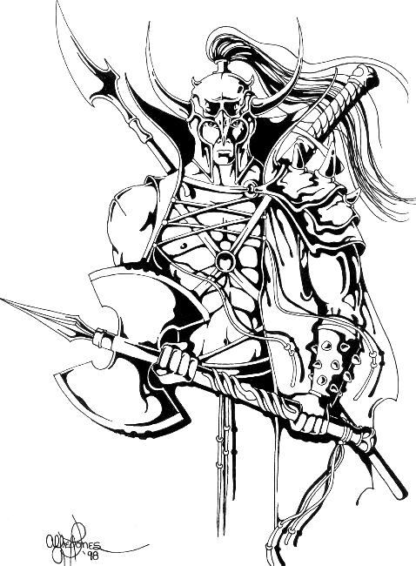
Aura of Courage (level 2) – immune to fear (magical or otherwise). Allies within 10 feet gain a +4 morale bonus on saving throws against fear effects. Granting the morale bonus is a supernatural ability.
Heroic Smite (level 2) – Once per day the Immortal may attempt a Heroic Smite. He adds his Charisma modifier (if positive) to his attack roll and deals 1 extra point of damage per level.

Luck of Legends (level 3) – 1/day for every 3 levels (once at level 3, twice at level 6 etc.) the Immortal may reroll one roll you have just made (all of the dice, if there was more than one). The second result must be taken and no single roll may be rerolled more than once using this power.

The Will To Live (level 4) – the Immortal’s stabilization check % raises by 2/level of Immortal. (example, a 10th level Immortal who has been dropped below 0 hit points will have a 30% chance per round to stabilize)

Heroic Repost (level 5) – as the feat (no prerequisites)

Damage Reduction 1 (level 6)
Bonus Feat (level 6)

Damage Reduction 2 (level 8)
Bonus Feat (level 8)

Strength of Ages (level 9) –The Immortal gains a Strength bonus equal to his level for the whole round. This ability may be used along with Heroic Smite. (example a 9th level Immortal with a Charisma bonus of +3 and a Strength score of 15 will gain a total of +10 to hit, and +16 to damage which includes the bonuses from the +9 (24) Strength). Gaining this strength enhancement is a free action useable once per day.
Unquenchable Spirit level 10 – the Immortal becomes immune to subdual damage dealt in combat. He still takes subdual damage from other sources (ie. cold, fatigue, etc.)

Damage Reduction 3 (level 10)
Bonus Feat (level 10)

Table 1-1: The Venturian Immortal
Class  Level | Base Attack Bonus | Fort Save | Ref Save | Will Save | Special
1st | +1 | +2 | +0 | +2 | Detect Evil, Divine Grace, Heroic Constitution, Legendary Recovery
2nd | +2 | +3 | +0 | +3 | Aura of Courage, Heroic Smite
3rd | +3 | +3 | +1 | +3 | Luck of Legends
4th | +4 | +4 | +1 | +4 | The Will to Live
5th | +5 | +4 | +1 | +4 | Heroic Repost
6th | +6 | +5 | +2 | +5 | Damage Reduction (1), Bonus Feat
7th | +7 | +5 | +2 | +5
8th | +8 | +6 | +2 | +6 | Damage Reduction (2), Bonus Feat
9th | +9 | +6 | +3 | +6 | Strength of Ages
10th | +10 | +7 | +3 | +7 | Damage Reduction (3), Bonus Feat, Unquenchable Spirit

Table 1-2: Paladin Immortal Abilities
Paladin Levels | Extra Abilities
2 | Heroic Smite ability is replaced by 1 extra smite evil per day. Aura of Courage extends to 15 feet. The character does not become an ex-paladin if he has 2 or more levels of Paladin when he takes a level of Venturian Immortal. He may continue to advance his Paladin levels as he wishes.
5 | Legendary Recovery ability applies also applies to the character’s mount.
6 | Discern Lies as the spell 1/day for every 4 levels total. (ie. a 8th level Paladin/1st level Immortal could use Discern Lies twice per day.) (DC = 10 + ½ level + Wis bonus)
8 | Emotion (hope) as the spell 1/day for every 4 levels total. Caster level is ½ of the characters levels of paladin.
10 | Holy Favour - the character never losses loss of level, constitution, or spells when raised.
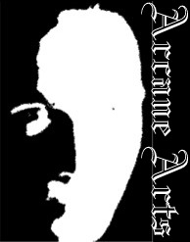


© 2000 D. Arthur Annable

