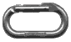Moraine Creek, Lake Adelaide and the Korako Glacier
By Murray Judge

From the Lower Hollyford Road cross the swing bridge over the Hollyford and follow the track for 15 minutes to the three wire bridge over Moraine Creek. The track rises steeply through thick bush, past a small rock bivy below the track then across two rock gullies. At the end of the bush (two to three hours) cross the open flats (Tent Flat) and follow a stream bed towards the bluffs below Revelation, continuing up the stream through scrub and ferns to an open area (Hut Flat, the old hut site). There is a small (three person) rock bivy at the bush edge on the lower side of Hut Flat near the main stream. To reach the head of the valley go up the tussock slope above Hut Flat to a saddle at the crest of the moraine wall, four to six hours from the road. (The route to the Korako Glacier departs here).
Descend to a tarn and follow the shingle valley staying close to the slopes of Apirana. After crossing two bands of boulders Lake Adelaide is reached. Climb up the tussock slope about 100m before the lake to a terrace which gives good travel until it is broken by a slab. Cross the slab and climb up to regain the terrace which continues to the outlet of Lake South America.

Lake South America to Phil's Bivy Rock
From the outlet Gill's Bivy can be seen about 200m away in a cluster of large rocks. Gill's is best approached by going above the rocks and descending the far side. Gill's Bivy (discovered and first used by Mike Gill) has room for eight to ten people and is used for climbs on the slabs and the Sentinel area, and trips from Homer to the Hollyford. The summer route to Phil's Bivy (across and higher up in the basin) is about 100m above Gill's Bivy, staying as high as possible on narrow terraces at the foot of the cirque wall. This route is threatened by avalanches in the early season and a lower route is necessary. Phil's Bivy (named after Phil Herron) is a large sunny bivy with a fine view and accommodation for ten to fifteen people. It is used as a base for routes on Sabre and Marian.

Phil's Bivy to Sabre
From Phil's drop down and across the basin towards the main waterfall below the North Buttress of Sabre, which usually has a large avalanche cone at its base. Cross 100m down from the foot of the waterfall to slabs on the north side, climbing these to a narrow ledge leading left, up and across a grassy gut to a short rock slab. At the top go left to a waterfall and then diagonally right up a rock ramp to a large terrace. Take the second gully at the right hand end to the foot of the North Buttress, then either left up slabs and snow to the Sabre Adelaide Col, or right on rock and snow to the Marian Sabre Col.

Lake Adelaide to Gifford's Crack and the Barrier Knob Traverse to Homer
From the outlet of Lake South America go around the lake and up the scree to the left hand end of the wall below Adelaide Saddle, climb the rock gut (Gifford's Crack) to a shoulder, descend slightly to the right and up a gully to the Saddle. (Gifford's Crack was spotted by A C Gifford who was resting under a rock while his companions Bill Grave, Arthur Talbot and A Lyttle were trying to find a way up to the saddle. All four made the first ascent in Jan 1909).
The traverse around Barrier Knob starts at a small col just before the North Face of Barrier Knob, about 200m above the Saddle. An alternative to Gifford's Crack is to climb the ridge on Sentinel directly above the outlet, or go to the northern end of the terraces above Lake Adelaide and take the slabs to the shoulder of Sentinel.

Gifford 2158m
From the large flats (Tent Flat) in Moraine Creek follow a branch of the main stream towards Gifford, heading for an open watercourse. (the bush on the moraine wall is very thick and full of huge boulders). The gully leads to open tussock slopes below Gifford. These tussock terraces can be followed to the head of the lake and Sabre.
Southwest (low) Peak: First Ascent: Bob Burnett, Murray Stewart, Lindsay Stewart Dec 1935.
West Ridge and first ascents of next two peaks with traverse to East Peak (now shown as highest): Richard Stewart, Jim Milne Jan 1959.
North West Face of Low Peak: John Dale, Richard Pears, Dennis Kemp Feb 1981. A small rock face, seven pitches (17).

Hunka 1981m
First Ascent: Mike Gill, Phil Houghton 1959. They also made the first crossing from Lake Adelaide to Gunn's Camp, over the col between Hunka and Adelaide.

Adelaide 2085m
The col north of Adelaide gives a route to the Gunn Basin and the track down to the Hollyford.
North Ridge: First Ascent: Bryce Wood, Gerry Hall-Jones, Rod Ryan Dec 1953. An easy route up the ridge.
West Face: Hugh Logan, Ian Whitehouse 1975.
South West Ridge: Jim Milne, Richard Stewart, A M Greet Jan 1959.

Sabre 2167m
East Ridge: First Ascent: Bill Gordon, Bryce Wood, Dal Ryan Dec 1954. From the Sabre Adelaide Col traverse 10m left then climb a steep pitch onto the ridge. Move right up a slab to a short chimney and groove above. From this point the ridge may be climbed directly or easier broken ledges followed right towards the top of the North Buttress and up the broken ridge to the top. The broken ledges descending from the top of the North Buttress to the Sabre-Adelaide Col are the most commonly used route of descent, with an abseil down the final pitch to the Col. *
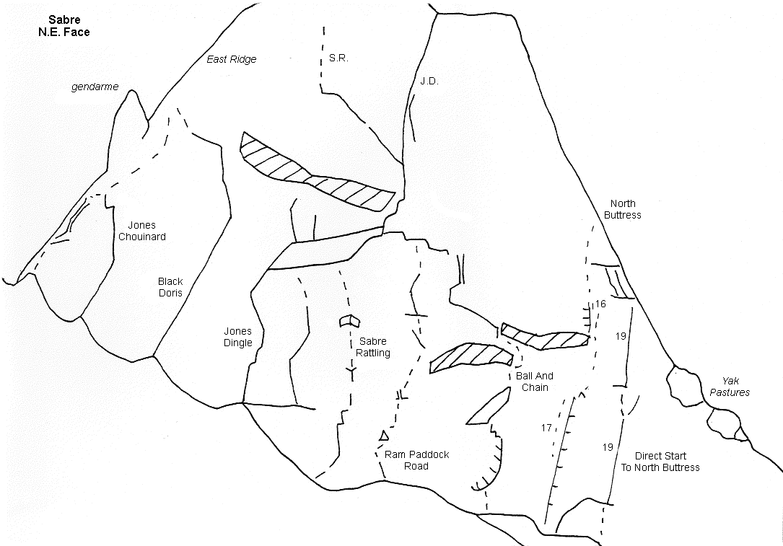
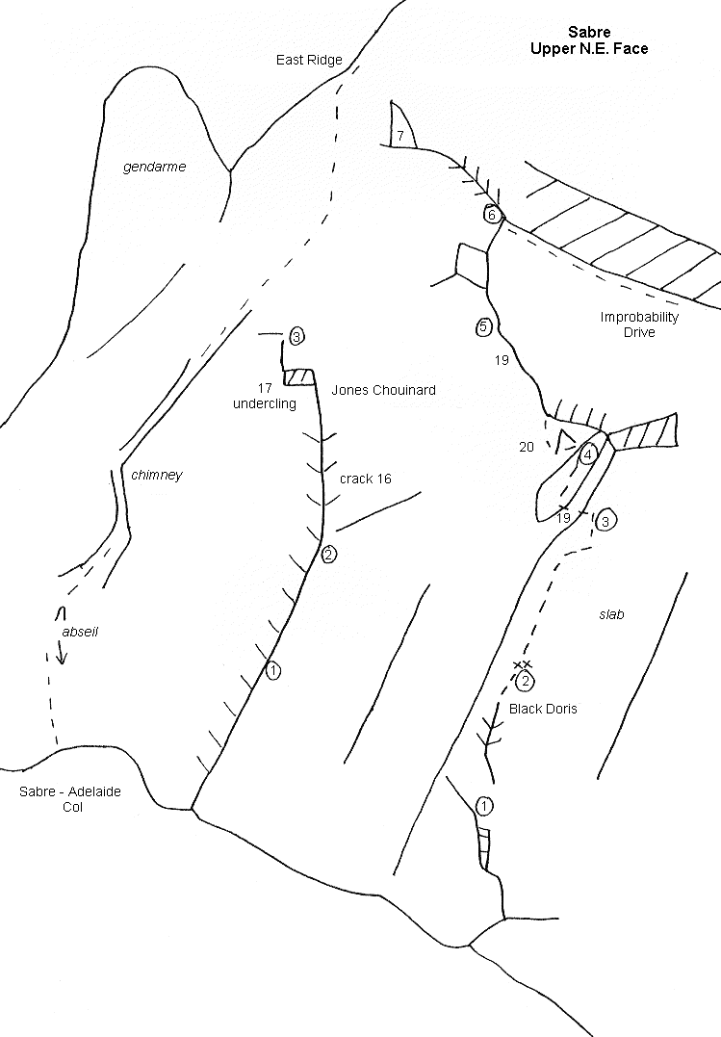
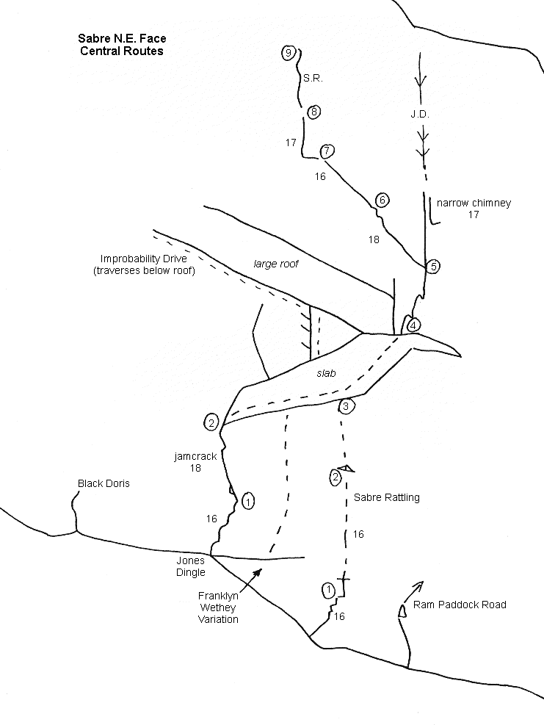
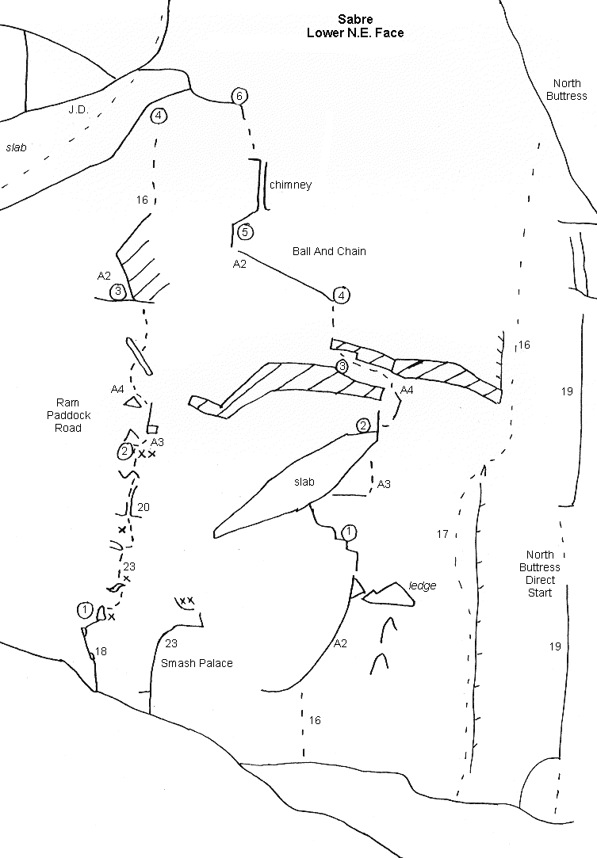

Sabre North East Face
Jones Chouinard: Murray Jones, Yvon Chouinard 1971. ** An excellent three pitch corner crack to the East Ridge.
Black Doris: Calum Hudson, Stephan Schachtl 1985. *** A superb route with steep slabs and a long leaning jamcrack higher up.
T V Route: Graeme Dingle, Murray Jones Jan 1971. ** The scene of an early Television spectacle which was filmed mostly at other locations, it is still a classic Darrans Route. Free soloed by Calum Hudson.
Improbability Drive: John Dale, Nigel Perry Feb 1981. A slanting line with some loose rock under the roof, best avoided.
Sabre Rattling: Murray Judge, Andrew Mcfarlane 1985. ** 9 pitches of good free climbing, the headwall has some very good rock.
Ram Paddock Road: Murray Judge, Hugh Logan Feb 1984. Originally mixed aid and free climbing, the first two pitches were freed by Paul Rogers and Andy Teasdale Feb 1990.
Smash Palace: Dave Vass, Murray Judge Feb 1990. (23) An overhanging layback and undercling crack.
Ball and Chain: John Dale, Murray Judge 1985. A quality aid line. *

Sabre North Buttress
North East Face start: Duncan Chessell, Kylie Wakelin March 1997. From the R hand end of the flat ledges under the N E Face climb a corner /face to a good ledge at 50m. (17) Move R on easy ground under the overhanging wall for 10m then up an initially steep R facing corner 50m (16). Head up R to join the standard route (14). 40m
North Buttress, Little North Face start: Rick McGregor. (19, 19)
North Buttress Direct Start: Calum Hudson, Judy Terpstra, Allan Soon Jan 1982. This is now the usual way to start the Buttress, scramble up to a belay, then one run-out pitch (16) to the ridge
North Buttress: Harold Jacobs, Murray Jones Dec 1968. The route starts at the toe of the Buttress on the North East side, crossing the large grassy terraces, the Yak Pastures. From the upper left of the top terrace climb grooves to a steep wall with cracks (crux, 16). Above this follow the left edge of the Buttress tending towards the centre in the upper section. ***
Right Hand Variation: Ted Coates, John Howard 1973. Climbed the right side of the Buttress.
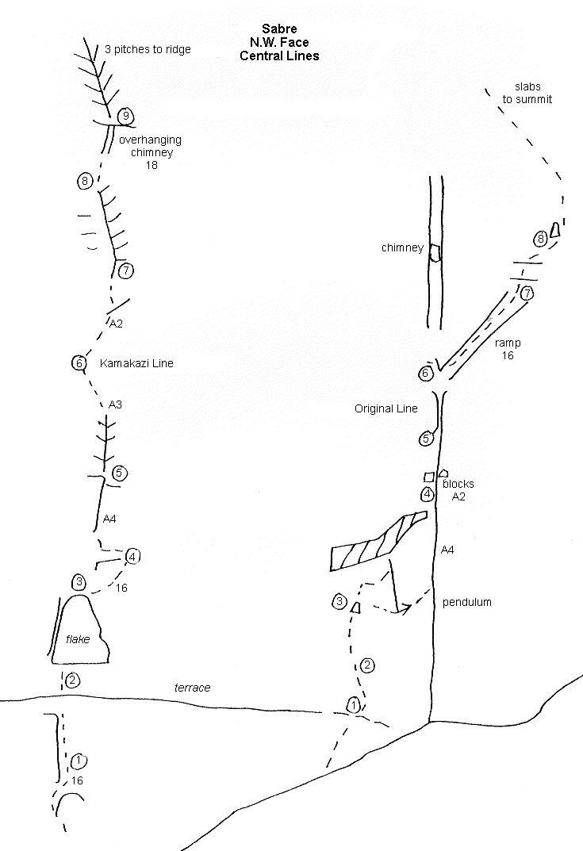

Sabre North West Face
Herron Whiston Aitken: Phil Herron, Neal Whiston, Rob Aitken Jan 1975. From the ledges right of the Yak Pastures climb the corner immediately right of the North Buttress, angling right to the gully between the Buttress and the North West Face. (13 pitches, 17)
Sarkasmos: Calum Hudson, Nigel Perry Feb 1982. Starting from the snow-field under the North west Face where the Buttress meets the face. 1, Right facing corner. 2, Traverse right and up a rib onto the right side of the ledges.(18) 3,Left up the ledges. 4, Up ledges and traverse right. 5, twenty metre wall then up ledges. 6, Traverse right take a chimney on the left side of a flake then across the top to a belay. 7, Traverse right into a slabby groove, up this and swing out left into a crack. (loose blocks, 18). 8, Up ledges and short walls left to join the large right slanting corner. 9, Up the corner to a gully with a steep flake. 10, Traverse right to a slabby gully and up this 11, 12, to the ridge. ***
Kamikaze Line: Bill Denz, Phil Herron, Murray Judge 1975. ** The initial slabs (3 pitches) lead to some thin aid climbing, mostly tied-off Knife-blades, with good free climbing on the upper pitches.
Original Line: Bill Denz, Phil Herron, Murray Judge Jan 1974. * Three pitches of steep wall climbing to the roofs, a wild pendulum regains the corner, followed by two aid pitches to easier chimneys and slabs above.
Rowell Route: Galen Rowell, Andy Campbell, Hugh Logan, Daryll Thomson 1977. This route takes a vertical corner just right of the Original Line, with some aid (19, A3), then follows broken ledges across to the West Ridge.
Garrity Parker: Dave Garrity, Robert Stavely Parker Feb 1982. Eight pitches,(crux 19 on the second pitch) to join the West Ridge.
English Hillary: Merv English, Peter Hillary Nov 1980. Climb slabs and walls to a large corner (17) capped by a roof. Climb the wall to the left of the roof (17) then a groove to broken ground and the West Ridge.

Sabre West Ridge
Phil Houghton, Mike Gill Feb 1959. The ridge rises in two steps from the Marian Sabre Col, these are usually climbed on the right (south) side. Near the summit the ridge is cut by a deep notch but this can be by-passed on ledges on the north side.
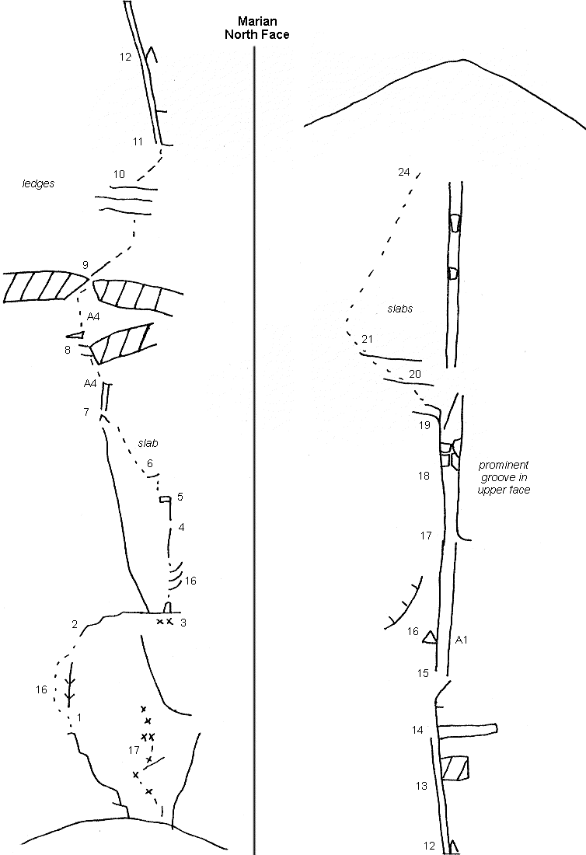

Marian 2109m
East Ridge: Mike Gill, Phil Houghton Jan 1959. A pleasant rock ridge from the Marian Sabre Col.
North East Rib: Graham Clendon, Murray Judge Nov 1972. A four pitch route at the head of the snow-field.
North Face: Bill Denz, Phil Herron, Murray Judge Dec 1973. Starts at the highest point of the scree in the centre of the face, three pitches of slabs to a ledge, three pitches of steep wall climbing and two aid pitches to the lip of the roof. Above grassy slabs are climbed to a large groove which is followed to its top, breaking out left onto ledges leading to the summit. (24 pitches, A4 18).
North Face John McCartney Al Ritchie 1996. 21 pitches, all free except for 6m of aid through a roof 20m left of the original line, climbed over three days.
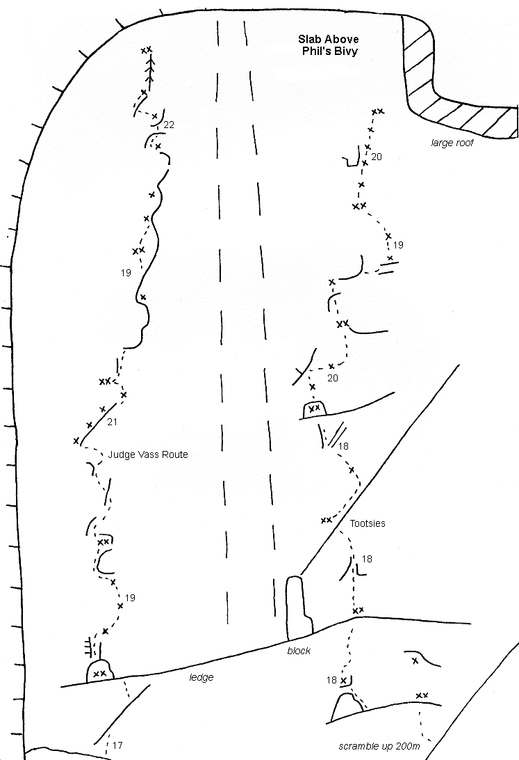

Slab above Phil's Bivy
Dave Vass, Murray Judge Feb 1990. An excellent line of five pitches, left of the central water-streak. ***
Tootsies: Dave Vass, Steve Moore, Murray Judge, Pete Grey March 1987. The recessed slab behind Phil's Bivy. Scramble up for 100m to start the route below a black wall, on the right side of the water-streak. **
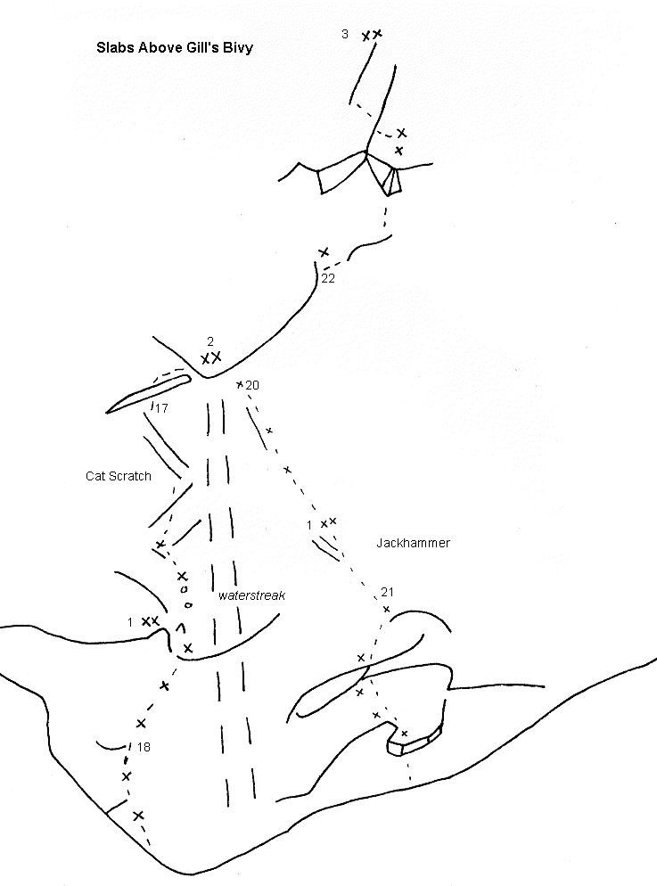
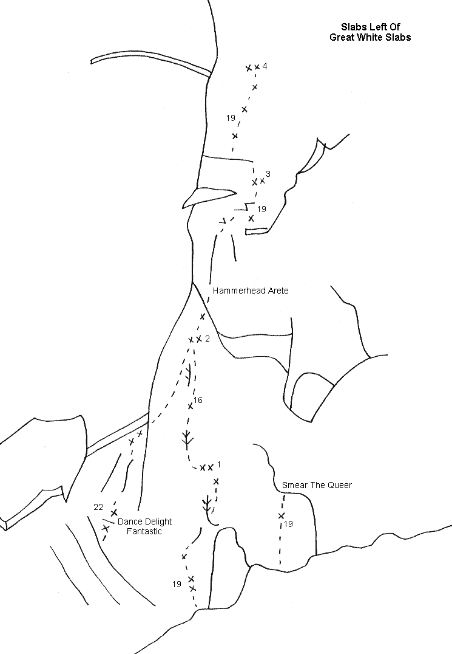

Slabs behind Gill's Bivy
Cat Scratch Slab: Andrew Mcfarlane, John Fisher, Murray Judge 1986. (18, 17, 22) **
Jackhammer: Merv English, Graeme Dingle Feb 1990. (19, 19)
Dance Delight Fantastic: Dave Vass, Pete Grey 1988. To the second belay on Hammerhead Arete. (23) **
Hammerhead Arete: Stephen Alves, Murray Judge, John Fisher 1986. ** The prominent arete left of the Great White Slabs, a quick drying route with less risk from avalanches.
Smear the Queer: Al Mark, Phil DeJoux 1985.
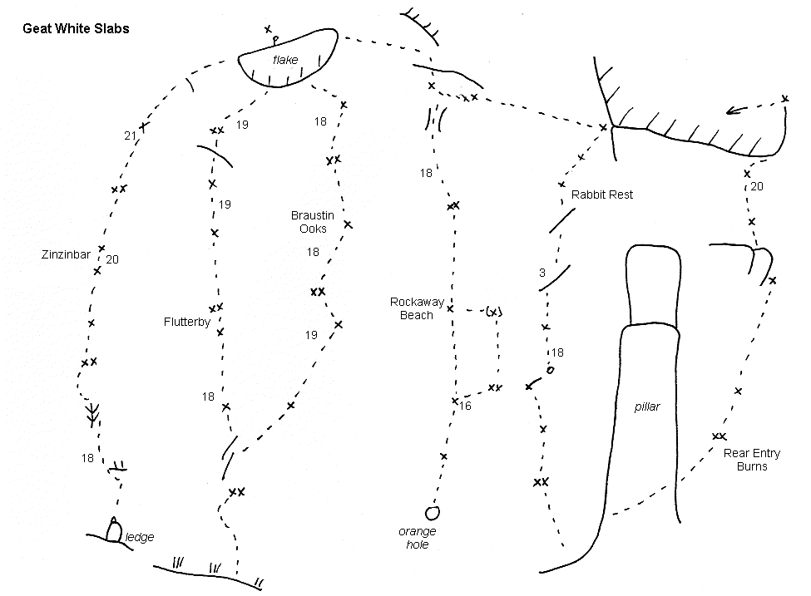

Great White Slabs
(WARNING - some of the bolts on these routes may be damaged or missing because of the exposure to avalanches, particularly on Zinzinbar.)
Zinzinbar: Dave Vass, Steve Moore 1986. On the smooth left side of the slabs, kept clean by frequent avalanches. Strictly a late summer route.
Flutterby: Brian Fish, Chris Morris Feb 1980. **
Braustin Ooks: Bill Atkinson, Brian Fish, Al Cutler, Rick McGregor, Peter Newton 1979. **
Rockaway Beach: Brian Fish, Peter Morris Feb 1980. **
Rabbit Test: Brian Fish, Richard Mortensen Feb 1980. *
Rear Entry Burns: Al Mark. Phil DeJoux 1985.
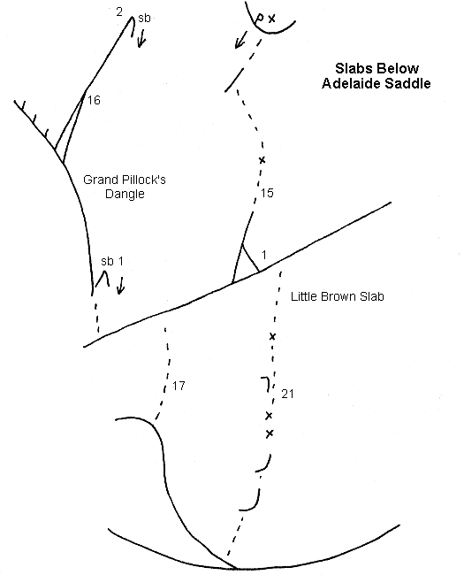

Little Brown Slab
The smooth slab below Adelaide Saddle.
Grand Pillock's Dangle: Luke Newnham, Margot Harkness, Rob Turner 1985. (17, 16)
Little Brown Slab: Murray Judge, Andrew Mcfarlane 1984, pitch 2 Rick McGregor 1985. A fine friction slab. (21, 15)**

Sentinel Shoulder
Denz Herron: Bill Denz, Phil Herron 1975. From Lake South America, six pitches of steep slab to the ridge.
Life Begins at Sixty: John Dale, Dennis Kemp Feb 1981. On the slabs above the terrace around Lake Adelaide, a steep wall (18), two pitches of slabs and up a corner (18).

Barrier 2051m
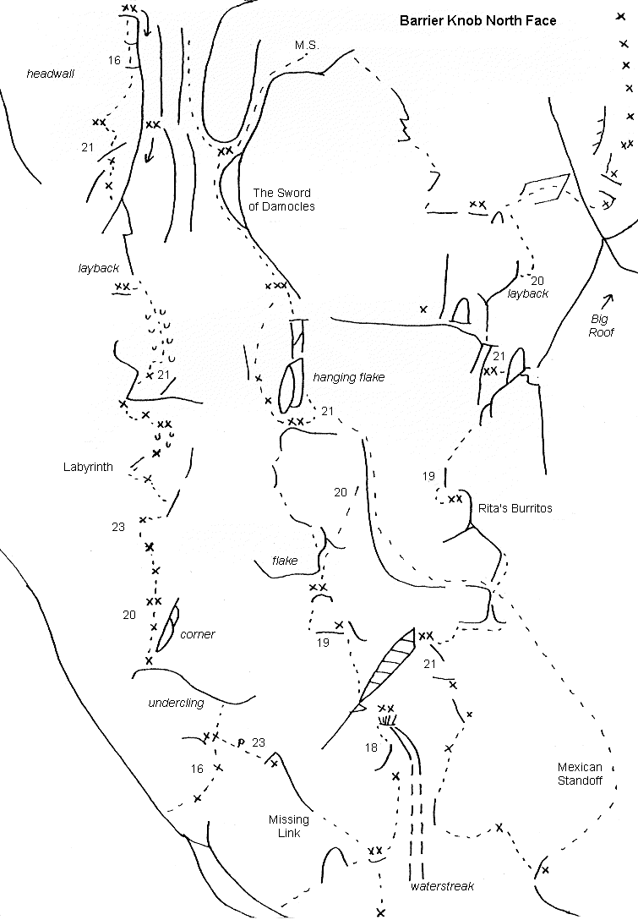
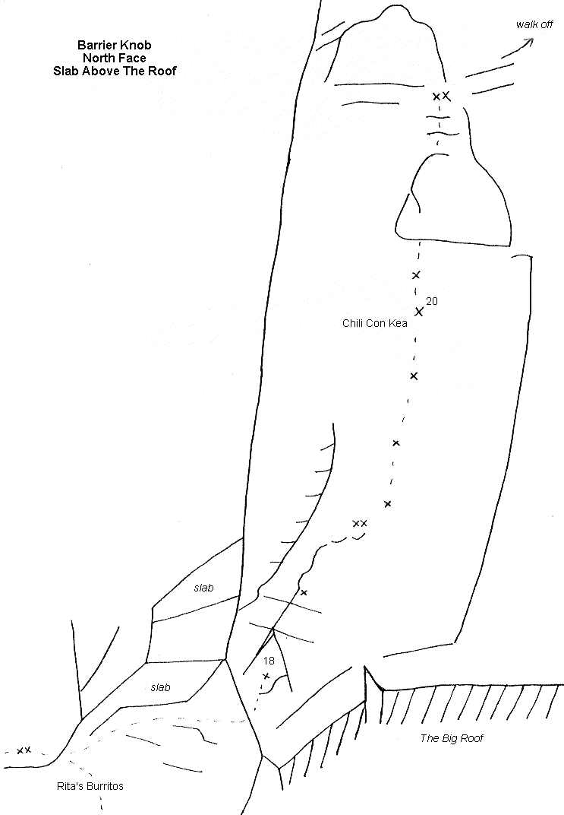

Barrier Knob 1829m North Face
Planet of My Dreams: Calum Hudson, Rob Turner 1987. On the slabby face just down from the col with Barrier, six pitches (18). (This route is easily reached from the Barrier Knob-Barrier Col. The following routes are best approached from the ridge above Adelaide Saddle, traversing and then dropping below a rock rib to reach the foot of the face.) *
Original Line: Pete Glasson, Ken Calder, Al Smith Jan 1972.
Labyrinth: Paul Rogers, Murray Judge March 1988. ****
Missing Link: John Fisher. Murray Judge Jan 1987. (23)
Sword of Damocles: John Fisher, Murray Judge, fifth and sixth pitches Bill McLeod, John Fisher Jan 1987. **
The Sword was a large hanging flake above the third belay which was dislodged by an earthquake in the winter of 1988. This section has now been climbed with 2 bolts (Andrew Mcfarlane, Dave Brash (21) 1996) Andy also added a variant third pitch trending right through an overlap to finish up a sharp fin of rock, grade 20.
Rita's Burritos: Murray Judge, Bronwyn Judge, fifth pitch Murray Judge, Paul Rogers Jan 1989. ***
Chili con Kea: Jeremy Strang, Murray Judge Feb 1990. Two exposed pitches on fine crystalline granite, an alternative finish to Rita's. (18, 20)
Mexican Stand-off: Bill Denz, Stu Allan Feb 1978. Start directly below the left hand end of the large roof, climbing up left to finish as for the Sword. (19). *
Carson Judge: Doug Carson, Murray Judge 1988. A two pitch route 50m right of Mexican Stand-off. (16)

Right side of North Face
There have been five or six routes climbed on the more broken face towards Adelaide Saddle.
Murray Judge and others. 16, 16, 21, Starts at the Right hand of the rib which divides the slabs.
Bill Denz, Murray Judge Feb 1977. A four pitch route midway along the steep section of the face, climb a groove to a loose block in an overhang, step right and up a corner to the ridge.
Merv English, Geoff Gabites, Peter Reichwein 1977. The gully at the right hand end of the steep section of rock.
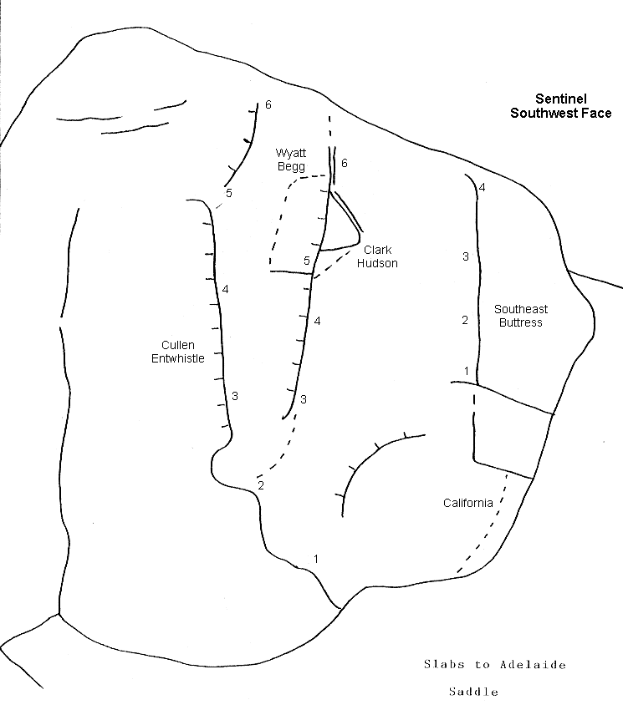

Sentinel 1781m
First Ascent: Lindsay Stewart, Jim Dakin, Jack Warren Nov 1936.
South West Face: Murray Cullen, John Entwistle 1974. *
Wyatt Begg: Geoff Wyatt, Dave Begg Jan 1974. *
Clark Hudson: Bruce Clark, Calum Hudson Jan 1974. *
South East Buttress: Bill Atkinson, Rick McGregor, Judy Terpstra 1975. Traverse left from the ridge and climb the Buttress direct, four pitches. (16) **
California: Calum Hudson, Paul Rogers Mar 1988. Four pitches up a steep flaky crack system leading to the South East Buttress. (18)*

East Twin 1876m
First Ascent: Lindsay Stewart, Jim Dakin, Jack Warren Dec 1936. The ridge from Sentinel.
South Face: Geoff Wyatt, Calum Hudson, Bruce Clark, Dave Begg Jan 1974. From the col between Sentinel and the East Twin make two abseils to the snow-field. The route takes the left side of the face, eight pitches and quite grassy. (not recommended)

West Twin 1855m
First Ascent: Hamish McInnes, Ken Hamilton Jan 1955. From East Twin.
South Face: Bill Denz, Phil Herron, Murray Judge Jan 1974. ** Start on the left side of the face, one pitch up a left slanting gully then follow a line up and right across the face. Good free climbing on excellent rock, seven pitches. (17) **

Darran Pass
Ascend the tussock fan north of Sentinel and traverse along the ridge to the north a short way before descending the tussock basins into the Donne Valley. (First ascended by the face of Mihj 1955. First crossing from the Donne Valley 1962.

Mihj 1814m
South Ridge: First Ascent: Malcolm Imlay, Gerry Hall-Jones 1955. Descended the West Ridge.
East Face: Murray Judge, Bronwyn Tilly, Judy Terpstra Feb 1975. Eight pitches, grassy in places.
South West Face: Murray Jones, Vicki Thompson. 1974. Cross over Darran Pass to gain this small face.

Apirana 1958m
From the route around the moraine, climb the fan and sidle right across slabs to the small glacier below the South Face of Apirana
South Ridge: Pete Glasson, Al Smith, Ken Calder, Bruce Clark, Calum Hudson Jan 1972. The overhanging step at the foot of the ridge is passed on the west side.
South Face: Murray Judge, Al Soon Feb 1974. A steep clean face, twelve pitches on good rock. **
East Ridge: Mike Gill, Phil Houghton, Ian Cave Feb 1962. Climb the slabs to the start of the rock rib, good rock up to the snow-field. *
East Ridge Variation: Richard Thomson, John McCallum Feb 1986. At the start of the rib traverse right, above the gulf then straight up the steep wall. (17) **
North East Face: Dave Begg, Murray Judge Feb 1974. Up easy slabs to the centre of the face and up the central corner, loose in places.
North Ridge: First Ascent: Maurice Bishop, Peggy Matthews 1951. Climb the slabs from Moraine Creek and an easy scramble up the ridge.

Revelation 2194m
South Ridge: Mike Gill, M Hutchins April 1965. A short ridge with steep sections.
South East Ridge: John Cocks, Pete Glasson Feb 1971.

Moraine Creek to the Korako Glacier and Te Puoho Glacier
From the saddle at the top of the moraine wall above Hut Flat take the crest of the curving moraine till it meets the wall below Revelation, sidling left a short way to break through a rock band. Follow a faint track zigzagging upwards to a small col on the ridge. Cross some steepish slabs by either a high or a low traverse to a small tussock ledge below the Korako Icefall. An alternative is to climb the South East Ridge directly from the col. (On returning across the slabs one tends to lose height and arrive at the ridge below the start of the track down. Climb back up the ridge to where a cairn at a small col marks the way down to Moraine Creek).
From the Korako Glacier there are two routes to the Te Puoho Glacier, along the South East Ridge, summit and North Ridge of Revelation, or over Crampon Pass, the lowest col near Taiaroa. This involves a rock climb of 50m on each side. (grade16) In late summer the Te Puoho side can be heavily crevassed.

Revelation 2194m
Korako Glacier through Crampon Pass to the North Ridge: First Ascent: Lindsay Stewart, Jim Dakin, Jack Warren Dec 1936.
East Ridge: John Cocks, Al Smith, Richard Whinham, Pete Glasson Jan 1972. The ridge from Crampon Pass.

Taiaroa 2147m
South Face: Murray Judge, Dave Begg, Hugh Logan, Andrew Smith 1974. An easy scramble up a left slanting groove and ledges to the South Peak.

