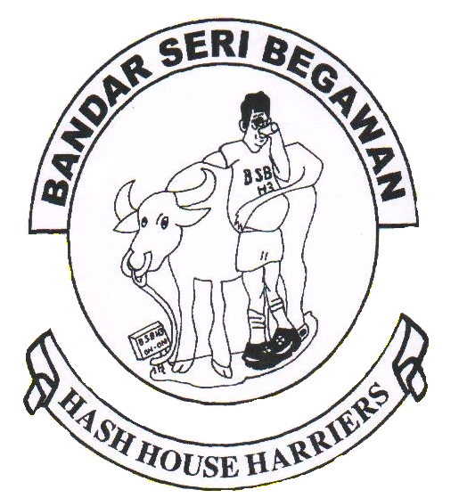
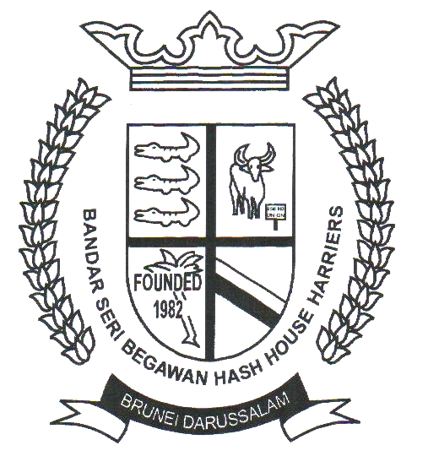
Grand Mother: Angle Lips
Jaunt Maestro: Danny
Jaunt Maestro: Gordon
Religious Advisor: Ninja I
Hash Flash: Chairman Mao
On-Sec: James Lee
Hash Shop: Raisins
Hashwords: hashwords@gmail.com

Hash Whip: Slappy
Holy Water: Spam
Hash Nurse: Chai Chee Bye
Website: www.bsbh3.com
E-Mail: bsbh3@yahoo.com
Address: P.O.Box 546, Seri Complex Post Office, BSB, BA1779,
BRUNEI DARUSSALAM

Bandar Seri Begawan Hash House Harriers

Last week run : Rimba (01-11-2006) Hare: Frankie
Run No : 1256 Co-Hares: Henry yong, KBChu

The drinking club with a slight running problem.
What they did last week:
Before this week run could start – the dick of the week was easily picked up by JM, who is none other than Mathew – who called up the Gordon (5pm) to pick him up as he ran out of gas!

To say something about this week run… Frankie’s 100th run… big expectations… ooooooossssspppppsss…!
Good trails at the beginning… while all hashers busy looking the first check – came up from behind our great Ninja I, who can be a hare for Live run, found the paper but picked it up - after the second check the hares lost all their imaginary ideas and couldn’t get near DST tower … and lead the run to the shortest finish…! Good nomination for the lousy run of the year! – Most probably screwed up by Henry Yong! Such no brain stupid dick…. Oh sorry …. Should be a stupid cunt…as a co-hare went in the jungle to do another different run…in different fucking direction! Deserves to get hashshit but landed with half a yard!

Oldie Bill looking for a hash relay name and looking for some 65 to join him! Stupid Cunt! Yappie-Puppie!

Free beers for hashers returning from World Interhash-Chang Mai and please consult Dr. Fong!

Dick of the week : Mathew
Cumpiss : Henry Yong
Stupid cunt : Bill/AhChoon
Half a yard : Henry Yong
Hashshit :

This Week Run : Lucky Garden Date: 08 – 11 - 06
Run No : 1257 Hare: JM run
Next week run : 15-11-06 Run No: 1258
Run Site : DST towers Hare: LCL- 400 runs

Run No Date Hare Venue
1259 22 Nov Hau FC Kota Batu
1260 29 Nov Ting Su Woo/Ahboi TBA
1261 06 Dec Garry/Max Mabohai(Lapau)
1262 13 Dec Medicine Man Mata-mata
1263 20 Dec Ding-a-Ling TBA
1264 27 Dec Quddus Kong TBA
1265 03 Jan AhKee TBA
1266 10 Jan Chazzitty TBA
1267 17 Jan Chong Tart Hen TBA
1268 24 Jan Cobrahead TBA
1269 31 Jan Soon Leong TBA
Please update your run site with MOHAN (8830828) or email to: hashwords@gmail.com
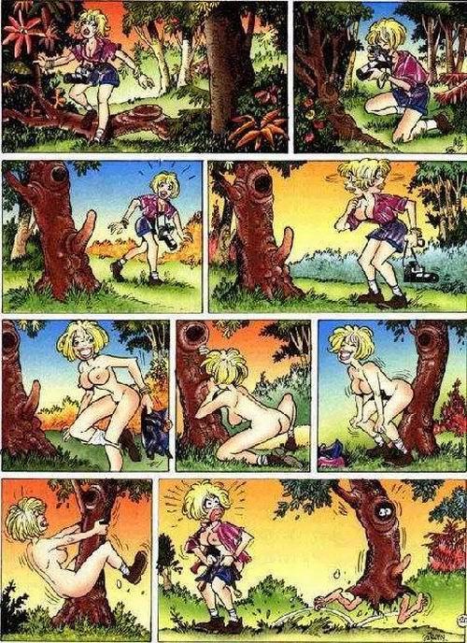
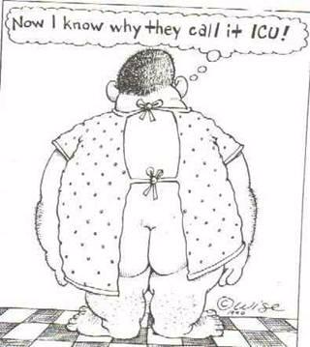
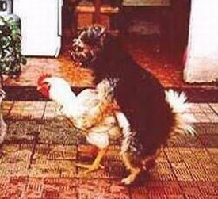

Punishment
A Sardar, a German and a Pakistani got arrested consuming alcohol which is a severe offense in Saudi Arabia, so for the terrible crime they are all sentenced 20 lashes each of the whip. As they were preparing for their punishment, the Sheik announced: "It's my first wife's birthday today, and she has asked me to allow each of you one wish before your whipping."
The German was first in line, he thought for a while and then said: "Please tie a pillow to my back." This was done, but the pillow only lasted 10 lashes & the German had to be carried away bleeding and crying with pain.
The Pakistani was next up. After watching the German in horror, he said smugly: "Please fix two pillows to my back." But even two pillows could only take 15 lashes & the Pakistani was also led away whimpering loudly.
The Sardar was the last one up, but before he could say anything, the Sheikh turned to him and said: "You are from a most beautiful part of the world and your culture is one of the finest in the world. For this, you may have two wishes!"
"Thank you, your Most Royal and Merciful highness," Sardar replied. "In recognition of your kindness, my first wish is that you give me not 20, but 100 lashes."
"Not only are you an honorable, handsome and powerful man, you are also very brave." The Sheik said with an admiring look on his face. "If 100 lashes is what you desire, then so be it.
"And what is your second wish?" the Sheik asked. Sardar smiled and said: "Tie the Pakistani to my back".

