Charlotte’s Web
By E.B. White
Report by Jennifer Opper

The main characters of Charlotte’s Web are a girl, a pig, a spider, and rat. The story takes place on a farm where Wilbur, the pig is born. Wilbur is the runt of the litter and is saved by Fern when her father wants to kill him. Fern raises Wilbur. He goes to live in the Zuckerman’s barn. There he meets Charlotte, the spider, Templeton, the rat and the other farm animals. The story takes place over the summer, Wilber grows, and Charlotte becomes his friend.

In order to save Wilbur, Charlotte weaves spider webs with words in them about Wilbur. The Zuckerman’s put Wilbur in a crate to take him to the fair. Wilbur wins a special award. Templeton and Charlotte go to the fair with Wilbur. Charlotte spins a web at the fair that says “Humble”. She also spins an egg sack.
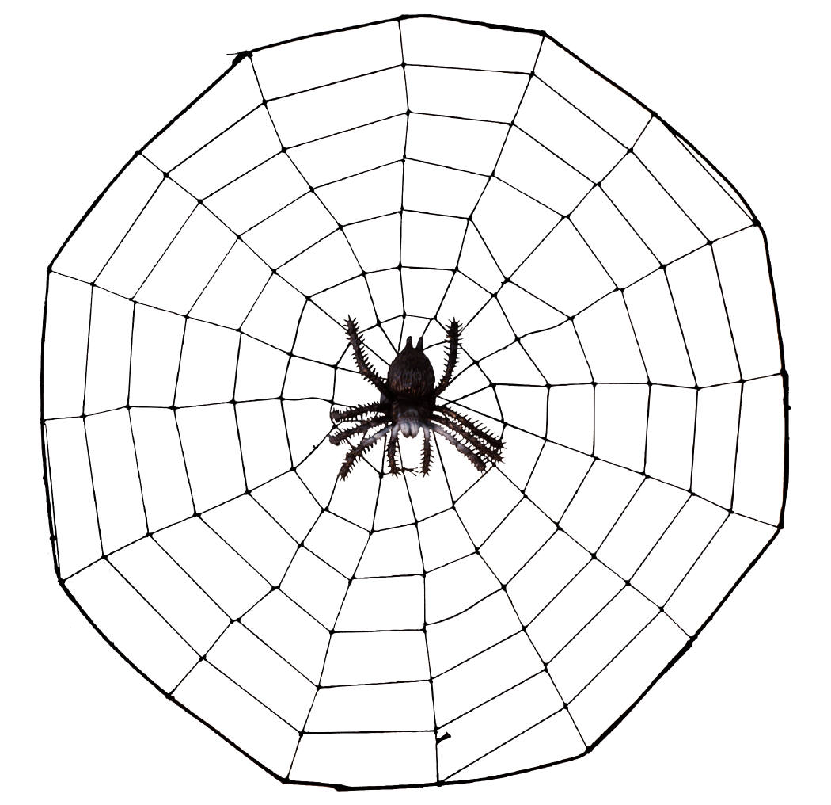
Charlotte may have looked something like this spider.

This is what Wilbur could have looked like.

