The Pentothal Advertising Postcards Posted from Wilkes Base
by Martin Walker (martin.walker@drakefoodmarkets.com.au), 2001, “Philately in Australia”

During the 1950s an American pharmaceuticals company, Abbott Laboratories, began to advertise their anaesthetic, Pentothal, by postcard. The campaign involved sending tourist type picture postcards from around the world to a mammoth mailing list of American doctors. The cards bear a message about the availability (or lack of availability) of Pentothal in each of the places from which the cards were posted. I have seen cards from dozens of different countries including Australia, Hong Kong, Uruguay and even Lundy Island in Great Britain. As the advertising campaign progressed the company looked for more and more exotic places from which to send their postcards. One of the most exotic places was Antarctica and in 1961 the company succeeded in getting their cards mailed from Wilkes Base – apparently after attempts to have the cards mailed from an American base were refused.

This mailing precipitated some angry responses from the personnel at Wilkes and as a result the first limitations were imposed on mail sent to Australian Antarctic Territory bases for postmarking. The Postmaster-Generals Department file on this episode has recently been located and forms the basis for much of this article.

In the middle of 1960 Abbott Laboratories’ Australian office based at Camperdown, N.S.W. purchased some £7,700 worth of 5d and 8d AAT stamps from the Sydney Philatelic Sales Section. As an outcome of this sale 34 bags of mail were received at the Philatelic Sales Counter, Sydney and forwarded on to the Philatelic Bureau at Melbourne. It was required that the contents be postmarked at Wilkes. The bureau staff at Melbourne determined that it would have been impossible for the mail to be hand postmarked at Wilkes during the short stay of the relief vessel. In order to cope with the unusually large mail additional postmarkers were made and arrangements were made to allow postmarking of the mail during the ship’s voyage to and from Wilkes.

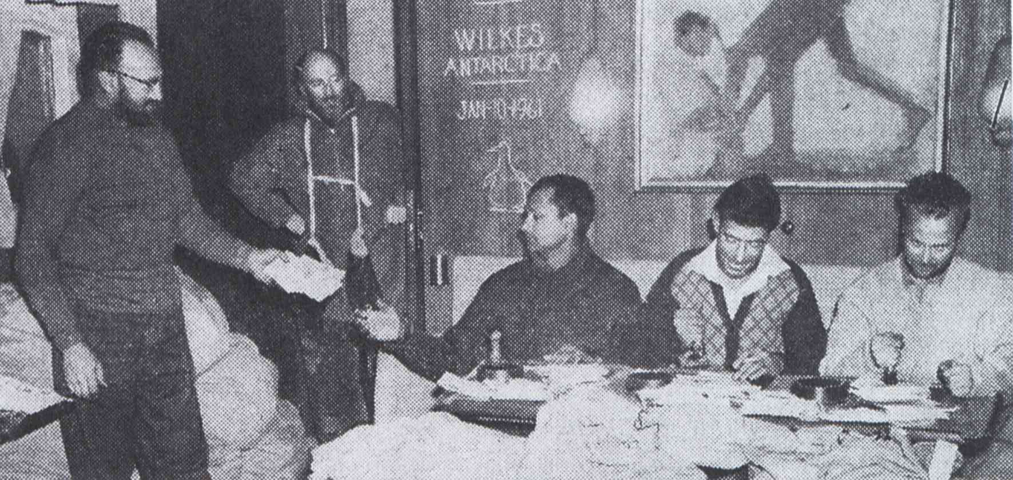

An unknown quantity of the mail was postmarked at Wilkes as this illustration from Melbourne’s Herald newspaper clearly shows. It was captioned “Mail is heavy at Wilkes. Here officers are franking some of the 286,000 letters brought to Wilkes in the Magga Dan. A great deal of the mail is sent by philatelists. From left: Postmaster Stan Church, Mr. Phillip Law, Ram Charan (an Indian observer), Tom Cordwell and Fred Jewell.” Of the 286,000 letters, 280,000 were postcards advertising Pentothal.
This unforeseen burden on the staff at Wilkes was too much for Phillip Law, Director of the Antarctic Division, and a strongly worded signal was sent to the philatelic bureau:
“We have stamped by hand during last fortnight 280 thousand covers. Almost all of these are postcard advertisements for American drug firm. Such mail not accepted by USA Expeditions. We cannot during pressure of relief operation afford man power involved. In future suggest frank these automatically in Melbourne or refuse to accept because we will not handle them next time.”

Following the receipt of Law’s signal arrangements were made to inspect the mail when it arrived back in Australia. The Magga Dan returned to Fremantle on 22 January 1961 and the mail was sent overland to Melbourne, arriving on 26 or 27 January. The relevant postmarkers were also returned with the mail. A portion of the mail was inspected by Phil Collas in his capacity as Assistant Controller, Stamps and Philatelic Branch. He reported that the mail was mainly comprised of “picture postcards of American origin with a colored view of Wilkes Base (as it had appeared under American control) on one side. On the right hand side of the address-face was a gummed on label bearing the name and address of an American doctor and on the left hand side a printed message, in handwritten script style, extolling the merits of a particular pharmaceutical preparation.” Collas also arranged for the Melbourne Mail Exchange Branch to postmark (with the Wilkes handstamp) any cards that were missed at Wilkes or on board the Magga Dan.

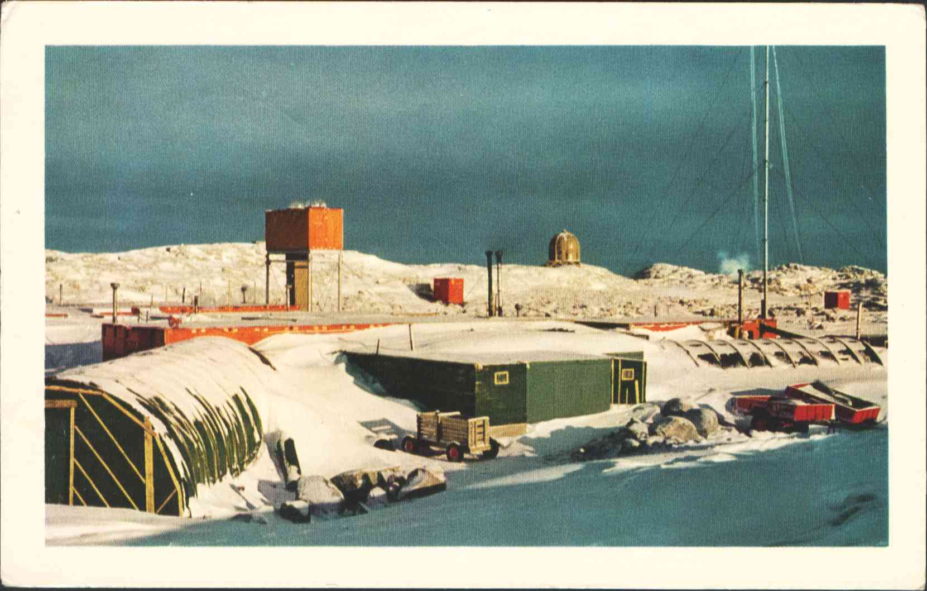

When in America in 1997 I picked up a couple of these cards at a postcard fair. I actually grabbed them as examples of the 8d postcard rate to foreign countries by surface mail. I was surprised that local polar philatelists were not aware of the cards when I met several of them at the Canberra 2000 exhibition. Having now learned the facts behind the episode it is not surprising that Australian philatelists would be unaware of a piece of junk mail sent to the other side of the world. How many of the 280,000 cards have survived will probably never be known but the cards do seem to appear quite regularly on the internet auctions and American postcard dealers lists. I would recommend this avenue to Antarctic collectors wanting an example. The PMG report mentioned that 5d stamps were also purchased by the sender of these postcards. This may suggest that the cards were also sent to Australian doctors but I have yet to see an example of one. The 5d stamps were more likely to have been used on cards addressed to other Commonwealth countries, particularly Canada.
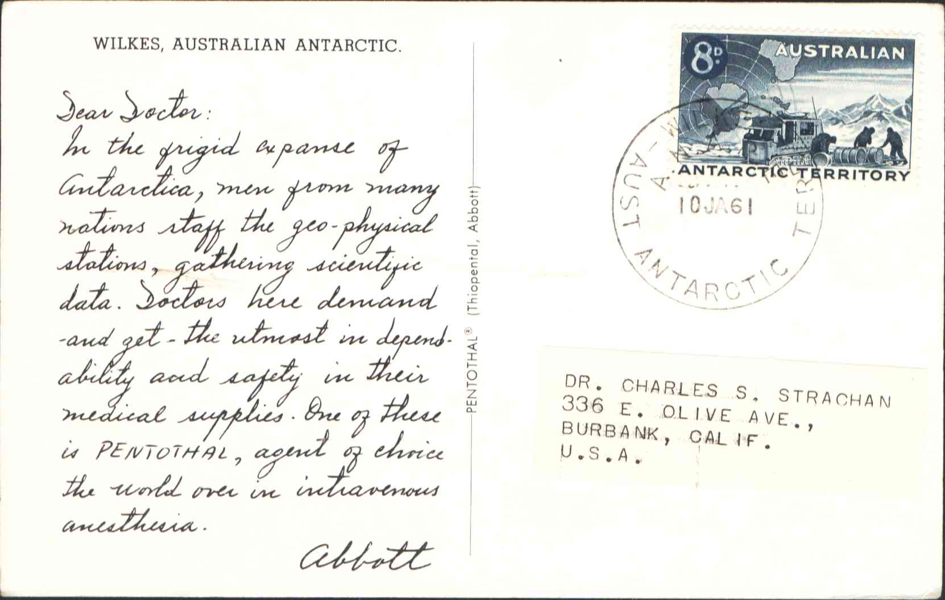

I have now seen about a dozen of these cards cancelled by three different types of postmark. Two of these are identified as Milner types E1a and E1c. The third type is a variant of Milner type E1c. The illustration shows the major difference between the two. On type E1c a line drawn along the date line passes to the right of the ‘E’ of ‘TERR’ and on the variant the same line passes to the left of the ‘E’. Another point of difference between the two types is the size of the space between “ANTARCTIC” and “TERR.”

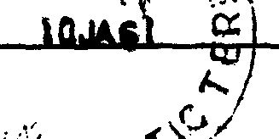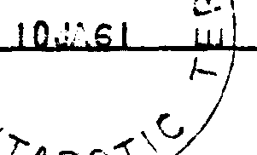

Milner type E1c E1c variant.

The report reveals that additional postmarks were sent to accommodate the unusually large amount of mail. Exactly how many is not revealed but the photo of the base staff postmarking the mail clearly shows three handstamps in use. It is possible that the only source of the E1c variant, and perhaps other postmarks is on these cards.

Following the complaint from the Director of the Antarctic Division the Superintendent of the Melbourne Mail Exchange Branch and the Assistant Controller of the Stamps and Philatelic Section made the following recommendation. Should any similar mailings be received in the future, “the whole mail would still be carried to the appropriate Antarctic Post Office; as much as possible there postmarked, and the whole then returned to Melbourne where the untreated mail would then be postmarked with the same date reading, utilizing similar hand postmarkers, which would be made for the purpose.” This recommendation was varied slightly and the final arrangements for the 1961/62 season stipulated that
- not more than 100 covers to be accepted from any one person or firm; and
- any very large posting (especially advertising) to be accepted only on basis of postmarking on return from Antarctic.
The new conditions for the acceptance of mail for postmarking at the Australian Antarctic Post Offices were first publicized in the Philatelic Bulletin distributed in August 1961. The file on this episode closes with letters from W. Hornadge of Seven Seas Stamps. In a well-written letter, Hornadge indicated that Seven Seas had already organized the production of 4,000 postcards before the new posting restrictions became known. 1,000 of each were intended for postmarking at each of the four Australian bases. He sought, and received, permission to send the 4,000 cards.

The Pentothal advertising cards are important in the philatelic history of the Australian Antarctic Territory. The single mailing of 280,000 postcards caused the manufacture of postmarks just to cancel these cards and brought about the need to introduce mailing restrictions, or alternative postmarking facilities, to allow the staff involved in relief operations to be employed in tasks more useful and suitable to Antarctic research and endeavour.

