Zube – Crossroads: Roberts Rd. and 2920
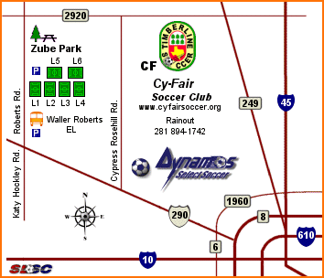

Dyess - Crossroads: Telge and Kitzman Road

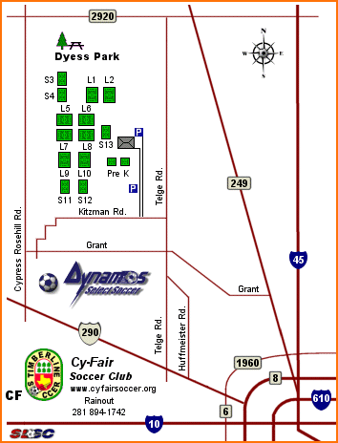

Bear Creek - Cross Streets: Clay Road (or Eldridge) and Park Rd; 281-894-8885 correct rainout number. Do not use the rain out number on the map.
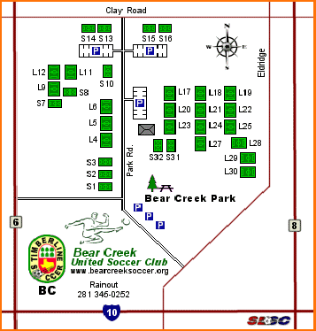

CARL BARTON – Crossroads: Loop 336 and FM1314; 936-756-0604 correct rainout number. Do not use the rain out number on the map.

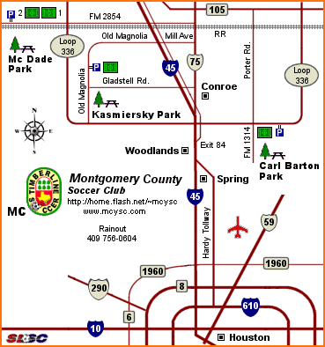

Bear Branch – Cross streets: Research Forest Road and Shadowbend; 281-210-3977 correct rainout number. Do not use the rain out number on the map!

