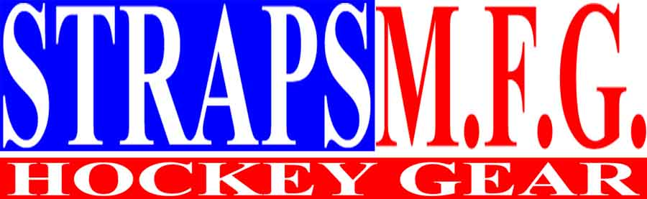

RETAIL

ORDER FORM
Welcome to

STRAPS M.F.G. HOCKEY GEAR

Tel: 212.695.1743 Fax: 212.695.1728
Web http://www.geocities.com/colosseum/rink/3568
Email: strapsmfg@hotmail.com

ORDER DATE:  PERSONAL CHECK  If paying by check, please make payable to:  STRAPS M.F.G.  - Please note that check must be received and clear before we can ship your tape to you.  Signature required for all payment methods | METHOD OF PAYMENT:
SHIP TO: | METHOD OF PAYMENT:
ADDRESS: | METHOD OF PAYMENT:
CITY: STATE: ZIP: | METHOD OF PAYMENT:
PHONE: | METHOD OF PAYMENT:
FAX: | METHOD OF PAYMENT:

QTY | TAPE STYLE | COST PER ROLL | TOTAL
 | PUCK N WHEELS – REGULAR PRINT | $ 3.00
 | PUCK N WHEELS – BLUE REVERSE PRINT | $ 3.00
 | * PUCK N HOCKEY – BLACK PRINT | $ 4.90
 | * PUCK N HOCKEY – BLUE PRINT | $ 4.90
 | ROLL ON | $ 3.00
 | * SUCK IT – RED | $ 4.90
 | * SUCK IT – YELLOW | $ 4.90
 | GEARED FOR ACTION | $ 3.00
 | TEARIN’ IT UP | $ 3.00
 | SKATES | $ 3.00
 | CANAM | $ 3.20
 | MORGUE – BLACK ON WHITE | $ 3.30
 | MORGUE – BLACK AND RED ON YELLOW | $ 3.50
 | HOCKEY GIRL | $ 3.50
 | SURE SHOT | $ 3.00
 | BLACK JACKS | $ 3.20
 | * I.S.C.A. | $ 4.90
AMOUNT
A * denotes the tape is 2” x 55 yards. All other tapes are 2” x 27.5 yards.

Please note there is minimum order of $20 and shipping & handling is $5.25

To order by phone, simply call 212.695.1743 between 8am and 5pm EST, Monday through Friday.
STRAPS M.F.G.
245 W 29th Street
New York, NY 10001

S&H
$ 5.25
 |  |  | TOTAL

