Name:____________________
Song of the day:________________________
Worksheet II – The Saga Continues
Week 2 Session 2
Ok, so do as much as you can without your notes then fill in the rest with your notes and text.
- Other than the fact that Sponge Bob is an artificial sponge what characteristic obviously identifies Sponge Bob as an imposter?
- What does the word Porifera mean?
- What are the general features of this phyla? What type of environment can it be found in?
- Porifera come in 3 shapes …what are they?
- Did you fill out the song of the day? If you haven’t stand up and do the chicken dance. I hope the other members of your group will enforce this for me ☺

- What are the cell types of this phyla? Which one is the diagnostic feature of this phyla?
- Define the following words for that have to do with the cell type Porifera. Group anywords that belong together as a group and tell how they are a group.
-Spongocoel
-Osculum
-Spicules
-Asconoid
-Syconoid
-Leuconoid
-Monaxon
-Diaxon
-Triaxon
-Hexaxon
-Spongin
- wow…so now that we got all the back ground done we need to go through the this phyla. First…what font is this worksheet in?
- Phylum Porifera has a number of classes. Below the information for all these classes are missing. (Oh no!) Your challenge, should you choose to accept it is find the missing information and put the correct information in its place. If you choose to accept this mission and you make a mistake the SI leader and Dr. Adams will, as always, deny any knowledge of you and this mission. Good Luck
  - Class ________________
-Spicules made of (CaCO3)
-This class is the only one to contain these body types, these are?
Examples:
  - Class Demospongiae

Example: ( why is this sponge interesting?)
  - Class ___________________
    - Spicules are :
Example: Venus Flower basket
- What are the four methods of Asexual reproduction? And describe them.

- What is dioecious mean?
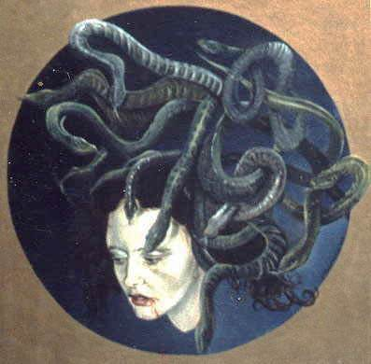
- Phylum Cnideria. What are the general adaptive zones for Cnideria. What are the general features of this phylum?(yes all 7 of them) Why is it diploblastic (What does this mean)? Draw a medusa labeling the different layers of the body.(Not like the one that is below!!)

- What is the Diagnostic Feature of Cnidcytes? Describe what they do. Why don’t sea slugs qualify as being in the Phylum Cnideria?
- What are the differences between a polypoid and medusoid forms. Draw each and draw the characteristics below.
- How does this phylum reproduce sexually and asexually?
- Ok…let break down this phylum…you ready??? Ok…I don’t feel like you are ...get motivated because here we go!!!
  - Class Hydrozoa
    - General Characteristics?
Example of Solitary Polyp. Sketch the lifecycle.
Example of Colonial Polyp Sketch the lifecycle
Example of one that is predominately Medusa
Examples of Colonial Pelagic Preditors

