How Can XQuery be Implemented in XML?

Vickie Pi-Fen Chen

School of Business Systems

Faculty of Information Technology

Monash University

October 2003

Chapter 1 Introduction
On the Internet, increasing numbers of people are using Extensible Markup Language (XML) to interchange information across different platforms. The flexibility of XML has caused it to be commonly used.
In XML, the pair tags, start and end, are user definable, which makes the language be easily extensible (Ishikawa 2002). Because it can be used to exchange electronic data in one model from various applications, a query language is in demand to be developed for queries in XML documents.
In October 1999, the World Wide Web Consortium (W3C) organized a XML Query Working Group to develop a XML query language called XQuery (W3C 2003). It can query not only XML documents but also relational database such as Oracle and SQL server. Through this, XQuery can do query across different applications.
There are some different aspects between a relational database and XML data. Unlike relational data, which are flat and store data separately, XML data usually are hierarchy and store data throughout the document. Therefore, due to the above reasons, XML cannot use existing query language for doing query directly. (Chamberlin, 2003).
The XML Query Working Group is still working on the XQuery language design. It is developing XQuery using W3C standards, including Schema, XSLT, XPath and XML itself (W3C, 2003). Additionally, XQuery is influenced by several languages, such as Quilt, OQL, SQL, XQL, XML-QL, Lorel. (Liu, 2002).
In this project, Chapter 2 discusses W3C documentation and other resources. This is followed by a brief introduction to XSLT and XPath language. Chapter 4 introduces the model and syntax of XQuery language while the installation of the Oracle parser is illustrated in the following Chapter. The implantation of XQuery is discussed in the final Chapter.
Chapter 2 xquery documentations in W3C and Other Resources
Many organizations provide XQuery documentations for reference, which are found in many websites. For instance, W3C provides numerous specifications, while Oracle provides several white papers and the following two sections will discuss them in detail.

2.1 W3C Documentations
The best reference for XQuery is the XML Query website maintained by W3C. This website contains twelve different specifications (Marchiori, 2003):
- XML Query Requirements
- XML Query Use Cases
- XQUERY 1.0 AND XPATH 2.0 DATA MODEL
- XSLT 2.0 and XQuery 1.0 Serialization
- XQuery 1.0 and XPath 2.0 Formal Semantics
- XQuery 1.0: An XML Query Language
- XML Syntax for XQuery 1.0 (XQuery)
- XQuery 1.0 and XPath 2.0 Functions and Operators
- XPath Requirements Version 2.0
- XML Path Language (XPath) 2.0
- XML Query and XPath Full-Text Requirements
- XML Query and XPath Full-Text Use Cases
These specifications provide the requirements and usage scenarios for the data model, which includes XPath, XSLT and XQuery (Chamberlin, 2003; Scardina, 2003; Buxton, 2003). The user should have the full knowledge of the data model of XQuery and XPath, and how parser works for search the specific node in advance to running query in XML. It will be shown in third and fourth chapters (Fernandez, 2003).
The definitions of serialization for the XSLT and XQuery are provided in the serialization documentation (Kay, 2003), which is specifically for the information that needs to be stored or serialized in transfer.
The syntax specification compares the syntax of XML and XQuery and is a theoretical specification that describes the schema and DTD of XML (Malhotra, 2003). Comparatively, the “Formal Semantics” describes more deeply than the “XML Syntax” (Draper, 2003). Besides, the “Formal Semantics” dicouemt is to supplement the “XQuery 1.0: An XML Query language” document by specifing the definition of XQuery expression with arithmetic ways. Moreover, the basic operators and functions for using XML, XQuery, XPath and XSLT are included in “Operators and Functions” specification. The document illustrates the usage of XQuery and XPath functions, which is covered more extensively in Chapter 3 and 4 (Malhotra, 2003).
As opposite to “Formal Semantics” documentation, use cases specification provides many examples for executing XML Query. Additionally, in the XML Query Use Cases document, many XQuery and the result have been illustrated. The specification also groups the cases into nine categories; they are XMP, Tree, SEQ, R, SGML, STRING, NS, PARTS and STRONG (Chamberlin, 2003). It contains 77 example questions and results in this documentation; they have been commonly used in many XQuery demo website.
Group | Meaning | Description
XMP | Example | Provides various basic examples and some functions.
TREE | Hierarchy | XQuery can do query in hierarchy database, and in its elements structure, some elements can be empty. In this section it introduce how does XQuery navigate element node from one document to another.
SEQ | Sequence | This section is to examine the sequence of the nodes that locate in a database.
R | Relational Database | It’s important that XQuery can access data from relational database. XML can set up relationship by where clause or predicate expression in let clause.
SGML | Standard Generalized Markup Language | In this section, it introduces how to access specific node in SGML file. The function input() is use to return the input node. However, most demo websites and parser have not this function yet, including Microsoft, X-Hive and Oracle XDK.
STRING | String | String search, for instance, using contain() function to find the node that contains the string in this group, illustrates in this section.
NS | Namespaces | It uses namespaces to query, but Microsoft XQuery Demo and Oracle XDK cannot work for namespaces, however, X-Hive can implement successfully.
PARTS | Parts | Explores recursive parts in database.
STRONG | Strongly typed data | This section has done the queries in exploit strong-type database.
The “An XML Query Language” documentation defines the expression, data type and model of XQuery. In this documentation, the XQuery expressions have been described in details, especially, FLOWR expression (Chamberlin, 2003). Not only XQuery language, the expression of XPath language is also provided here (Berglund, 2003). In this project, XQuery language description will be discussed in Chapter 4.
Compare with the use cases specification of Chamberlin, the full-text use cases of Amer-Yahia is more advanced. It provides the scenarios of full-text queries in using XML Query and XPath and the expected result; however, the example XQuery codes are not fully provided (2003).
As above documentations, they define the syntax, expression and requirements of XQuery language and also provide other three related language usage, including XML, XPath and XSLT. During these twelve specifications, the most three important documentations are: XML Query language, XQuery and XPath 2.0 Function and Operators and XQuery 1.0 and XPath 2.0 Data Model. Beside W3C, Oracle has provided various technical documentations. It will be introduced in next section.

2.2 Oracle Documentations
Oracle has provides specification that based on different platforms, including Java, C++, C and SQL. However, most papers specifies on PL/SQL. In Oracle XML DB webpage (2003), Drake presents the emerging SQL and XML way and processing these two types documents together in his Oracle Oracle XML DB technical white paper. Also, in Oracle XML DB Demo Script (9.2.0.2.0), it provides the installation and implementation of XML in Oracle server. More over, various SQL sources code can be downloaded and related XML files also.

Chapter 3 XPath and XSLT
Three languages, XQuery, XPath and XSLT, structure XML query languages. XQuery is the most capable and powerful while XPath is simple and efficient, on the other hand XSLT is full feature language (Son, 2002).

3.1 XPath
The idea of XPath is from the path expression of an object database, OQL. The data model in XPath views a document as a tree. Absolute and relative operators are used to traverse the tree; and will return a collection of nodes from the tree. Following is an XPath data model tree; it is an example of Products.xml (Son, 2002).
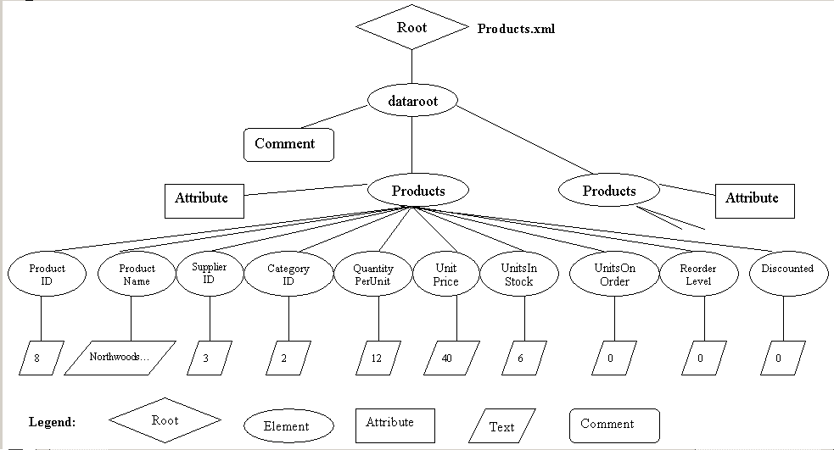
Figure 1 XPath Document Tree
More over, the product examples of XPath expressions are demonstrated as below table.
XPath Expression Example | Mean
/data/Products/UnitPrice | Returns the collection of references to the nodes that correspond to the UnitPrice elements
CategoryID or ./CategoryID | If current position is Products, it will return the node that correspond to the same CategoryID elements
/dataroot/Products/ProductName/text() | The Collection of content of ProductName element
/dataroot/Products/@ProductID | The collection of values of ProductID attribute
/dataroot/Products[1]/CategoryID[1] | First Products node and first Category node will be return
//CategoryID | All CategoryID elements in the tree (descendant-or-self)
Products/* | All element children of the Products children of the current node
/dataroot/Products[search_expression] | All dataroot nodes suiting the expressions

3.2 XSLT
XSLT is a transformation language of XML, it stands for eXtensible Stylesheet Language Transformation means extracting XML document into other type of output, including XML, XHTML, HTML and text. It is a functional programming language and uses the same syntax as XML (Son, 2003). To convert XML document into another type of document, it must contain “<?xml-stylesheet type="text/xsl" href="productCtg.xsl"?>”, and assign the type as text/xsl to the parser. Moreover, the location of the XSLT file should be assigned to href, hypertext references, and the location is in the same directory as the xml file in this case. Otherwise the http will be used. Following is an XSLT example, it converts a tagged XML file into a HTML style file.
<?xml version="1.0" encoding="ISO-8859-1"?>
<xsl:stylesheet version="1.0"
xmlns:xsl="http://www.w3.org/1999/XSL/Transform">
<xsl:template match="/">

<html>
<body>
<h2>First Product Item</h2>

<table border="1">
<tr bgcolor="#9acd32">
<th align="left">ProductID</th>
<th align="left">ProductName</th>
<th aligh="left">CategoryName</th>
<th aligh="left">UnitPrice</th>
</tr>

<xsl:for-each select="dataroot/productCategory[1]">
<tr>
<td><xsl:value-of select="ProductID"/></td>
<td><xsl:value-of select="ProductName"/></td>
<td><xsl:value-of select="CategoryName"/></td>
<td><xsl:value-of select="UnitPrice"/></td>
</tr>
</xsl:for-each>
</table>

</body>
</html>

</xsl:template>
</xsl:stylesheet>
Figure 2 XSLT Expression
And following is the result that link with XSLT expression.
First Product Item
ProductID | ProductName | CategoryName | UnitPrice
2 | Chang | Beverages | 19

Figure 3 Result of XSLT Combination

Chapter 4 XQuery Language Description

4.1 the Data Model of XQuery Language
In XQuery, either the input or output has the same data model as XML. The concepts in XML data model is presented in the following table (Chamberlin 2003). Also, it illustrates a data model tree as figure 4 (Harbarth, 2003).
Data Model | Description
Sequence | A set of zero or more items that is collected in a specific order
Item | It may be a node or an atomic value
Atomic Value | In XML, data types are defines by schema, for example, string, integer, and date
Node | There are seven categories of nodes; they are element, attribute, text, document, comment, processing instruction and namespace node. Data model could be in a hierarchy, that a node may contain children node. Some nodes have their names or type values.
Typed value | It is “a sequence of zero or more atomic values”
Document Order | There is an overview ordering in a node hierarchy
Schema Validation | The schema validation parses and validates input XML document against a specific schema into the query data model. It is represented as a hierarchy of node and atomic values
Serialization | From the procedure of serialization, the XML representation of the result of a query can be transformed from a query
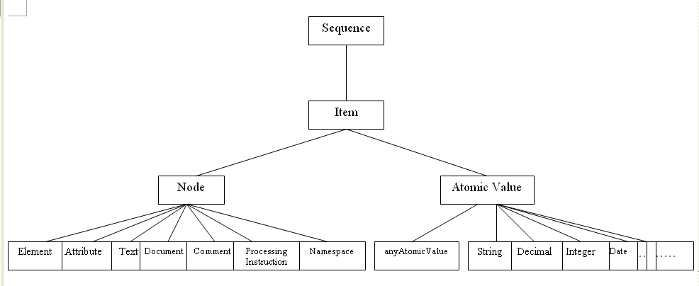
Figure 4 Data Model
Following, the Products.xml file is taken for example. In figure 3, correspondingly, the labels D, E and T in circles stand for document, element and text nodes.
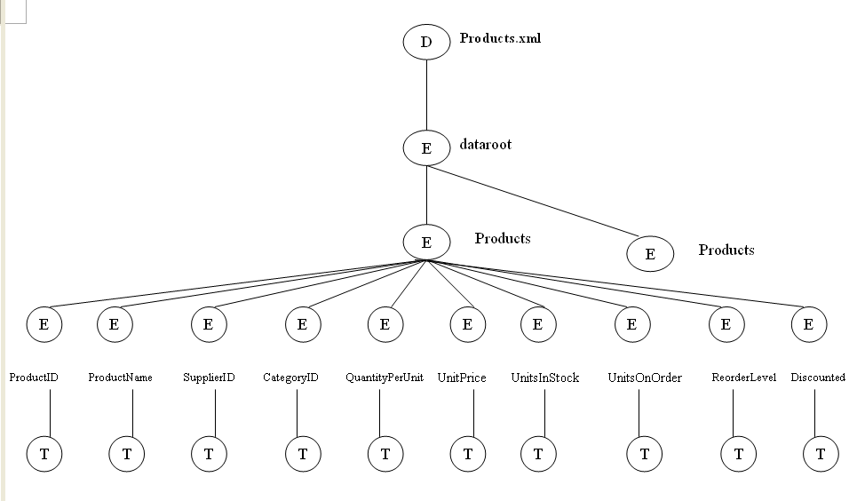
Figure 5 Data Model of Products.xml

4.2 XQuery Expression
Traditionally, XQuery is a case sensitive language and using lowercase characters as its keywords . More over, the rules are the same as XML and XPath. XQuery is a functional language that is made up of expressions and return result values without side effect (Chamberlin, 2002). Comments are enclosed between “{--” and “--}”. A special feature of XQuery is the FLWOR expression. Next, the FLWOR will be discussion.
FLWOR stands for: for, let, where, order by and return, and it pronounced flower. XQuery uses FLWOR expression to process query (Harbarth, 2003). Combining with the theory of Draper (2003), XQuery language structure can be viewed as:
(for clause | let clause)+ where clause? order by clause? return expression
Clause | Syntax
for clause | “for” ”$”variableName TypeDeclaration? PositionVariable? “in”expression
let clause | “let” ”$”variableName TypeDeclaration? PositionVariable? “:=”expression
where clause | “where”expression “
order by clause | order by”variable (“ascending”| “descending”)?
return expression | return <Tag> { <!--!!!Snip!!!--> } </Tag>
Table 1 FLWOR Syntax
The following XQuery expression is taken two XML file, Products.xml and Categories.xml for example, they are transferred from the MS Access sample database, Northwind.mdb. The XQuery expression loops over all product instances and finds the related category and return the nodes that contain the category name for each product, please check following figure.
for $p in document("Products.xml")/dataroot/Products
for $c in document("Categories.xml")/dataroot/Categories[CategoryID = $p/CategoryID]
where $p/Discontinued = 0
order by $p/ProductID
return
<productCategory>
{ $p/ProductID }
{ $p/ProductName }
{ $p/CategoryID }
{ $c/CategoryName }
</productCategory>
Figure 6 XQuery FLWOR Expression
Generally, the for clause assigns each record that expressed by “document(“Products.xml”)/dataroot/Products” to the $p variable. Next, the let clause retrieves the respective category and assigns it to the $c variable. The where clause is filtering the items by the specific condition; and order by clause is used for sorting. Finally, return clause uses the two, $p and $c variables to construct the result items. Every productCategory element contains the product’s ID, name and category’s name.
The XQuery result of this example will be a list of productCategory elements containing one record for each product item. The following is the first entry.
<productCategory>
<ProductID>8</ProductID>
<ProductName>Northwoods Cranberry Sauce</ProductName>
<CategoryName>Condiments</CategoryName>
</productCategory>
Figure 7 Result of XQuery

4.3 Built-in Functions in xquery
XQuery built-in functions consist of XQuery 1.0 and XPath 2.0 Functions and Operators. More than one hundred functions are included. Generally, they can be separated into eight categories; which are math, string and regular expression, date and time, node and QName, sequences, type conversion, Booleans and input (Hunter, 2003).

4.3.1 Math
Function | Meaning
+, -, *, div, mod | These five arithmetic operators are using for arithmetic calculation. To distinguish a subtraction operator and a hyphen, a leading blank should be used before a name.
count() | Returns the number of items in a sequence.
min() | Selects the minimum value from a set of comparable numbers
max() | Selects the maximum value from a set of comparable numbers
avg() | To get the average value
sum() | To sum values

4.3.2 String and Regular expression
Function | Meaning
compare() | Compares two strings
string-join() | Combine strings in a sequence. For example, string-join($e/LastName,$e/FirstName)
concat() | Does the same thing as string-join()
contains() | contains($operand1, $operand2):checks wheather operand1 contains $operand2
substring() | substring($SourceString, $StartingLoc, $Length)
translate() | translate($srcval,$mapString, $transString)

4.3.3 Date and Time
The date and time functions are the same as numeric functions. They are used as comparison and mathematic operators.
Function | Meaning
current-date() | Returns today’s date
current-time() | Returns current time
current-dateTime() | Returns current date
+, -, div | Date and Time us the same three mathematic operators for calculation.
eq, ne, lt, gt, le, ge | To compare date/time, it uses these functions to compare if they are equal, not equal, less than, greater than, less, less than or equal, and greater than or equal

4.3.4 XML Node and QName
Function | Meaning
node-kind() | Returns the type of node, for example “element”, “attribute”
node-name() | Returns QName of node
eq, ne | Compares node and QName
is, isnot | Identify the type of node and QName

4.3.5 Sequences
Function | Meaning
distinct-values() | Makes a sequence unique
empty() | Tests if the sequence is empty
exists() | Returns true if the sequence is NOT empty

4.3.6 Type conversion
Function | Meaning
string() | Converts the data type into string
decimal() | Converts the data type into decimal
boolean() | Converts the data type into Boolean
data() | Returns the value type of the node

4.3.7 Booleans
Function | Meaning
true(), false() | These two functions are the only functions that uses the true and false keyword
not() | Negates the value of a Boolean

4.3.8 Input
Function | Meaning
document() | Returns the nodes identified by the URI
Input() | Returns general input nodes
collection() | Returns a collection based on some parameter or documents

Chapter 5 Implementations
W3C provides a list of parser or test website which implements XQuery; there are more than 28 web pages on it (W3C, 2003), including Internet and off-line prototype implementations. The non-commercial parsers can be tested on line or downloaded from the website freely. Five of these parsers will be discussed in this section.

5.1 W3C Grammar test page
W3C provides a grammar test page for XQuery 1.0 (W3C, 2003). There are two windows in this page. The expression is typed in the first window. Click “Parse” and the syntax will be checked. The second window will list the test information either correct or incorrect grammar show in following figure, when the correct XQuery is typed, the result will show an XPath expression. Otherwise, the errors will be shown. In figure 9, the XQuery expression misses an end tag, so the parser show the line and column number where the mistake occurs. However, the XML expression of the query result is not known by the website.

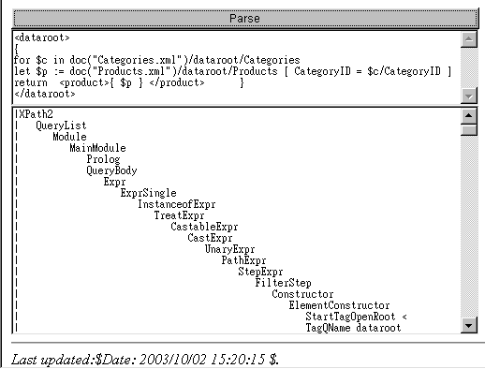
Figure 8 Correct XQuery Expression
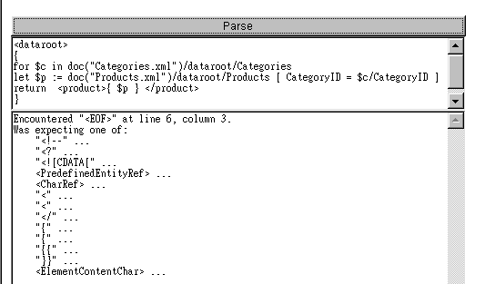
Figure 9 Incorrect XQuery Expression

5.2 XQuantum DATABASE
Cognetic Systems's XQuantum has a website where you can try a subset of the XQuery language (Cognetic 2003). There are three sections in the demo page. The first section allows you to choose the test types, including user cases, simple queries and type examples from the left list. The second section displays the description while the third section shows the XQuery itself. After filling in everything, press the Submit button. The result will be shown in a new window. For example, in the test type of user cases, there are 7 choices: Path Expression, Selection, Flattening, Maintain Structure, Multiple Source, Changing Structure and Sorting. In addition, the styles can be set up as four different types.
For example, if the use case “C2: Selection” has been selected, the description and query sections will be showed as below.
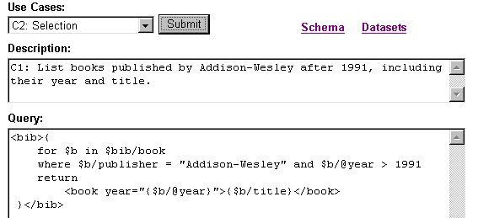
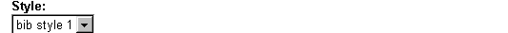
Figure 10 XQuantum Demo in Selection User Cases and Bib Style 1.
After clicking the submit button, the result will be showed as below.
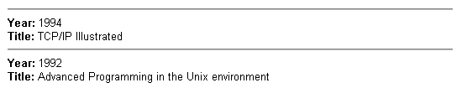
Figure 11 XQuantum Demo Bib Style1 Execute Result.
On the other hand, if the bib style 3 is selected, the result will be changed in to another style as below.
Figure 12 Bib Style3 Result

5.3 Microsoft XML Query Language Demo
In Microsoft's XML Query Language Demo, you can test XQuery user cases on line. (Microsoft 2003), this webpage is based on December 2001 version of W3C.
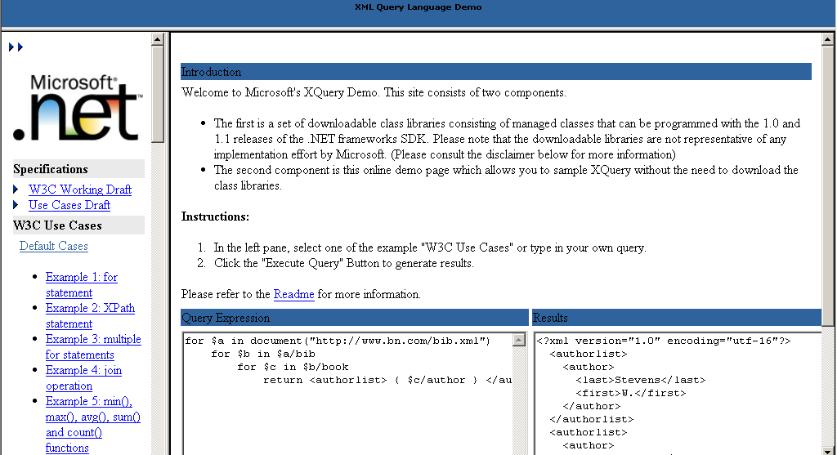
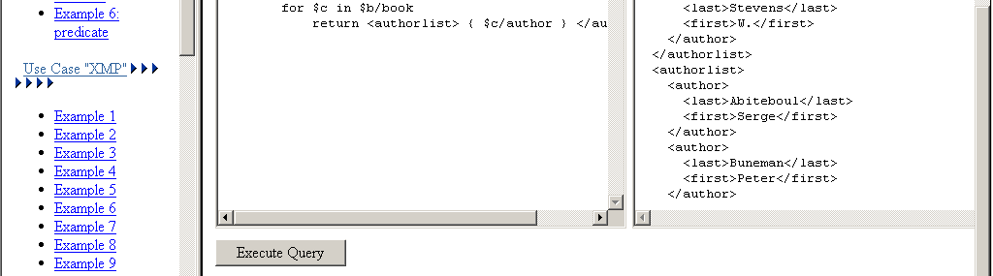
Figure 13 Microsoft XML Query Language Demo
Alternatively, download “xquery.msi” from the website. However, there are some prerequisites for installing it, for example, Microsoft .Net Framework RTM version is required.

5.4 Oracle XML Query
Oracle provides a standard way for doing XQuery. The XDK (XML Developer's Kit) includes Java, C and PL/SQL prototype which is downloadable (Oracle 2003), and these prototypes are based on W3C November 2002 version. The details of installation and implementation will be illustrated in Chapter 6 and 7.

5.5 TaminO XML Query Demo
Tamino XML Server is belong to Software AG. The Tamino webpage provides two XQuery testing website, one is a simple XQuery while another is an advanced version (Tamino 2003). The demo websites are created against W3C November 2002 version. In the simple version, most of the W3C XQuery use case can be tested here. The advanced version uses a real estate database. In the Tamino website, you can select a database and specify function, replace, insert or delete. The XQuery expression will be shown. 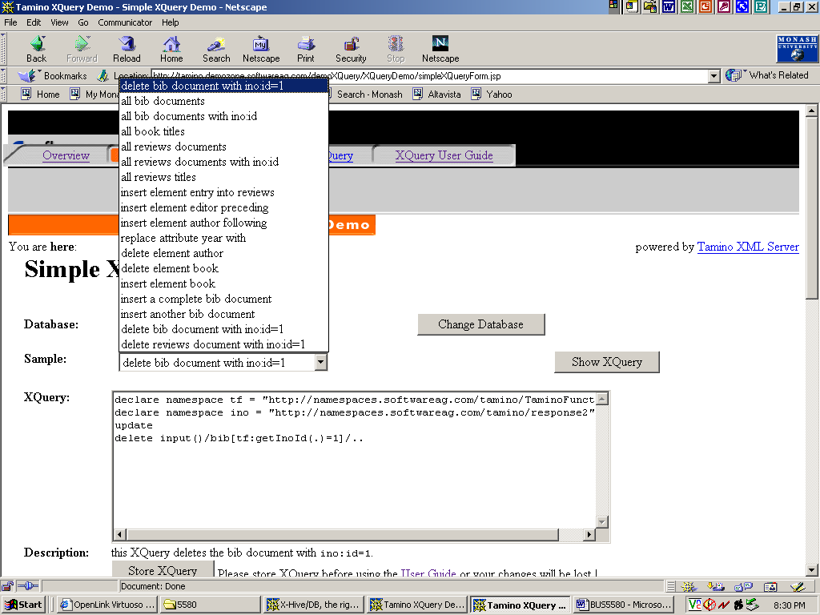
Figure 14 Tamino XML Query Demo
Besides the Demo page, Tamino also provide a lot of function and examples.

5.5 X-Hive
The X-Hive demo page is based on April 2002 version, you can choose the use case from a drop down box in top-right frame, the XQuery content will be showed on the left window, also, modification can be made by users; when you click “Submit Query” button, the result will be showed on the right section. Please refer to the following figure (X-Hive 2003).
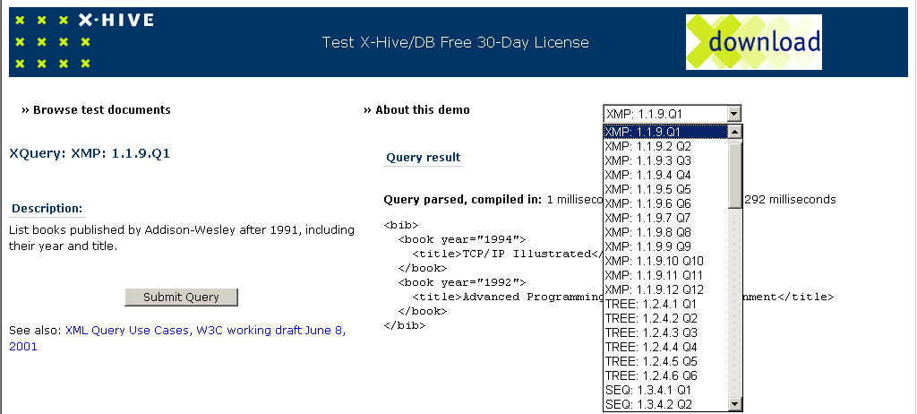
Figure 15 X-HIVE Demo page

Chapter 6 Oracle XQuery Prototype installation
There are a lot of XQuery parser packages that can be downloaded from the Internet and installed in your computer. After installation, the XQuery can be tested off line. Most of the packages are developed in Java except Microsoft’s. In this section, JXQI, Oracle’s package, will be introduced (Oracle 2003).

6.1 Installation instructions
The installation consists of 3 steps. Firstly, set up the Java environment. It can be downloaded from Sun website (Sun, 2003). The version must be JDK1.3 or later. Secondly, download the XDK, Oracle XML Developer’s Kit, from Oracle website (Oracle, 2003). The kit, xdk_java_9_2_0_5_0.zip, is meant to be installed and executed in a Java platform. Thirdly, install XQuery (Oracle, 2003) xq.zip. Before you run the test, two JAR files should be copied into the Java directory, those are xmlparserv2.jar and xquery.jar. The directory is “c:\program files\java\jre\lib\ext”.
After setting up the environment XQuery can be started. For practice the work, there are some step should be followed:
Firstly, change the mode from Window into DOS. In DOS mode, either save all required files in the same directory or set up the path. For instance, if the xquery.jar file is saved in the xquery directory, we will type the command as “set CLASSPATH = c:\xquery\xquery.jar; %CLASSPATH%”. For simplicity, you can save all files under c:\xquery.
Secondly, execute the command “cd c:\xquery” to change to the directory under DOS. Then, type the java command: java oracle.xquery.XQLPlus <filename>.

6.2 Details of Problems
There are some W3C XQuery expressions that can not work in Oracle XQuery. For instance, in the function part, in sorting, the sortby() function is used instead of “order by”. It is a problem that if you use order by to sort the database, it cannot be implemented successfully. Here some unavailable functions of Oracle XQuery (available “√”, unavailable “X” ):
Table 2 Function Comparison
W3C XQuery function | Oracle XQuery Parser |  | Microsoft .Net Website  XQuery Language Demo
W3C XQuery function | Availability | Alternative | Microsoft .Net Website  XQuery Language Demo
order by | X | sortby() | √
substring() | X | ? | √
sum() | X | avg()
string-join() | X | ? | X
To calculate and compare numbers, the data type of the variables should be numbers. However, Oracle parser views XML content as text and most of the conversion functions are unavailable in the Oracle parser. For example, the integer() function cannot be run so text cannot be converted to number. Moreover, even though a schema is used and we add the expression ‘xsi:noNamespaceSchemaLocation="Products.xsd"’ into Products.xml, and variable has been specified as integer, it is useless as well. Alternatively, avg() can be used in calculation. All text can be convert to number by using avg().
In the XPath part, search expression is not allow in let clause. For example, if “let $p := document("Products.xml")/dataroot/Products [ CategoryID = $c/CategoryID ]” is used, the error message will be shown as “XQE: Expected ']' instead of '/'.”. However, this XQuery expression is valid in W3C grammar test page, see figure in chapter 5 (W3C 2003). Alternatively, for Oracle parsing to be successful, the search expression can be changed to “[ CategoryID = $c ]”, and we declare $c as “/dataroot/Categories/CategoryID” first.

Chapter 7 sample application using oracle parser
In this section, a Microsoft Access database, NorthWind.mdb will be taken as an example. In Access 2002 or later, the database can be exported into XML files, including XML, XSD and XSL files (Microsoft, 2003). There are 8 XML files that have been exported from the database; those are Products.xml, Customers.xml, Employees.xml, OrderDetails.xml, Orders.xml, Categories.xml, Shippers.xml, Suppliers.xml.
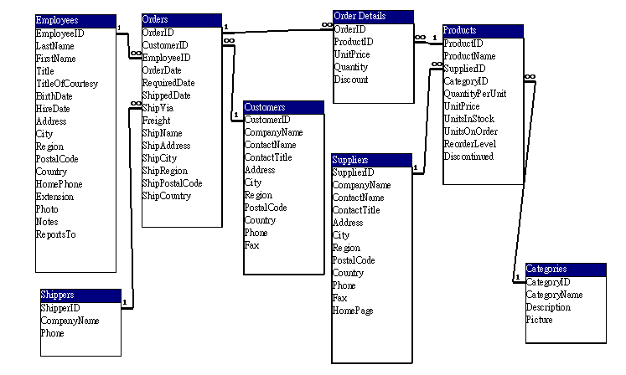
Figure 16 Northwind Relationship
Next, some MS Access queries have been selected for example. Because the execution speed is very slow, if three xml files, Orders, OrderDetails and Customers have been linked together, it needs more than one hour to compute using a Celeron CPU and more than twenty minutes on a Pentium IV CPU. For the sake of efficient executing, Orders.xml and OrdersDetails.xml is devided into smaller databases, and only OrderID greater than or equal to“11001” have been examined.

7.1 Transfer data type and filter data
This example using avg() function to transfer data type from text to number and filter product items which need to place a new order, including stock units and on order units under reorder level, all product details and category name will be listed.
7.1.1 SQL
SELECT Categories.CategoryID, Categories.CategoryName, Products.*
FROM Categories INNER JOIN Products ON Categories.CategoryID = Products.CategoryID
WHERE (((Products.Discontinued)=No) AND (([Products].[UnitsInStock]+[Products].[UnitsOnOrder])<[Products].[ReorderLevel]))
ORDER BY Categories.CategoryID, Products.ProductID;
Figure 17 SQL in Northwind Query
7.1.2 XQuery
Because Oracle parses all content as text, for calculating and comparing number, data values should be converted into numbers. The only solution that has been found is to use avg() function.
for $c in document("Categories.xml")/dataroot/Categories
for $p in document("Products.xml")/dataroot/Products
let $stock := avg ($p/UnitsInStock + $p/UnitsOnOrder)
where $p/Discontinued = 0
and $stock < $p/ReorderLevel
and $c/CategoryID = $p/CategoryID
return
<productCategory>
{ $p/ProductID }
{ $p/ProductName }
{ $p/SupplierID }
{ $p/CategoryID }
{ $p/QuantityPerUnit }
{ $p/UnitPrice }

{ $p/UnitsInStock }
{ $p/UnitsOnOrder }
{ $p/ReorderLevel }
{ $p/Discontinued }
{ $c/CategoryName }
</productCategory>
sortby(ProductID)
Figure 18 ProductsList.xql XQuery of XML
7.1.3 XQuery Result
XQuery Command Line Tool
Version 1.0
Enter XQuery statements followed by /;

Result
----------------------------------------------------
<dataroot>
<productCategory>
<ProductID>30</ProductID>
<ProductName>Nord-Ost Matjeshering</ProductName>
<SupplierID>13</SupplierID>
<CategoryID>8</CategoryID>
<QuantityPerUnit>10 - 200 g glasses</QuantityPerUnit>
<UnitPrice>25.89</UnitPrice>
<UnitsInStock>10</UnitsInStock>
<UnitsOnOrder>0</UnitsOnOrder>
<ReorderLevel>15</ReorderLevel>
<Discontinued>0</Discontinued>
<CategoryName>Seafood</CategoryName>
</productCategory>
<productCategory>
<ProductID>70</ProductID>
<ProductName>Outback Lager</ProductName>
<SupplierID>7</SupplierID>
<CategoryID>1</CategoryID>
<QuantityPerUnit>24 - 355 ml bottles</QuantityPerUnit>
<UnitPrice>15</UnitPrice>
<UnitsInStock>15</UnitsInStock>
<UnitsOnOrder>10</UnitsOnOrder>
<ReorderLevel>30</ReorderLevel>
<Discontinued>0</Discontinued>
<CategoryName>Beverages</CategoryName>
</productCategory>
</dataroot>
Figure 19 ProductsList.txt
To output the XQuery into a text file, the DOS operator “>” is used. The command line is as follows:
Java oracle.xquery.XQLPlus ProductsList.xql > ProductsList.txt
The first 7 lines in ProductsList.txt are the headings that are computed by Oracle parser.

7.1.4 XSLT
The following XSLT file is modified from the Product.xsl file. The file name is named ProductsList.xsl.
<?xml version="1.0"?>
<xsl:stylesheet xmlns:xsl="http://www.w3.org/TR/WD-xsl" language="vbscript">
<xsl:template match="/">
<HTML>
<HEAD>
<META HTTP-EQUIV="Content-Type" CONTENT="text/html;charset=UTF-8" />
<TITLE>
Products
</TITLE>
<STYLE TYPE="text/css">
</STYLE>
</HEAD>

<BODY link="#0000ff" vlink="#800080">
<TABLE BORDER="1" BGCOLOR="#ffffff" CELLSPACING="0" CELLPADDING="0"><TBODY>
<xsl:for-each select="/dataroot/productCategory">
<xsl:eval>AppendNodeIndex(me)</xsl:eval>
<xsl:eval>CacheCurrentNode(me)</xsl:eval>
<xsl:if expr="OnFirstNode">
<TR>
<TH style="width: 2.433cm"> Category ID</TH>
<TH style="width: 2.433cm"> Category</TH>
<TH style="width: 2.01cm"> Product ID</TH>
<TH style="width: 5.661cm"> Product Name</TH>
<TH style="width: 0.931cm"> Supplier</TH>
<TH style="width: 3.571cm"> Quantity Per Unit</TH>
<TH style="width: 1.904cm"> Unit Price</TH>
<TH style="width: 2.539cm"> Units In Stock</TH>
<TH style="width: 2.724cm"> Units On Order</TH>
<TH style="width: 2.645cm"> Reorder Level</TH>
<TH style="width: 2.433cm"> Discontinued</TH>
</TR>
</xsl:if>
<TR>
<TD>
<xsl:eval no-entities="true">Format(GetValue("CategoryID", 3),"" ,"")</xsl:eval></TD>
<TD>
<xsl:eval no-entities="true">Format(GetValue("CategoryName", 202), "", "")</xsl:eval></TD>
<TD>
<xsl:eval no-entities="true">Format(GetValue("ProductID", 3),"" ,"")</xsl:eval></TD>
<TD>
<xsl:eval no-entities="true">Format(GetValue("ProductName", 202),"" ,"")</xsl:eval></TD>
<TD>
<xsl:eval no-entities="true">Format(GetValue("SupplierID", 3),"" ,"")</xsl:eval></TD>
<TD>
<xsl:eval no-entities="true">Format(GetValue("QuantityPerUnit", 202),"" ,"")</xsl:eval></TD>
<TD>
<xsl:eval no-entities="true">Format(GetValue("UnitPrice", 6), "$#,##0.00;($#,##0.00)", "")</xsl:eval>
</TD>
<TD>
<xsl:eval no-entities="true">Format(GetValue("UnitsInStock", 2), "General Number", "")</xsl:eval>
</TD>
<TD>
<xsl:eval no-entities="true">Format(GetValue("UnitsOnOrder", 2), "General Number", "")</xsl:eval>
</TD>
<TD>
<xsl:eval no-entities="true">Format(GetValue("ReorderLevel", 2), "General Number", "")</xsl:eval>
</TD>
<TD>
<xsl:eval no-entities="true">Format(GetValue("Discontinued", 11), "Yes/No", "")</xsl:eval>
</TD>
</TR>

<xsl:if expr="OnLastNode">
</xsl:if>
<xsl:eval>NextNode()</xsl:eval>

</xsl:for-each>
</TBODY></TABLE>
</BODY>
</HTML>
<xsl:script>
……………….(Please check Appendix A)
</xsl:script>
</xsl:template>
</xsl:stylesheet>
Figure 20 ProductsList.xsl
In the stylesheet, a VB script has been generated by MS Access. Please refer to Appendix A for more details. To convert the XQuery result ProductsList.txt into an XML file, the expression must be modified by deleting the heading and inserting the following two lines, The result will be changed to following table.
<?xml version="1.0" encoding="UTF-8"?>
<?xml-stylesheet type="text/xsl" href="ProductsList.xsl"?>
Figure 21 Link XSLT

Table 3 XQuery Result ProductsList.xml
Category ID | Category | Product ID | Product Name | Supplier | Quantity Per Unit | Unit Price | Units In Stock | Units On Order | Reorder Level | Discontinued
8 | Seafood | 30 | Nord-Ost Matjeshering | 13 | 10 - 200 g glasses | 25.89 | 10 | 0 | 15 | No
1 | Beverages | 70 | Outback Lager | 7 | 24 - 355 ml bottles | 15 | 15 | 10 | 30 | No

Table 4 MS Access Query Alphabetical List of Products.html
Alphabetical List of Products
1 | Beverages | 70 | Outback Lager | 7 | 1 | 24 - 355 ml bottles | $15.00 | 15 | 10 | 30 | 0
8 | Seafood | 30 | Nord-Ost Matjeshering | 13 | 8 | 10 - 200 g glasses | $25.89 | 10 | 0 | 15 | 0

7.2 sorting function
The shipping slip lists the details of shipper, shipping information, order information and employee ID of a sales person. The details of order products are shown below:
7.2.1 SQL
SELECT Orders.ShipName, Orders.ShipAddress, Orders.ShipCity, Orders.ShipRegion, Orders.ShipPostalCode, Orders.ShipCountry, Orders.CustomerID, Orders.OrderID, Orders.OrderDate, Orders.RequiredDate, Orders.ShippedDate, Shippers.CompanyName, [Order Details].ProductID, [Order Details].UnitPrice, [Order Details].Quantity, [Order Details].Discount, CCur([Order Details].[UnitPrice]*[Quantity]*(1-[Discount])/100)*100 AS ExtendedPrice, Orders.Freight
FROM Shippers INNER JOIN (Orders INNER JOIN [Order Details] ON Orders.OrderID = [Order Details].OrderID) ON Shippers.ShipperID = Orders.ShipVia
ORDER BY Orders.OrderID, [Order Details].ProductID;
Figure 22 SQL Query of Shipping Slip

7.2.2 XQuery
for $o in document("Orders.xml")/dataroot/Orders
for $s in document("Shippers.xml")/dataroot/Shippers
where $o/ShipVia = $s/ShipperID
return
<Order>
{ $o/OrderID }
{ $o/OrderDate }
{ $o/RequiredDate }
{ $o/ShippedDate }
<Salesperson ID = "{ $o/EmployeeID }"/>
<Customer ID = "{ $o/CustomerID }"/>
<Shipper Name = "{ $s/CompanyName }"/>
{ $o/Freight }
{ $o/ShipName }
{ $o/ShipAddress }
{ $o/ShipCity }
{ $o/ShipRegion }
{ $o/ShipPostalCode }
{ $o/ShipCountry }
{
for $d in document("OrderDetails.xml")/dataroot/Order_Details
where $o/OrderID = $d/OrderID
return
<Product ID = "{ $d/ProductID/text() }" >
UnitPrice$ { $d/UnitPrice/text() }
_Qty: { $d/Quantity/text() }
_Discount%: { $d/Discount * 100 }
_ExtPrice$ { $d/UnitPrice * $d/Quantity * avg( 1 - $d/Discount) }
</Product>
sortby(ProductID)
}
</Order>
sortby(OrderID)
Figure 23 XQuery of Shipping Slip

7.2.3 Result
Only the first query result record is listed.
<Order>
<OrderID>11001</OrderID>
<OrderDate>1998-04-06T00:00:00</OrderDate>
<RequiredDate>1998-05-04T00:00:00</RequiredDate>
<ShippedDate>1998-04-14T00:00:00</ShippedDate>
<Salesperson ID="2"/>
<Customer ID="FOLKO"/>
<Shipper Name="United Package"/>
<Freight>197.3</Freight>
<ShipName>Folk och fa HB</ShipName>
<ShipAddress>Akergatan 24</ShipAddress>
<ShipCity>Bracke</ShipCity>
<ShipPostalCode>S-844 67</ShipPostalCode>
<ShipCountry>Sweden</ShipCountry>
<Product ID="7">UnitPrice$30_Qty:60_Discount%:0.0_ExtPrice$1800.0</Product>
<Product ID="22">UnitPrice$21_Qty:25_Discount%:0.0_ExtPrice$525.0</Product>
<Product ID="46">UnitPrice$12_Qty:25_Discount%:0.0_ExtPrice$300.0</Product>
<Product ID="55">UnitPrice$24_Qty:6_Discount%:0.0_ExtPrice$144.0</Product>
</Order>
< !--!!! Snip !!! -- >
Figure 24 Result of Shipping Slip

7.3 Calculate operators
It shows each product of every order and also calculates the subtotal of a single product and names as extended price. Additionally, it uses text() function to neglect tags.

7.3.1 SQL
SELECT [Order Details].OrderID, [Order Details].ProductID, Products.ProductName,
[Order Details].UnitPrice, [Order Details].Quantity, [Order Details].Discount,
CCur([Order Details].UnitPrice*[Quantity]*(1-[Discount])/100)*100 AS ExtendedPrice
FROM Products INNER JOIN [Order Details] ON Products.ProductID=[Order Details].ProductID
ORDER BY [Order Details].OrderID;
Figure 25 SQL of Order Detail

7.3.2 XQuery
for $d in document("OrderDetails.xml")/dataroot/Order_Details
for $p in document("Products.xml")/dataroot/Products
let $f := avg( 1 - $d/Discount)
where $p/ProductID = $d/ProductID
return
<Order ID = "{ $d/OrderID }">
ProductID: { $p/ProductID }
_Name: { $p/ProductName/text() }
_UnitPrice${ $d/UnitPrice/text() }
_Qty: { $d/Quantity/text() }
_Discount%: { $d/Discount * 100 }
_ExtendedPrice$ { $d/UnitPrice * $d/Quantity * $f }
</Order>
sortby(OrderID)
Figure 26 OrderDetailsExt.xql

7.3.3 XQuery Result
<Order ID="11001">ProductID:7_Name:Uncle Bob's Organic Dried Pears _UnitPrice$30_Qty:60_Discount%:0.0_ExtendedPrice$1800.0</Order>
<Order ID="11001">ProductID:22_Name:Gustaf's Kn瓣ckebr繹d _UnitPrice$21_Qty:25_Discount%:0.0_ExtendedPrice$525.0</Order>
<!-- !!! Snip !!! -->
Figure 27 OrderDetailsExt.txt

7.4 Group data
It lists all customer names that are responsible to the specific sales person using nesting structure to group data.

7.4.1 SQL
SELECT Employees.LastName, Employees.FirstName, Customers.CompanyName
FROM Employees INNER JOIN (Customers INNER JOIN Orders ON
Customers.CustomerID = Orders.CustomerID) ON Employees.EmployeeID = Orders.EmployeeID
GROUP BY Employees.LastName, Employees.FirstName, Customers.CompanyName
ORDER BY Employees.LastName, Customers.CompanyName;
Figure 28 SQL of Order by Sales

7.4.2 XQuery
for $e in document("Employees.xml")/dataroot/Employees
return
<Sales>
{ $e/LastName,$e/FirstName }
{
for $c in document("Customers.xml")/dataroot/Customers
for $o in document("Orders.xml")/dataroot/Orders
where $o/EmployeeID = $e/EmployeeID
and $o/CustomerID = $c/CustomerID
return
<Customer>
{ $c/CompanyName/text() }
</Customer>
sortby(CompanyName)
}
</Sales>
sortby(LastName)
Figure 29 XQuery of Order by Sales

7.4.3 XQuery Result
<Sales>
<LastName>Buchanan</LastName>
<FirstName>Steven</FirstName>
<Customer>Sp矇cialit矇s du monde</Customer>
</Sales>
<Sales>
<LastName>Callahan</LastName>
<FirstName>Laura</FirstName>
<Customer>Cactus Comidas para llevar</Customer>
<Customer>Drachenblut Delikatessen</Customer>
<Customer>Eastern Connection</Customer>
<Customer>Folk och f瓣 HB</Customer>
<Customer>LILA-Supermercado</Customer>
<Customer>Old World Delicatessen</Customer>
<Customer>Princesa Isabel Vinhos</Customer>
<Customer>Queen Cozinha</Customer>
<Customer>Richter Supermarkt</Customer>
<Customer>Die Wandernde Kuh</Customer>
</Sales>
<!--!!! Snip !!! -- >
Figure 30 Result of XQuery Order by Sales

7.5 aggregative function
In this example, it uses aggregate function to list the record count and the average of unit prices in Product.xml.

7.5.1 SQL
SELECT Count(Products.ProductID) AS ProductCount, Avg(Products.UnitPrice) AS UnitPriceAvg
FROM Products;
Figure 31 SQL of ProductCount_Avg query

7.5.2 XQuery
let $p := document("Products.xml")//Products
return
<ProductSummary>
count = { count($p) }
_avgPrice = { avg($p/UnitPrice) }
</ProductSummary>
Figure 32 XQuery of Order by Sales

7.4.3 XQuery Result
The result in DOS will be in figure 33.
<ProductSummary>count=77_avgPrice=28.866365</ProductSummary>
Figure 33 Result of XQuery ProductCount_Avg.xql
In MS Access query, the view will like table 5.
Table 5 MS Access Query ProductCount_Avg.html
ProductCount_Avg
77 | $28.87

Conclusion and Recommendation
XML has improved the interactivity of business on the Internet. Many kinds of data can be obtained through various platforms, including Java, C, .Net, Linux and Solaris. By using the XQuery language, not only XML database but SQL database can be queried. As a result, the specific data can be search more efficiently.
However, a lot of the related XQuery technologies are still developing and are not matured enough. In this research, we found some limitations in the XQuery parsers. On the XQuery demo web pages, only the databases provided by the software companies can be used. Users could not upload their own database and run XQuery. On the other hand, the off-line XQuery parser can query users’ own database. However, it is not connected to the network, so namespace cannot be link and used in XQuery. Additionally, the parser is out of date: a lot functions have not updated properly. Beside this, the speed of execution is also too slow. They are serious limitations in the XQuery implementations.
To increase widespread use of XQuery, the software vender should provide updated solutions. On the Internet demonstration websites, they should provide a way for the programmer to upload their own database to be processed by XQuery expression properly. On the other hand, the off-line version should improve their execution efficiency and upgrade the functions quickly.

References
Amer-Yahia, S. and P. Case (2003). XQuery and XPath Full-Text Use Cases. http://www.w3.org/TR/xmlquery-full-text-use-cases/ (2003/1/10).
Berglund, A., S. Boag, et al. (2003). XML Path Language (XPath) 2.0. http://www.w3.org/TR/xpath20/ (2003/1/10).
Buxton, S. and M. Rys (2003). XQuery and XPath Full-Text Requirements. http://www.w3.org/TR/xquery-full-text-requirements/ (2003/1/10).
Chamberlin, D. (2003). XQuery: An XML query language. IBM Systems Journal 41, No.4: 597-615.
Chamberlin, D., S. Boag, et al. (2003). XQuery: An XML query language. http://www.w3.org/TR/xquery/ (2003/09/10).
Chamberlin, D., P. Fankgauser, et al. (2003). XML Query (XQuery) Requirement. http://www.w3.org/TR/xquery-requirements/ (2003/1/10).
Chamberlin, D., M. Marchiori, et al. (2003). XML Query Use Cases. http://www.w3.org/TR/xquery-use-cases/ (2003/30/08).
Cognetic (2003). XQuery Demo. http://www.cogneticsystems.com/xquery/xquery.html (2003/10/08).
Draper, D., P. Fankgauser, et al. (2003). XQuery 1.0 and XPath 2.0 Formal Semantics. http://www.w3.org/TR/xquery-semantics/ (2003/30/09).
Fernandez, M., A. Malhotra, et al. (2003). XQuery 1.0 and XPath 2.0 Data Model. http://www.w3.org/TR/xpath-datamodel/ (2003/04/08).
Harbarth, J. (2003). XQuery 1.0: Primer. http://www.softwareag.com/xml/tools/xquery_primer.pdf (2003/29/7).
Hunter, J. (2003). X Is for XQuery: Part 2. http://otn.oracle.com/oramag/oracle/03-may/o33devxml_2.html (2003/10/09).
Ishikawa, Y., Kawada, J., Kitagawa, H. (2002). Processing XML View Queries Including User-defined Foreign Functions on Relational Database. International Conference on Web Information Systems Engineering, IEEE.
Kay, M. and N. Walsh (2003). XSLT 2.0 and XQuery 1.0 Serialization. http://www.w3.org/TR/xslt-xquery-serialization/ (2003/30/09).
Kifer, M. (2002). XML and Web Data. http://www.ug.cs.sunysb.edu/~kifer/cse532/slides/xquery.pdf
Liu, M., Ling, T. W. (2002). Towards Decarative XML Querying. IEEE 2002.
Malhotra, A., J. Melton, et al. (2003). XQuery 1.0 and XPath 2.0 Functions and Operators. http://www.w3.org/TR/xpath-functions/ (2003/1/10).
Malhotra, A., M. Rys, et al. (2003). XML Syntax for XQuery 1.0 (XQueryX). http://www.w3.org/TR/xquery-requirements/ (2003/1/10).
Marchiori, M. (2003). W3C XML Query (XQuery). http://www.w3.org/XML/Query (2003/04/08).
Microsoft (2003). Using XML and Access. http://office.microsoft.com/assistance/preview.aspx (2003/09/09).
Microsoft (2003). XML Query Language Demo. http://xqueryservices.com/ (2003/11/08).
Oracle (2003). Oracle XML Developer's Kit. http://otn.oracle.com/tech/xml/xdk/xdkprod.html (2003/18/08).
Oracle (2003). Oracle XQuery Prototype. http://otn.oracle.com/sample_code/tech/xml/xmldb/xmldb_xquerydownload.html (2003/18/08).
Oracle (2003). Querying XML in a Standard Way. http://otn.oracle.com/tech/xml/xmldb/htdocs/querying_xml (2003/10/08).
Scardina, M. and M. Fernandez (2003). XPath Requirements Version 2.0. http://www.w3.org/TR/xpath20req/ (2003/1/10).
Son, T. C. (2002). XML and Web Data. http://www.cs.nmsu.edu/~tson/classes/cs582/note10.pdf
Sun (2003). Java 2 Platform, Standard Edition (J2SE). http://java.sun.com/j2se/1.4.2/download.html (2003/18/08).
Tamino (2003). Tamino XML Query Demo. http://tamino.demozone.softwareag.com/demoXQuery/index.html (2003/12/08).
W3C (2003). The XQuery 1.0 Grammar Test Pages. http://www.w3.org/2003/05/applets/xqueryApplet.html (2003/04/08).
X-Hive (2003). X-Hive XQuery Demo. http://support.x-hive.com/xquery/index.html (2003/10/09).

