1. Letter of Transmittal

May 9, 2003

Joanne Cheng
Vickie Chen
C & C Consulting
Clayton
Vic 3168

Head
Police Monitoring System
Vic

RE: POLICE OFFENDER MONITORING PROPOSED SYSTEM REPORT

Dear Sir,
We are pleased to present you the enclosed report of the Proposed Police Offender Monitoring System which we have been contracted to draw up.
This report provides the technical and functional aspects of the proposed system. Existing and potential shortcomings of the current system are identified and solutions are derived to assist in eliminating and minimizing these problems. Opportunities arising from the proposed system are also brought to your attention. Included in the report are statements of the problems of the current system, Process Models, Data Models, Data Dictionary entries, narrative descriptions, solutions and recommendations.
We wish to express our sincere appreciation to the staff who assisted us in the gathering and providing us with any relevant information useful for the preparation of this report.
We are confident that the proposed system will bring long term benefits to the organization and the results will be proven by the increase in productivity, efficiency and cost-savings if the proposed system is implemented.
Please feel free to forward us any doubts or queries.
Your comments and suggestions are welcome.

Respectfully submitted,

Joanne Cheng Vickie
System Consultant System Consultant

2. Executive Summary

This brief report analyses the current system employed by the Police Offender Monitoring system to understand the current system, its existing problems and its functional requirements and from there generate solutions and opportunities to those existing problems using techniques like process modelling and data modelling.

The objectives and functional requirements of the proposed system produced after analysing the system provide the guidelines in generating the technical and functional specifications of the proposed system. The objective of the proposed system is to propose an integrated relational database management system that resolves the problems of the current system and replace it with a more efficient and effective system that not only attempts to resolve shortcomings and identify new business needs, but also to identify and exploit future opportunities.

The scope of the system and its functional requirements are first established in order to carry out the analysis. The objectives of the proposed system are then derived, shortcomings of the current system highlighted and functional requirements for the proposed system established.

Problems identified after analysing the system are :
- Data Redundancy (unnecessary data duplication) and Confusion
- Inefficiency, data inconsistency and operational backlogs. i.e. double and triple handling of records
- Lack of data sharing (data accessibility and responsiveness) and availability
- Insufficient available data for organizational needs
- Delays in processes and reporting, bottlenecks and inaccuracies
- Data loss
- Lack of Flexibility
- Inaccurate and incomplete reporting
- Insufficient security measures
- Inefficient use of storage space due to related records in different locations
- Lack of clear functional purpose
- Lack of enforcement of standards
- Technical and operational difficulties

Process Models and Data models for the proposed system are developed and drawn to facilitate in generating the proposed system. Narrative descriptions are also written to provide temporal and sequential aspects that DFDs lack and enhance reader understanding and readability.

Finally, a brief explanation of how the proposed system solves existing problems and addresses opportunities are drawn and recommendations will conclude this report.
.

3. Table of Contents

1. Letter of Transmittal 1

2. Executive Summary 2

3. Table of Contents 4

4. Introduction 6
4.1 Scope of Current System 6
4.2 Objectives 7

5. Overview 8

6. Functional Narrative description of the Proposed System 10
6.1 Process Arrested Offender 10
6.2 Monitor Charge 11
6.3 Monitor Hearing 11
6.4 Monitor Convictions 12
6.5 Information Presentation 12
6.6 Monitor Legislative Change 12

7. Process Models 13
7.1 Context Diagram 13
7.2 Level 0 Diagram 14
7.3 Level 1 15

8. Data Models 21
8.1 ER Model 21
8.2 UNF: 22
8.3 1NF: 23
8.4 2NF: 25
8.5 3NF: 27
8.6 Assumptions 28
8.6 DSD 29

9. Data Dictionary 30
9.1 Data Entity 30
9.2 Data Attributes 32

10. Support for the Proposed System 34
10.1 Reduction in data duplication, data redundancy, confusion and wastage and inefficient use of storage space 34
10.2 Data Consistency and improved Data Integrity 34
10.3 Improved validity of stored data 35
10.4 Sharing of data and more information from the same amount of data 35
10.5 Improved data accessibility, flexibility and responsiveness 36
10.6 Improved security hence reduced opportunity for sabotage 36
10.7 Enforcement of standards 37
10.8 Shorten Offender Monitoring Process, hence reduced backlogs and reduced delays in processes 37
10.9 Cost Savings, increased productivity and increased efficiency 38

11. Recommendations and Conclusion 39

APPENDIX: Minutes of Meeting 40

4. Introduction

As Systems Consultants, C & C Consulting have been appointed by the Police to analyze and review the current Police Offender Monitoring System. Its main focus is to understand the current system, its existing problems and its functional requirements and from there generate solutions and opportunities to those existing problems using techniques like process modelling and data modelling.

In order to carry out the analysis, the scope of the system and its functional requirements have to be first defined, followed by identifying and analysing the current system’s existing shortcomings. The objectives and functional requirements of the proposed system are then produced to provide the guidelines in generating the technical and functional specifications of the proposed system.

To further elaborate, tools used in developing and delivering the proposed system are Process Models and Data Models. Narrative descriptions are also considered as an important aspect of system specification and documentation and are hence written and utilized as a valuable support and explanatory mechanism for the models mentioned above.

4.1 Scope of Current System

The scope of system is solely on the recording and monitoring of criminal offenders and suspects. No actual police work is performed in this system. It only interacts with the physical police systems and various actors like the judicial system and the legislative system etc. that require information.

The system is not involved with what happens in external entities and actors e.g. the forensic department, judicial system, court system etc. Its main and only concern is recording the details of some of the actual police work performed when monitoring criminal offenders and suspects and generating reports which are useful to other systems.

In short, the system monitors and records the details of the interactions between criminal offenders and their arresting officer who arrested them from the time they are arrested and charged to the time the final results of the trials are recorded. All the process and activities mentioned above are within the scope of the system and anything beyond, like how and why the judicial system changed the law and why the court gave its verdict is beyond the system.

4.2 Objectives

The objectives of the proposed system are to propose an integrated relational database management system that helps the Police Offender Monitoring System reduce running cost, increase productivity, reduce redundancy, improve data integrity, reduce wastage of storage space, allow sharing of data, reduce processing time, improve data security, improve data accessibility, improve flexibility and responsiveness, and last but not least, increase efficiency and effectiveness.

5. Overview

To give a brief overview of the current state of the system, it first looks at the processes of having a desk sergeant determine the identity of the offender and also in regards to the offender’s pass criminal records. Those not possible to be identified will be automatically held in remand until a positive identification can be made. An investigation and questioning of the suspect is then carried out whether they are identified or not and they are either charged with a criminal conviction or released without further questioning. Once charges have been laid, a preliminary hearing is held to determine whether they are granted bail or held in remand. The conditions of the bail and remand are recorded. The preliminary hearing also determines the date and location for the eventual hearing.

Upon hearing the final charges brought against the offender, a guilty or not guilty verdict is reached for each charged. A conviction is registered if the charges are proven guilty. The necessary documentations of the final results are documented and a copy of the report is sent to the arresting officer and then the necessary amendments to the Charge Report are made. This is then sent to the Central records for all the necessary adjustments to be made. It is possible that charges are dropped before they are heard in the final trial due to a plea bargaining process. In these circumstances, a Charge Amendment Notice is sent from the Department of Public Prosecutions to the arresting officer and a copy sent to Central Records so that the Charge record can be modified.

Several reports like Monthly Activity Report and Monthly Arrest Report including variances are generated and sent to Police Management for performance assessment and operational decision support at the end of each month. The system also allows for internal ad hoc enquiries to support field operations or ongoing investigations. Examples of such ad hoc enquiries are Arrest Report, Charge Report and Offender Known Associate Report.

The maintenance of offences details are needed to be updated when issued a statement of a new legislation to be introduced or changes made to existing legislations. This involves updating the offences details in a card file stored in the Central records. The statements are also filed in a Legislative Amendments folder that is kept together with the card file in alphabetical order.

This system interacts with other systems and external entities such as police officers and agencies, the judicial system and the legislative system.

The current system as it stands at the moment is far from perfect. It riddles with problems such as unnecessary data duplication, risk of losing data, data interpretation due to a manual process, timeliness of generating and producing reports etc. The system described contains many opportunities for improvements. To further elaborate the problems are as follows:-

- Data Redundancy (unnecessary data duplication) and Confusion
- Inefficiency, data inconsistency and operational backlogs. i.e. double and triple handling of records
- Lack of data sharing (data accessibility and responsiveness) and availability
- Insufficient available data for organizational needs
- Delays in processes and reporting, bottlenecks and inaccuracies
- Data loss
- Lack of Flexibility
- Inaccurate and incomplete reporting
- Insufficient security measures
- Inefficient use of storage space due to related records in different locations
- Lack of clear functional purpose
- Lack of enforcement of standards
- Technical and operational difficulties

Opportunities for the proposed system are outlined below :

- Control of Data Redundancy
- Increase Data Consistency
- Improve Data Integrity
- Generate more information for the same amount of Data
- Enable sharing of Data
- Improve data accessibility and responsiveness
- Enforce necessary of standards
- Economy of scale
- Improve data security
- Increase productivity
- Cost savings
- Increase efficiency
- Increase Flexibility
- Improve validity of stored data

6. Functional Narrative description of the Proposed System

The proposed system is to replace the current system with a relational database management system. Instead of creating, updating and retrieving similar and related data separately in every document, a relational database management system enables one to store, modify and extract information from a single integrated database. In this instance, the arresting offenders process, charging offences process, monitor hearings and their results, record conviction details, monitor change to legislative offences and preparing reports are all integrated into a single relational database.

6.1 Process Arrested Offender

Once arrested, arrest details are recorded into the arrest file
A query enquiring whether offender has past records is run using the offender details available as the key for the search
If records relating to the offender exist, all the files relating to the offender will be retrieved from the corresponding files e.g. Offender, Associate and Offence. Included are the offender personal details, fingerprints, copies of police photograph, personal documents obtained as a result of investigations, arrest and charge reports from prior incidents, a list of offender known associates and date association was noted printed out and handed over for use in questioning
If Offender does not have past records, search will return no value
If an offender refuses to provide identification, his/her fingerprints will be taken. An online fingerprint request form, attaching the scanned fingerprint, will be electronically sent to forensics department(Officer) for identification purposes
If a match for the fingerprints is found, the identification results will be sent back electronically by the forensics department. Returned details will be the forensic officer’s number, date and time identification completed, offender number and offender name
A set of the current fingerprint will be updated electronically replacing the old fingerprints in the offender file
If no match of the fingerprint is found, an identification reply from the forensics department will be sent online, stating reasons for the unsuccessful search. The forensic officer number, date and time the identification process was stopped is also included in this reply
The forensics department will retain the scanned fingerprints by its own means(whether it is a printed copy or soft copy)
On receipt of results of the successful fingerprint identification, the process of requesting and retrieving existing details of the offender outlined above will be carried out
If identification of offender is not possible at this point, the offender file will be updated, listing the offender as “unknown” and filling out any information which is available about the offender till this point
If a suspect is unknown because they are a first time offender, a offender record is created for that offender and Offender file is updated
Once offender records have been retrieved and created, all suspected offenders can be questioned regardless of whether or not the offenders could be identified
Any additional information regarding the offender or the offences found during questioning will be updated in the system anytime

6.2 Monitor Charge

If it is still impossible to identify the suspect, an additional charge of “Obstructing an investigation by failing to give name” will be recorded and the offender will automatically in custody be remanded until a positive identification can be made
If the arresting officer find the suspect not guilty, he will be released without charge and the relevant information updated in the chargesht file
If the arresting officer found the suspect guilty of one or more offences, the arrest file and the charge file will be updated with the corresponding offence, arresting officer details and date charged, also including any specific details of all the charged resulting from the arrest

6.3 Monitor Hearing

The above information will be sent to the Court for a request for Preliminary Court Hearing and a Hearing record will be created for the offender
Hearing file’s Hearing_status will be updated as “Waiting for schedule response”
After reply from the Court System, Hearing file’s Hearing_status will again be updated, this time with the time, date and location for the final hearing
The results of the preliminary hearing will also determine if the offender is held in remand or granted bail. This result will be recorded in the Bail and Custody files
If the offender is held in remand, details about the date remanded and the remand location will be recorded in the Custody
If the offender is granted bail, the amount of bail set and conditions (Payment date and release date) attached to the bail will be recorded in the corresponding Bail File
If charges are amended followed by a plea bargaining process, the charge file will be updated hence all the related files will be updated as well

6.4 Monitor Convictions

When the court hears the final charges brought against the offender and find the offender not guilty, the offender is acquitted and the charges will be dismissed with no penalty incurred and the corresponding chargesht will be updated
On the event that the court found the offender guilty, a conviction is registered and details recorded in the conviction file
Any relevant information will be updated in the corresponding folders in the system, including any amendments made

6.5 Information Presentation

Pre-written queries which generate reports like Monthly Arrest Report and Monthly Activity Report will be run at the end of each month, printed, filed and distributed to Police Management for performance and operational decision support
Programs can be written to generate periodic monthly reports automatically at every month end
Other ad hoc enquiries like Arrest Report, Charge Report, Offender Record of Arrest, Offender Record of Convictions, Offender Activity Report and Offender known associate report etc all can be generated easily using pre-written or ad-hoc queries

6.6 Monitor Legislative Change

When new laws are passed or amendments are made to existing laws, the offence file and any corresponding information will be updated

7. Process Models

7.1 Context Diagram

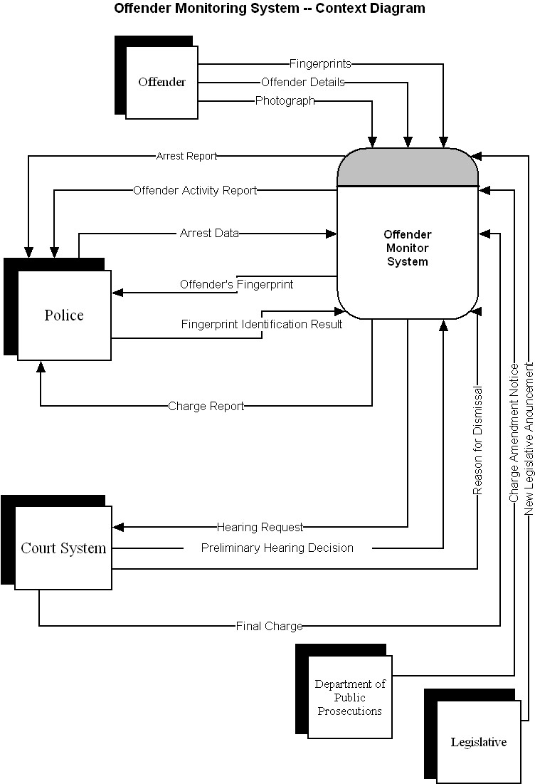

7.2 Level 0 Diagram

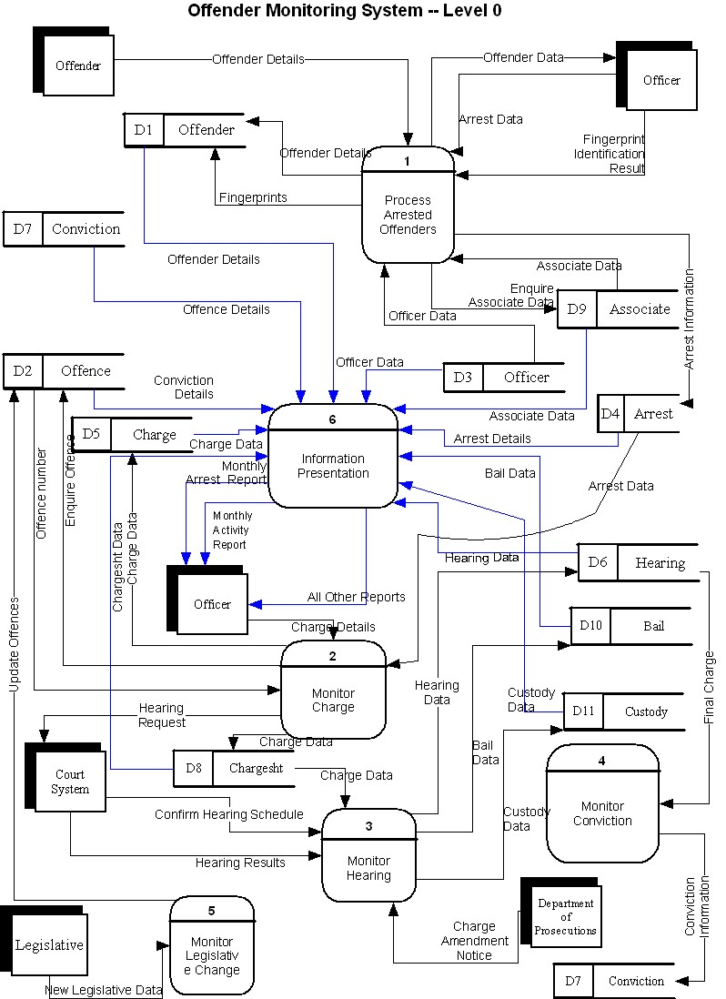

7.3 Level 1

7.3.1 Level 1 Diagram 1

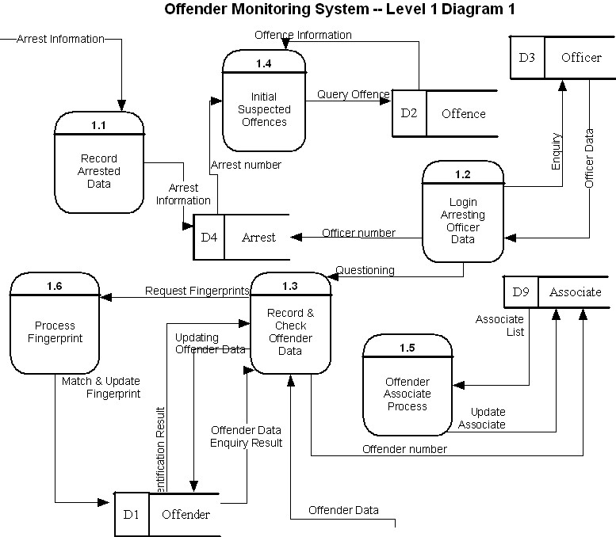

7.3.2 Level 1 Diagram 2

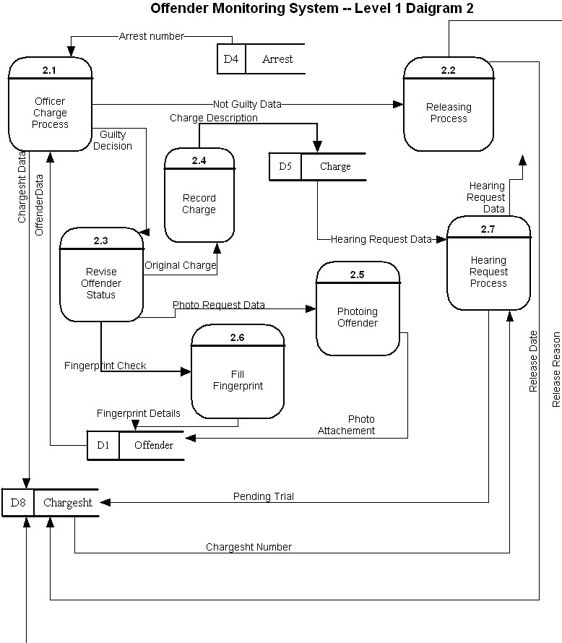

7.3.3 Level 1 Diagram 3

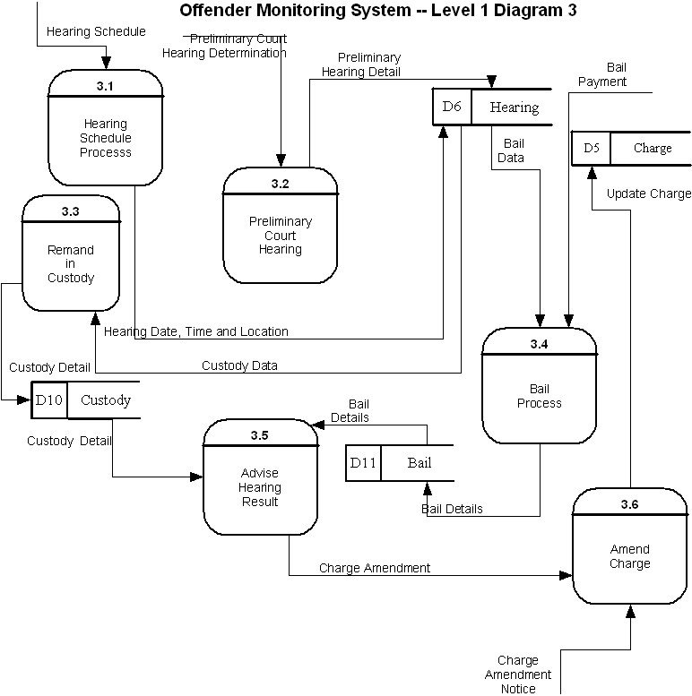

7.3.4 Level 1 Diagram 4

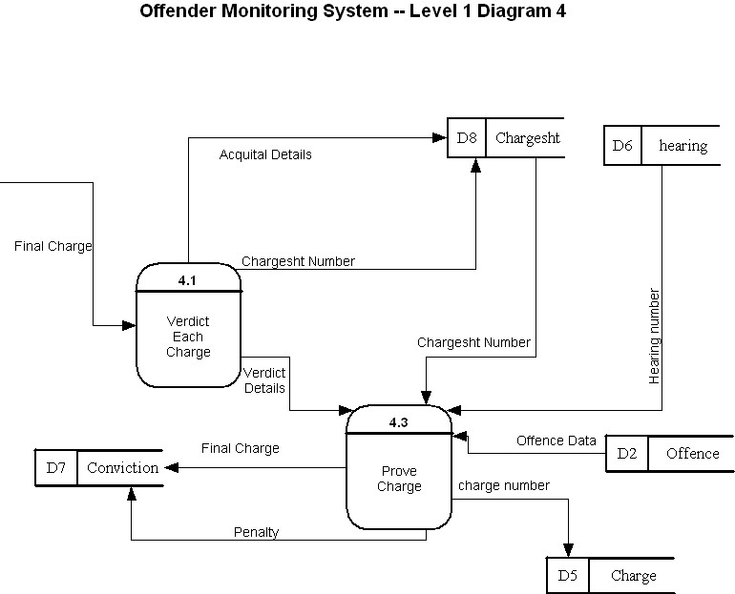

7.3.5 Level 1 Diagram 5

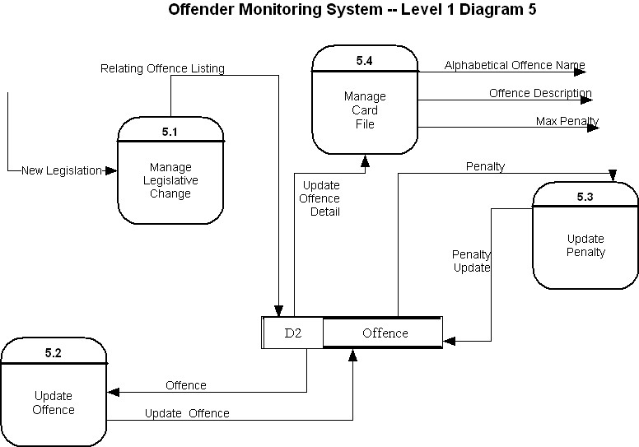

7.3.6 Level 1 Diagram 6

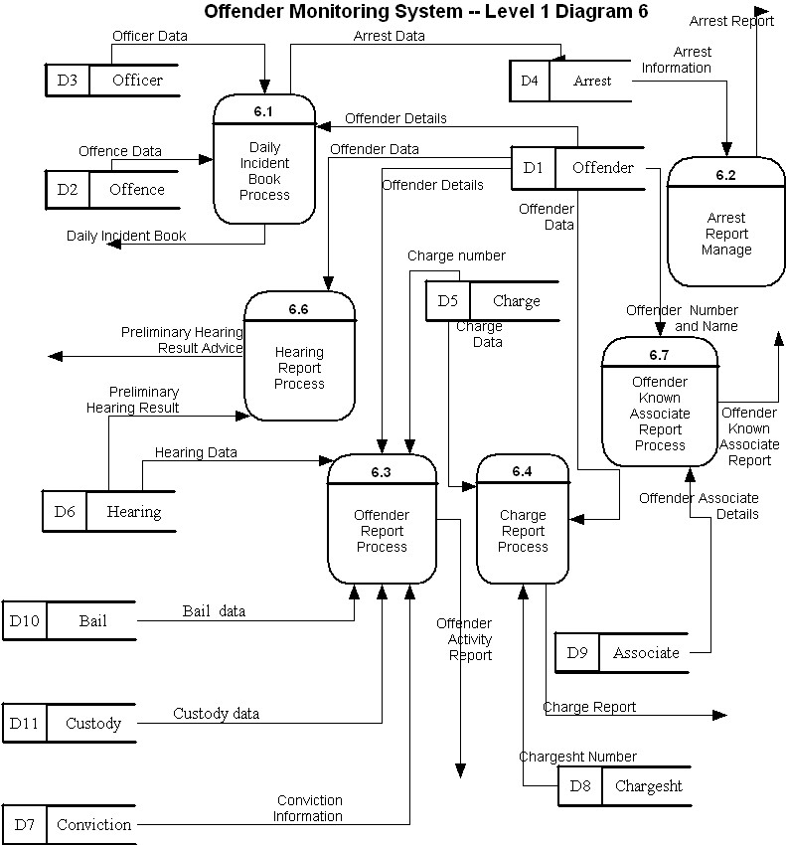

8. Data Models

8.1 ER Model
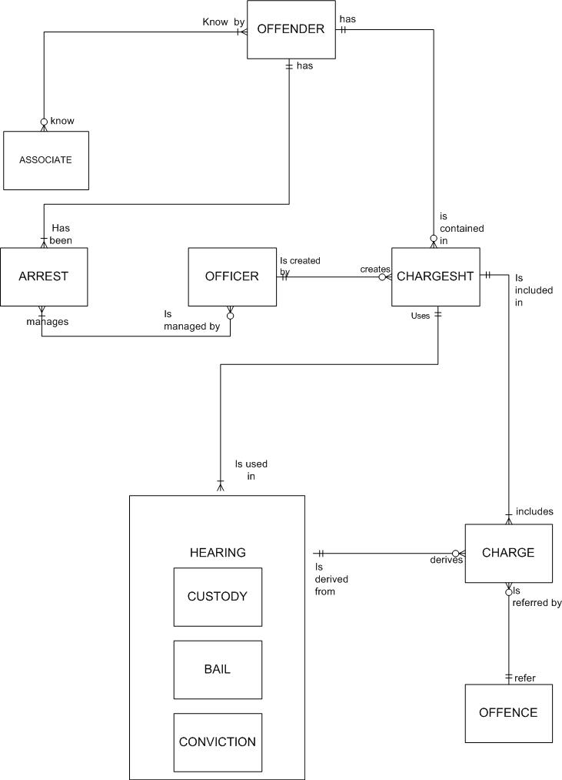

8.2 UNF:

OFFENDER (offender_number, offender_lastName, offender_firstName, nationality, offender_address, st_number, st_name, st_type, suburb, postcode, dob, gender, ht, wt, dist_mark, skincolor, , eyecolor, haircolor, medical_condition, occupation, employer, marry_status, religion, fingerprt_number, fingerprt_date, fingerprt_img, nok_name, alias, nickname,
(photo_number, photo_date, photo_img),
(arrest_number, (associate_number, ass_relationship),
(officer_number, role), (chargesht_number, release_date,
(charge_number, offence_number)),
(hearing_number, bail_number, bail_amount, bail_payDate,
repeating group
custody_number, custody_date, custody_detail,
(charge_number, offence_number), conviction_number))))
ARREST (arrest_number, arrest_date, arrest_time, arrest_location, arrest_detail, closure_date,
(offender_number, (associate_number)),
(officer_number, role),
(chargesht_number, chargesht_date, (charge_number, offence_number),
repeating group
(hearing_number, hearing_date, hearing_time, hearing_location,
bail_number, custody_number, conviction_number))
OFFICER (officer_number, officer_lastName, officer_firstName, officer_address, officer_phone) → 1NF
CHARGE (charge_number, offence_number, offence_name, charge_desc) → 1NF
HEARING (hearing_number, hearing_date, hearing_time, hearing_location) → 1NF
CONVICTION (conviction_number, hearing_number, penalty, conviction_desc) → 1NF
CHARGESHT (chargesht_number, arrest_number, chargesht_date, offender_number, officer_number, (charge_number))
Will add CHARGESHT_CHARGE entity in 2NF to relate charge_number and chargesht_number
ASSOCIATE (associate_number, offender_number, associate_lastName, associate_firstName, ass_relationship) → 1NF
BAIL (bail_number, hearing_number, bail_amount, bail_payDate) → 1NF
CUSTODY (custody_number, hearing_number, custody_date, custody_detail) → 1NF

8.3 1NF:

OFFENDER (offender_number, offender_lastName, offender_firstName, nationality, offender_address, st_number, st_name, st_type, suburb, postcode, dob, gender, ht, wt, dist_mark, skincolor, eyecolor, haircolor, medical_condition, nok_name, occupation, employer, religion, fingerprt_number, fingerprt_date, fingerprt_img, alias, nickname) →2NF
PHOTO (photo_number, offender_number, photo_date, photo_img) → 2NF
OFF_ARR (arrest_number, offender_number) → 2NF
Derive from OFFENDER in UNF
OFF_ARR_OFFICER (officer_number, offender_number, arrest_number, officer_lastName, officer_firstName, role) → derive from OFFENDER in UNF
Partial dependency:
officer_number → officer_lastName, officer_firstName (will be replaced by OFFICER entity)
officer_number + arrest_number → role (will be replace by ARR_OFFICER entity in 2NF)
OFF_ARR_ASSOCIATE (offender_number, arrest_number, associate_number)
It will be replaced by OFF_ARR entity (1NF) and OFF_ASSOCIATE and ARR_ASSOCIATE entity (2NF)
OFF_ARR_CHARGESHT (chargesht_number, offender_number, arrest_number)
Derive from OFFENDER in UNF
Partial dependency:
offender_number and arrest_number will be foreign keys of CHARGESHT entity
OFF_ARR_CHARGESHT_CHARGE (offender_number, arrest_number, chargesht_number, charge_number, offence_number, offence_name, offence_desc)
Partial dependency:
chargesht_number→ offender_number already exit in CHARGESHT entity
chargesht_number→ arrest_number
chargesht_number→ charge_number (will be replaced by CHARGESHT_CHARGE entity in 2NF)
charge_number→ offence_number (already exist in CHARGE entity)
OFF_ARR_CHARGESHT_HEARING (hearing_number, offender_number, arrest_number, chargesht_number, hearing_date, hearing_time, hearing_location, bail_number, bail_amount, bail_payDate,
custody_number, custody_date, custody_detail,
conviction_number, penalty, conviction_desc)
Partial dependency:
Every attributes are dependent on hearing_number, so hearing_number could be unique primary key and all non key attributes already exist in HEARING entity
OFF_ARR_CHARGESHT_HEARCHARGE (offender_number, arrest_number, chargesht_number, hearing_number, charge_number, offence_number, offence_name)
Partial dependency:
chargesht_number → offender_number already exit in CHARGESHT entity
chargesht_number→ arrest_number
hearing_number → chargesht_number
charge_number→ offence_number (already exist in CHARGE entity)
The relationship will be show in HEARING_CHARGE (2NF)
ARREST (arrest_number, arrest_date, arrest_time, arrest_location, arrest_detail, closure_date) → 2NF
ARREST_OFFICER (arrest_number, officer_number, role) → 2NF
OFFICER (officer_number, officer_lastName, officer_firstName, officer_address, officer_phone) → 2NF
CHARGE (charge_number, offence_number, offence_name, charge_desc) → 2NF
OFFENCE (offence_number, offence_name)
HEARING (hearing_number, chargesht_number, hearing_date, hearing_time, hearing_location) → 2NF
CONVICTION (conviction_number, hearing_number, penalty, conviction_desc) → 2NF
CHARGESHT (chargesht_number, chargesht_date, offender_number, officer_number, release_date, release_reason, arrest_number) → 2NF
ASSOCIATE (associate_number, offender_number, associate_lastName, associate_firstName, ass_relationship) → 2NF
BAIL (bail_number, hearing_number, bail_amount, bail_payDate) → 2NF
CUSTODY (custody_number, hearing_number, custody_date, custody_detail)) → 2NF

8.4 2NF:

OFFENDER (offender_number, offender_name, nationality, offender_address, st_number, st_name, st_type, suburb, postcode, dob, gender, ht, wt, dist_mark, skincolor, eyecolor, haircolor, medical_condition, nok_name, occupation, employer, religion, alias, nickname, fingerprt_number, fingerprt_date, fingerprt_img)
Transitive dependency:
fingerprt_number→ fingerprt_date, fingerprt_img (will be replaced in FINGERPRINT entity)
PHOTO (photo_number, offender_number, photo_date, photo_img) → 3NF
OFF_ARR (arrest_number, offender_number) → 3NF
ARREST (arrest_number, arrest_date, arrest_time, arrest_location, arrest_detail, closure_date) → 3NF
ARR_OFFICER (officer_number, arrest_number, role) → 3NF
OFFICER (officer_number, officer_name) → 3NF
ARR_ASSOCIATE (arrest_number, associate_number) → 3NF
OFF_ASSOCIATE (associate_number, offender_number, ass_relationship) → 3NF
CHARGE (charge_number, offence_number, offence_name, charge_desc)
Transitive dependency:
offence_number→ offence_name (will be replaced by OFFENCE entity)
OFFENCE (offence_number, offence_name)
HEARING (hearing_number, chargesht_number, hearing_date, hearing_time, hearing_location) → 3NF
CONVICTION (conviction_number, hearing_number, penalty, conviction_desc) → 3NF
CHARGESHT (chargesht_number, chargesht_date, offender_number, officer_number, release_date, release_reason, arrest_number) → 3NF
CHARGESHT_CHARGE (charge_number, chargesht_number)
CHARGESHT_HEARING (hearing_number, chargesht_number, hearing_date, hearing_time, hearing_location, bail_number, bail_amount, bail_payDate, custody_number, custody_date, custody_detail)
Derived from OFF_ARR_CHARGESHT_HEARING entity in 1NF
Transitive dependency:
bail_number → bail_amount, bail_payDate (can be replaced by BAIL)
custody_number → custody_date, custody_detail (can be replaced by CUSTODY)
hearing_number → hearing_date, hearing_time, hearing_location (can be replaced by HEARING)
HEARING_CHARGE (hearing_number, charge_number)
Derived from OFF_ARR_CHARGESHT_HEARINGCHARGE entity in 1NF
ASSOCIATE (associate_number, offender_number, associate_lastName, associate_firstName, ass_relationship)
Transitive dependency:
associate_number + offender_number → ass_relationship (determined in OFF_ASSOCIATE (2NF) already)
BAIL (bail_number, hearing_number, bail_amount, bail_payDate) → 3NF
CUSTODY (custody_number, hearing_number, custody_date, custody_detail) → 3NF

8.5 3NF:

OFFENDER (offender_number, offender_name, nationality, offender_address, st_number, st_name, st_type, suburb, postcode, dob, gender, ht, wt, dist_mark, description, skincolor, eyecolor, haircolor, medical_condition, nok_name, occupation, employer, religion, alias, nickname)
PHOTO (photo_number, offender_number, photo_date, photo_img)
FINGERPRINT (fingerprt_number, offender_number, fingerprt_date, fingerprt_img)
OFF_ARR (arrest_number, offender_number)
ARREST (arrest_number, arrest_date, arrest_time, arrest_location, arrest_detail, release_date)
ARR_OFFICER (officer_number, arrest_number, role)
OFFICER (officer_number, officer_name)
ARR_ASSOCIATE (arrest_number, associate_number)
OFF_ASSOCIATE (associate_number, offender_number, ass_relationship)
CHARGE (charge_number, offence_number, charge_desc)
CONVICTION (conviction_number, hearing_number, penalty, conviction_desc)
CHARGESHT (chargesht_number, arrest_number, chargesht_date, release_date, release_reason)
OFFENCE (offence_number, offence_name)
CHARGESHT_CHARGE (charge_number, chargesht_number)
HEARING (hearing_number, chargesht_number, hearing_date, hearing_time, hearing_location)
HEARING_CHARGE (charge_number, hearing_number)
ASSOCIATE (associate_number, offender_number, associate_lastName, associate_firstName)
BAIL (bail_number, hearing_number, bail_amount, bail_pay_date)
CUSTODY (custody_number, hearing_number, custody_date, custody_detail)

8.6 Assumptions

- Offender : He/she can be arrested more than once
- Arrest: An arrest may contain one or more Offenders
- Address: We assume that Offenders only have one address
- Employer: An Offender may have zero or one employer
- Fingerprint: The latest updated version of the fingerprints is kept.
Every fingerprint record contains the prints of hands and fingers
- Medical condition: An Offender may have zero or one medical condition
- Alias: He may have zero or one alias
- Nickname: He may have zero or one nickname
- Dist mark: The most distinguishing mark e.g. the most prominent tattoo
- Photo: Front view, right view and left view
- Hearing: It can be once (preliminary) hearing or more than once
- Charge: Charges imposed by officer and court will belong to the same entity but can be distinguished separately by charge sheet number and hearing number
- NOK - next of kin: We assume that Offender only has zero or one nok and their relationship and details are of no importance
- Nationality: Assume the Offender only has one Nationality
- Release Date: If the Offender is found not guilty, he/she will be released and the release date in charge sheet will be updated. For example, if the final hearing determines that the offender is not guilty, the release reason and release date will be input into charge sheet
- Charge_Number: Charge_number is a unique serial number given automatically.

8.6 DSD
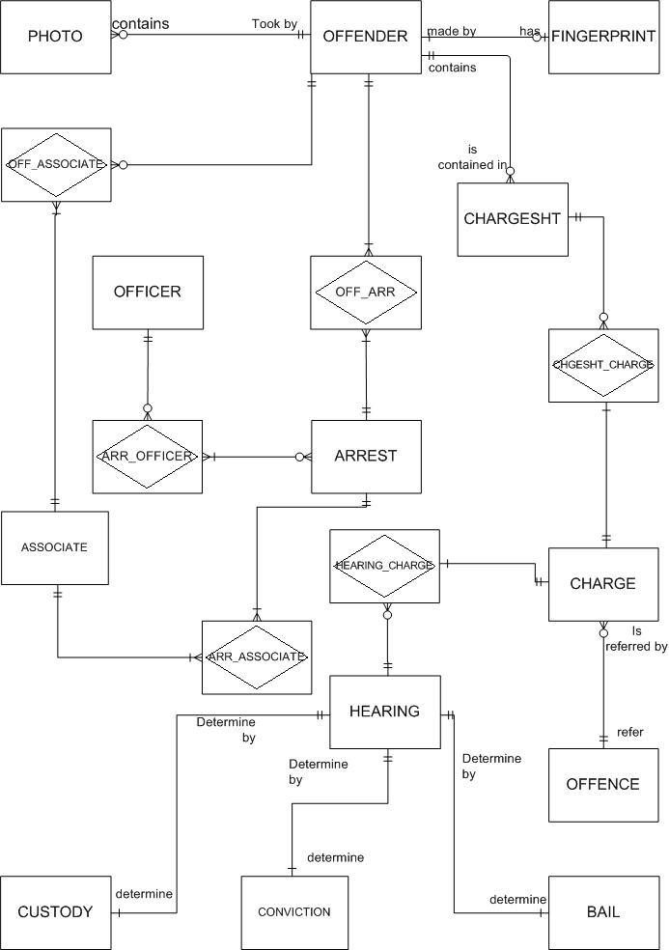

9. Data Dictionary

9.1 Data Entity

9.1.1 Data Entity: Offender

System Requirement Specification

Data Dictionary
System Name: Offender Monitoring System Designer: Joanne and Vickie Date: 5 May 2003
Data Entity Name: Offender
Alias :
Related Entities: Photo, Fingerprint, Off_Associate, off_Arr, Chargesht
Description:
The entity Offender includes all the information and details about the Offender.
Composition:
Offender = offender_number +
(offender_name +
nationality +
offender_address +
st_number +
st_name +
St_type +
suburb +
postcode +
dob) +
gender +
ht +
wt +
dist_mark +
skincolor +
eyecolor +
haircolor +
(medical_condition +
nok_name +
occupation +
employer +
religion +
fingerprt_number +
fingerprt_date +
fingerprt_img +
alias +
nickname)

9.1.2 Data Entity: Arrest

System Requirement Specification

Data Dictionary
System Name: Offender Monitoring System Designer: Joanne and Vickie Date: 5 May 2003
Data Store Name: ARREST
Alias:
Related Entities: Off_Arr, Arr_Officer, Arr_Associate
Description :

The entity arrest stores all the information regarding the arrests.

Composition:
arrest_number, arrest_date, arrest_time, arrest_location, arrest_detail, release_date)

Arrest = arrest_number +
arrest_date +
arrest_time +
arrest_location +
(arrest_detail +
release_date)

9.2 Data Attributes

9.2.1 Data Attribute—Arrest Number

System Requirement Specification

Data Dictionary
System Name: Offender Monitoring System Designer: Joanne and Vickie Date: 5 May 2003
Data Attribute Name: arrest_number
Alias: arrest_code, arrest_no
Data Entity : ARREST
Description:

A new arrest record and a unique number for the offender are created when they are arrested. This number identifies the offender.

Values:

“aa0000”
- First two characters must be text
- Last four character must be number

Range:

AA0001 → AL9999
A : January
B : February
C : March
D : April……….

The first alphabet is the month the offender is arrested.
The second number is a random sequential number.

9.2.2 Data Attribute—Arrest Date

System Requirement Specification

Data Dictionary
System Name: Offender Monitoring System Designer: Joanne and Vickie Date: 5 May 2003
Data Attribute Name: arrest_date
Alias: arrest_day
Data Entity : ARREST
Description:

This is the date the offender is arrested.

Values:

MMDDYYYY

Range:

01/01/1900 – 12/31/9999

10. Support for the Proposed System

As described earlier, using the current system which the Police Offender Monitoring system is using, give rise to numerous problems and inconsistency. Provided in the following is a list of how the proposed system will help change and improve the current situation, at the same time identifying opportunities that can be exploited now and in the near future.

10.1 Reduction in data duplication, data redundancy, confusion and wastage and inefficient use of storage space

Using the traditional method, the Police Offender Monitoring system stores similar information in separate files (i.e. in more than one file), which is undoubtedly unnecessary and redundant. For example, in the current system; after arresting an offender, the details of the arrest are recorded in the Daily incident book. The same type of information is also recorded in the Arrest Report, hence recording the same information more than once and in separate places. This causes data duplication, redundancy, and confusion and makes data more prone to errors which affect integrity.

If the proposed system is implemented, this problem is solved as converting the system to a relational database approach; files are integrated so that copies of the same and related data are stored only in one file. Any addition, deletion, update and modifications are executed only once and the modified or added data can be accessed anytime and from other related files.

As seen from the model of the proposed system the procedure for recoding offender details as described above needs to be carried out only once in order to do the same thing. Information regarding offender details is entered once into the offender file and all the corresponding and related files are updated immediately and users of the same information can retrieve the offender details from other related files as they are all linked. In this way, there is no confusion as to the values of the same information, no duplication of data which wastes storage space, reduced data redundancy and minimized rate of error. The same goes for other processes like retrieving offender details etc. where modifications need to be entered and updated only once.

10.2 Data Consistency and improved Data Integrity

Duplicate data files often result in loss of data integrity as there are chances where data values do not agree as information on the same information is inserted and modified in different files all over the place.

Using a relational database approach helps eliminate this data redundancy and the occurrence of inconsistent data. For example, if information on an offender charge is stored in only one charge file, any modifications made to its values are made once to that charge file. With one modification, all other files with this related offender charge is also modified in the system accordingly. Compared to the old system; if an offender charge is recorded wrongly, all the files related to that offender charge has to be retrieved and updated. This not only wastes times and effort, but also increases the margin of error. All it takes is just one mistake on one file containing that charge information to complicate information on the whole system.

As an example, If one file containing information on that offender charge is not retrieved and modified, its value will not be updated, hence its value will be inaccurate. This will cause contradiction to the other existing records holding the correct information. Furthermore, it may also cause data loss if the “unupdated” file can’t be retrieved due to the inaccurate information.

If the current system is replaced with the proposed system, all associated information will be updated as soon as additions and alterations are made regardless of who made these modifications and when. In doing so, all copies of that data remain consistent. Risk of loss of data and data integrity is also minimized.

10.3 Improved validity of stored data

By using a relational database approach, constraints can also be applied to data items to facilitate the validity and consistency of stored data. For example, only numbers are allowed when entering offender number. An integrity constraint can be enforced to state that no other alphabets and values except numbers are permitted when entering offender number. Hence mistakes in entering certain data can be avoided.

10.4 Sharing of data and more information from the same amount of data

With what the Police Offender Monitoring system is currently doing, each department stores and updates its own files. Users have limited opportunities to share data outside their own department. Additional efforts are required to obtain information from another department. Using a computerized relational database approach would facilitate the sharing of data between other departments. More information is also made available to different departments which was not originally so. For example, before integration, the desk sergeant has to send a record request slip to the Central Record department to locate existing offender details. If the proposed system is implemented, he will have all the information just by executing a query. He will have access to information which he previously did not when he had to request for that information separately from another department. Hence more information from the same amount of data is made available through integration. This saves a lot of time, effort and resources.

10.5 Improved data accessibility, flexibility and responsiveness

In the current system, several reports are generated at the end of every month and submitted to Police management. It is inflexible and slow as all data needed in the report is collected from separate files. Furthermore, this is a repetitive procedure occurring every end of month and a lot of time can be saved if reports can be generated in one single step.

On top of that, sometimes ad hoc enquiries are made and it takes time to answer them because time is needed to retrieve the relevant information from different areas and collate them. This not only causes unnecessary delays in police work but may also cause delay in nabbing an offender if information on that offender is not supplied on time due to delay in locating his/her file(s).

By implementing the proposed system, data that crosses department/process boundaries are made easily accessible to end-users because data is integrated. Query languages can be used to support ad hoc enquiries or reports. Hence any information can be extracted easily from the system; unlike before, where data has to be gathered first before supplying the information (inefficiency and a waste of time).

The system can also be programmed to generate the necessary reports at the end of every month and will help save a lot of time which can be used to carry out more productive work. It helps solves the problem of delays in reporting, data accessibility, flexibility and responsive as the system can provide any information, anytime and quickly.

10.6 Improved security hence reduced opportunity for sabotage

Integration allows improved enforcement of database security. In the current system, there is lack of control and security on data hence opportunity for sabotage. Anyone can access and supply data as long as one supply a request form or work in a particular department. There’s no verification of identity and authorization with who needs what information. The proposed Police Offender Monitoring System can change and improve this situation by enhancing protection against unauthorized access to the database. Some examples include usernames and passwords, firewalls etc. Anti-virus applications can also be installed to prevent corruption and loss of data and files.

Implementing the proposed system will hence help enhance their protection against unauthorized addition, deletion, updates and retrievals to their existing database at the same time preventing the loss and corruption of data.

10.7 Enforcement of standards

With the current system, no standards and standard procedures are used to name, store, update and access data. After implementing the proposed system, necessary standards can be defined and enforced to assists them in their naming conventions, update procedures and access rules etc. Therefore, data is more accurate and consistent.

10.8 Shorten Offender Monitoring Process, hence reduced backlogs and reduced delays in processes

As can be seen from the current system, many processes are lengthy, time-consuming and redundant. Take verifying fingerprints for example. In order to identify an “unidentified” offender, a fingerprint request form has to be filled and sent, together with the fingerprints to the forensic department. There is a lag time between the time the fingerprint request form is sent and the time the identification reply is received. This will delay the whole identification process. This is only one example. If all processes are delayed the same way because of waiting time, this causes incredible inefficiency, backlogs and delays in processes which delays not only that of the Police Offender Monitoring System, but may also affect the whole of the Police system,.

By implementing the proposed system, the problem can be solved easily. For example, in the verifying fingerprint process, an online fingerprint request form, attaching the scanned fingerprint, is sent electronically to the forensics department (Officer). If a match for the fingerprints is found, the identification results will be sent electronically back by the forensics department, including all the necessary details of the offender and the forensic officer if a match is found. This takes less than half the time and less resources to retrieve the same amount of data than it took for the current system to identify the offender (if possible).

10.9 Cost Savings, increased productivity and increased efficiency

Integrating their data applications into one relational database, the Police Offender Monitoring System uses a set of applications that works only on one source of data. This helps reduce a lot of labor costs, hence a higher fraction of the budget is available for other improvements such as purchasing better equipment used in monitoring offenders etc. Updates, modifications, deletions and addition of data need to be made only once and not more than once like before. This helps in saving time, hence increased available time therefore fewer resources will be employed in this area and more resources can be transferred and employed in other more important areas such as locating murderers etc, hence increased productivity and increased efficiency in the Police Offender Monitoring System.

11. Recommendations and Conclusion

As seen from the previous section, replacing the current system with a new integrated relational database management system will no doubt provide long term benefits to the Police Offender Monitoring System. However, the scope of the above proposed system is only for the Police Offender Monitoring System. It is suggested that If the proposed system is also implemented on a larger scale i.e. including the other systems in the Police Force, the benefits the proposed system will bring is incredible.

In the same context, if the proposed system is implemented successfully in the whole Police force, productivity and efficiency will be increased enormously, more resources will be utilized in dealing with more important issues and a higher portion of the budget can be used in nabbing offenders. Overall, there will be fewer offenders on the road as more resources are utilized to catch them and this will produce a more sound and safe community, and better support from the people.

Another suggestion is for the Police to install a data warehouse. It is a database with reporting and query tools that stores current and historical data extracted from various operational systems and consolidated for management reporting analysis. Benefits include improved information, easier decision-making, easier and faster accessibility to data without affecting the performance of the underlying operational systems

To conclude, we are confident that the proposed system will provide what it promises and the results will be proven by the increase in productivity, efficiency, additional cost-savings, reduced redundancy, higher quality and integrity and higher data security etc if the proposed system is implemented correctly.

APPENDIX: Minutes of Meeting

