Table of Contents

1. Design Elements 1
1.1 Home Pages 1

1.2 Frameset- Sales 2

1.3 Outline- Sales Links 3

1.4 Form 4
1.4.1 Product 4
1.4.2 Customer 5
1.4.3 Order 6

1.5 View 7
1.5.1 Product 7
1.5.2 Customer by State 8
1.5.3 Order 9
1.5.3.1 Order in Victoria 9
1.5.3.2 Order by Customer (subtotal) 10
1.5.3.3 Pending Order by Date 11

2. Formula 12

1. Design Elements

1.1 Home Pages
- Narrative overview:
It’s the first page of the system which will show whenever the website, http://bs-domino.bsys.monash.edu.au/bus5720/assignment/pifenchenassignment.nsf, be addressed either by Internet Explore or Notes, and the frameset of Sales Department and Human Resource Department can be navigated.

Page: | Home
Task: | The home webpage of P.Chen Telecommunication Pty. Ltd systems.

- Sample Design
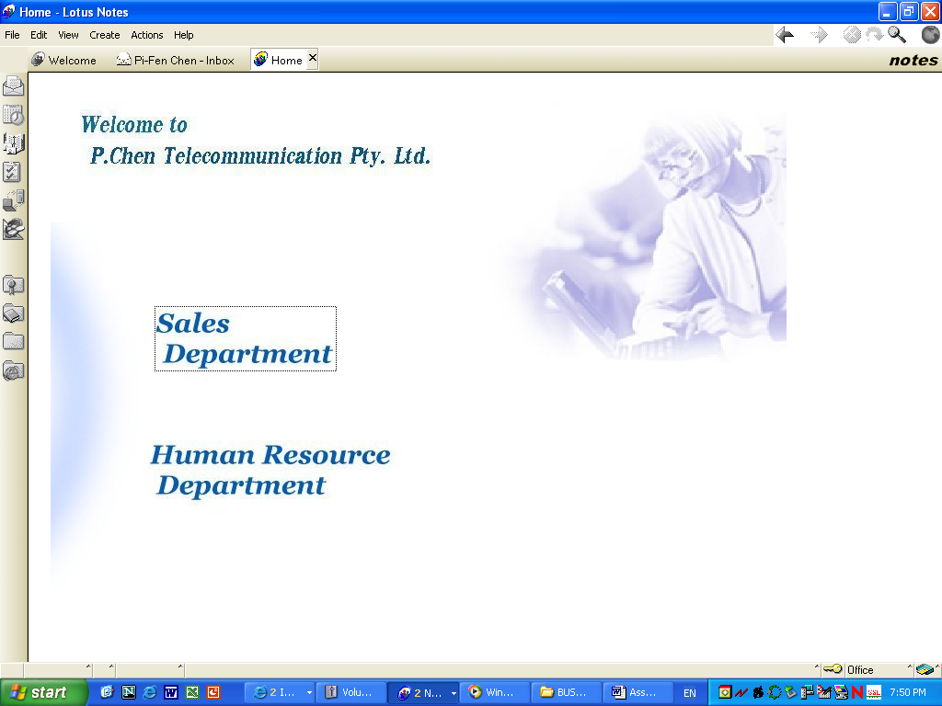

1.2 Frameset- Sales
(a) Narrative overview:
In this frameset, it includes three frames, Sales Banner, Sales Links and Sales Target. There are several hyperlink in Sales Links and can show the target in Sales Target frame.

Frameset: | Sales
Task: | To structure 3 frames in Sales frameset.

- Sample Design
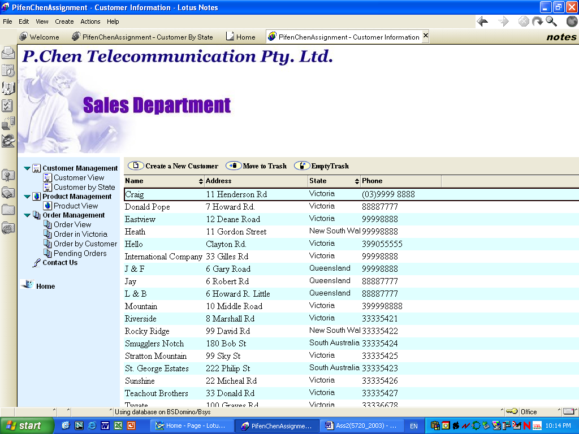

1.3 Outline- Sales Links
(a) Narrative overview:
The structure including 3 parent entries, customer management, product management and order management and link their forms as well. Moreover, per entry includes several views in their sub entries.

Outline: | Sales Links
Task: | To construct the outline of Sales department systems.

(b) Sample Design
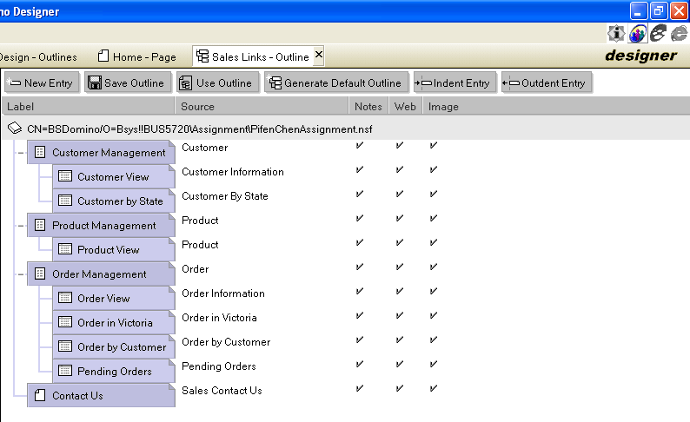

1.4 Form

1.4.1 Product
(a) Narrative overview:
The record of product can be created and edited and product image can be created and edit as well. Also, this form can link the Order form.

Form: | Product
Task: | Create and Edit the Product record.

(b) Sample Design
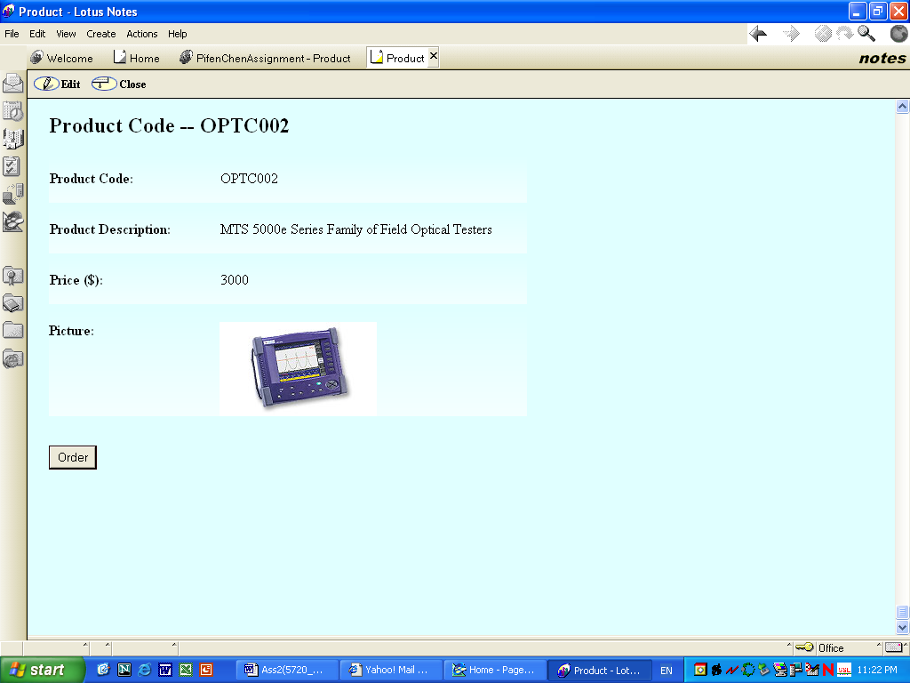

1.4.2 Customer
(a) Narrative overview:
The form is use to manage customer data, the Australian states list can be drop-down from State field.

Form: | Customer
Task: | Create and Edit customer record

(b) Sample Design
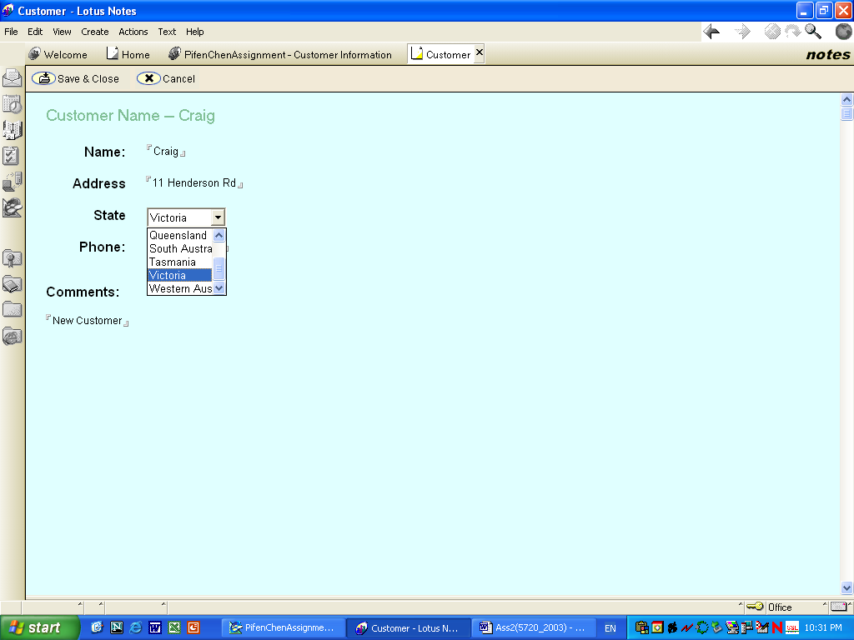

1.4.3 Order
(a) Narrative overview:
In Order form, the order Date can be chosen by calendar and status of order can be selected by click, either Completed or Pending. Order Reference should be unique and the format is “PCH” , ”yymm” and 3 characters of serial number for the number of order in the month. The Product Code can be chosen by Dialog Box and Product Description and Price value will be referred from Product view automatically. Similarly, in Customer detail, the customer Name can be chosen by Dialog Box and customer Address, State and Phone values will be computed from Customer view automatically.

Form: | Order
Task: | Edit and Create Order entry

- Sample Design
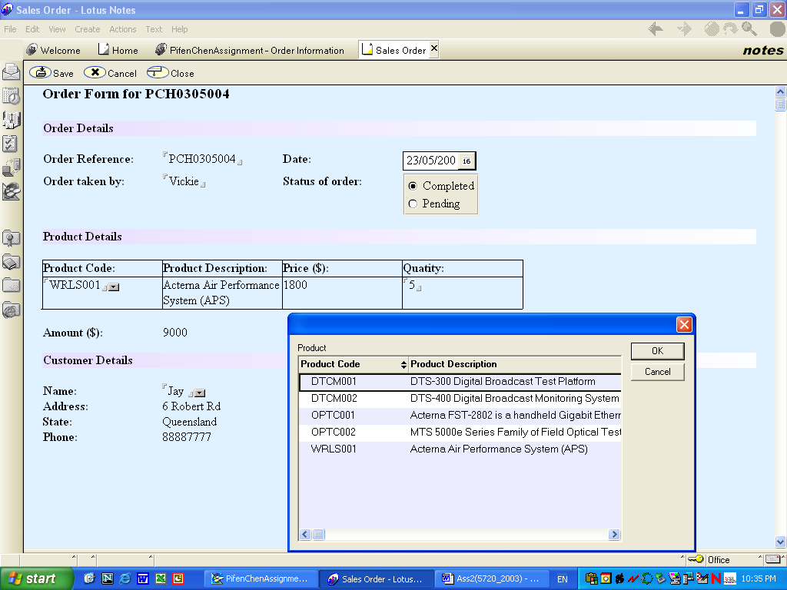

1.5 View

1.5.1 Product
(a) Narrative overview:
The Product view is ascending sorted by Product Code. Clicking “Create a New Product” button, the Product form will be showed.

View: | Product
Task: | The product records that are created by Product form will be listed.

- Sample Design
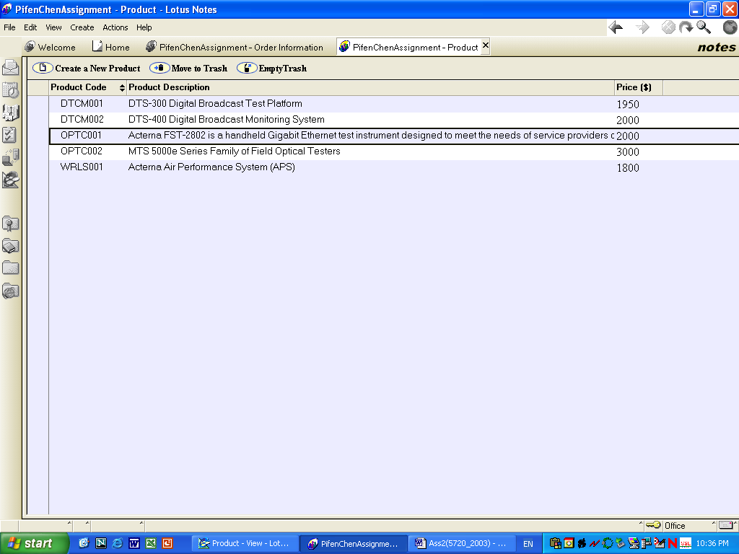

1.5.2 Customer by State
(a) Narrative overview:
Customer form can be executed by click “Create a New Customer” button.

View: | Customer by State
Task: | Showing all customer records and categorizing by State.

(b) Sample Design
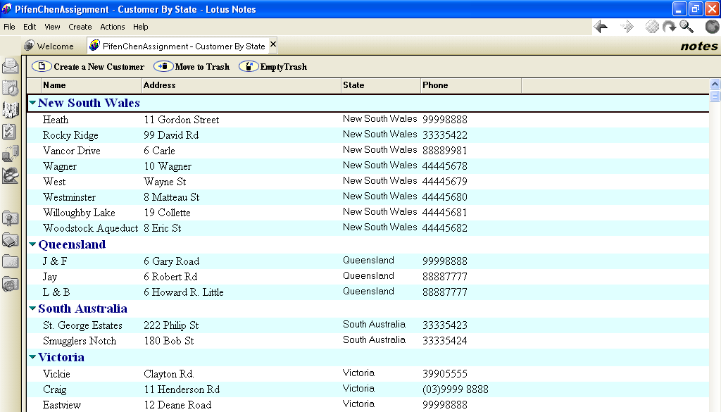

1.5.3 Order

1.5.3.1 Order in Victoria
(a) Narrative overview:
The view only lists the orders that are from Victoria customer and can sort on Order Reference and Date column by click.

View: | Order in Victoria
Task: | Show the order record that placed in Victoria

(b) Sample Design
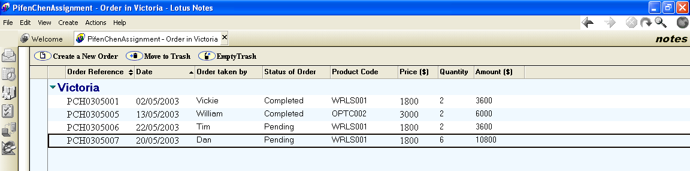

1.5.3.2 Order by Customer (subtotal)
(a) Narrative overview:
The subtotal will be calculated per customer.

View: | Order by Customer
Task: | Showing the Order view by customer category.

(b) Sample Design
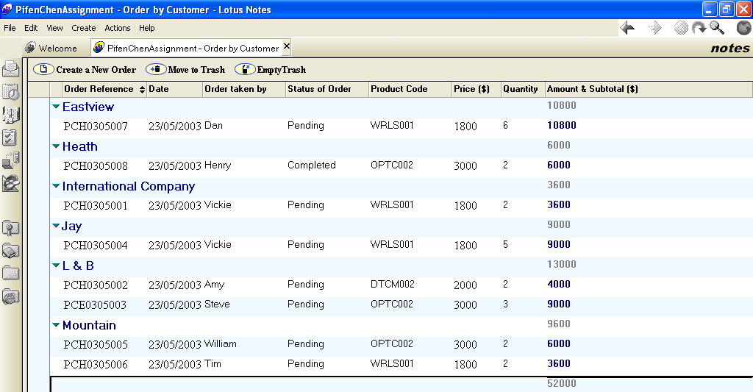

1.5.3.3 Pending Order by Date
(a) Narrative overview:
The order date will be ascending sorted.

Page: | Pending Order
Task: | The view only shows the records that the order are still Pending and sort by Date.

- Sample Design
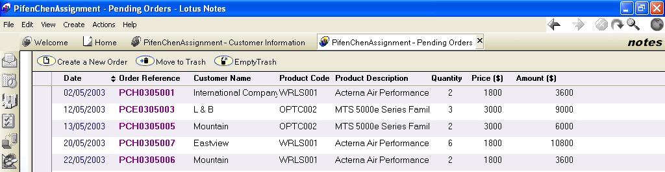

2. Formula
Formula | The purpose of the formula | Where is the formula?
 |  | Form: Product
@If(@IsNewDoc; "New Product Form"; "Product Code -- " + ProductCode) | Computing title for the Product record | <Computed Value>
@If(productCode !="";@Success;@Failure("Please enter a value in the Product Code field.")) | Input validation:  Prevent from null | productCode (Field)
@If(productDesc !="";@Success;@Failure("Please enter a value in the Product Description field.")) | Input validation:  Prevent from null | productDesc (Field)
@If(price !="";@Success;@Failure("Please enter a value in the Price field.")) | Input validation:  Prevent from null | Price (Field)
@Command([FileSave]);  @Command([FileCloseWindow]) | Save and Close the Product form | Save&&Close (Action)
@Command([EditDocument]) | Edit the existing product record | Edit (Action)
@Command([FileCloseWindow]) | Close Product Form Window | Cancel (Action)
@Command([Compose]; "Order") | Open Order Form | Create a New Order (Action)
 | Form: Customer
@If(@IsNewDoc; "New Customer Form"; "Customer Name -- " + custName) | Computed title for the customer record | <Computed Value>
@If(custName !="";@Success;@Failure("Please enter the Customer's Name.")) | Input Validate:  Prevent from null | custName (Field)
“Victoria” | Default Value | custState (Field)
@Command([FileSave]);  @Command([FileCloseWindow]) | Save and close the Customer form | Save && Close (Action)
@Command([FileCloseWindow]) | Cancel adding the new customer | Cancel (Action)
@Command([EditDocument]) | Edit the existing Customer record | Edit (Action)
@Command([FileCloseWindow]) | Close Customer Form Window | Close (Action)

Formula | The purpose of the formula | Where is the formula?
 |  | Form: Order
@If(@IsNewDoc; "New Order Form"; "Order Form -- Order Reference: " + OrderReference) | Computing the title of the Order record | <Computed Value>
@If(OrderReference !="";@Success;@Failure("Please enter the Order Number in the Order Reference field (eg. PCH0305009).")) | Input Validate:  Prevent from null | orderReference (Field)
@If (productCode !=""; @DbLookup( "":"NoCache"; "" : "" ; "Product" ; productCode ; 2); "") | Default Value:  Compute value from “Product” view. | productDesc (Field)
@If (productCode !=""; @DbLookup( "":"NoCache"; "" : "" ; "Product" ; productCode ;"Price"); 0) | Default Value:  Compute value from “Product” view. | Price (Field)
price*quantity | Multiple amount from Price and Quantity field | Amount (Field)
@If (custName !=""; @DbLookup( "":"NoCache"; "" : "" ; "Customer Information" ; custName ; 2); "") | Default Value:  Compute value from “Customer Information” view | custAddress (Field)
@If (custName !=""; @DbLookup( "":"NoCache"; "" : "" ; "Customer Information" ; custName ; 3); "") | Default Value:  Compute value from “Customer Information” view | custState (Field)
@If (custName !=""; @DbLookup( "":"NoCache"; "" : "" ; "Customer Information" ; custName ; 4); "") | Default Value:  Compute value from “Customer Information” view | custPhone (Field)
@Command([FileSave]) | Save the Order form | Save (Action)
@Command([EditDocument]) | Edit the existing Order record | Edit (Action)
@Command([FileCloseWindow]) | Close Order Form Window | Close (Action)

Formula | The purpose of the formula |  | Where is the formula?
 | View: Product
@Command([Compose]; "Product") | Open the Product form |  | Create a New Product (Action)
@Command([MoveToTrash]) | Delete the selected record |  | Move To Trash (Action)
@Command([EmptyTrash]) | Empty the records in trash |  | Empty Trash (Action)
 | View: Customer Information
SELECT ((Form = "Customer")) | View the records from Customer form |  | View Selection
@Command([Compose]; "Customer") | Open Customer form |  | Create a New Customer (Action)
There are 2 same action “Move to Trash” and “Empty Trash” as Product View
 |  | View: Order in Victoria
SELECT ((Form = "Order")) & (@Contains(custState; "Victoria")) |  | View the records from only “Victoria” Order | View Selection
@Command([Compose]; "Order") |  | Open Order Form | Create a New Order (Action)

There are 2 same action “Move to Trash” and “Empty Trash” as Product View
 |  | View: Order by Customer

The action “Create a New Order” is the same function as “Order in Victoria” view

There are 2 same action “Move to Trash” and “Empty Trash” as Product View
 |  | View: Pending Orders
SELECT ((Form = "Order")) & (@Contains(Status; "Pending")) |  | Select the orders that status are “Pending” | View Selection

The action “Create a New Order” is the same function as “Order in Victoria” view

There are 2 same action “Move to Trash” and “Empty Trash” as Product View

