Introduction
Since the number of organised sports and competitions, and the workload in training for adolescence have increased recently, the chance of these adolescent sport players to get physical problems has been increasing. The problems can be acute or chronic, and are most likely to be sparked off by overuse and overload. Knee problems are prevalent in pediatrics, and our group will investigate such problems in the case follows.

Mary Lee, 12, has played Ballet for 3 years. She has got anterior knee pain for the past few months, and left side is worse than right. The problem has worsened in the past few weeks as she feels so painful that cannot run fast or jump high. Going up and downstairs are painful, too.

In order to comprehend the situation and diagnose correctly, basic knowledge in anatomy is essential.

Anatomy of Knee
As the pain of Mary Lee is around the anterior side, we therefore focus on the anterior structures of knee.

The bony structures at knee joint are femoral condyles, tibial condyles, head of fibular and patella. These structures form three articulations: patellofemoral (PF) joint, tibiofemoral joint and superior tibiofibular joint.

Patella is embedded in the quadriceps tendon. There are two articular surfaces on patella: the medial facet and lateral facet.⁶ These articular surfaces are covered by hyaline cartilage. Two third of them articulates with the supratrochlear region and the trochlear facets depending on varying degrees of knee flexion.¹⁴ The patellar ligament, which attaches the patella to the tibial tuberosity, is a continuation of the tendon of the quadriceps muscle. Patella increases the mechanical advantage of extensor muscles, i.e. the quadriceps, by transmitting forces across knee at greater distance from axis of rotation²¹.

When the knee is fully extended, the patella covers the supratrochlear fossa to facilitate extension. The patella drifts distally when the knee flexes.

Q-angle is an important determinant of knee health. It is formed by a line drawn from the ASIS to the central patella and a second line drawn from the central patella to the tibial tuberosity. (see figure on the right)²³
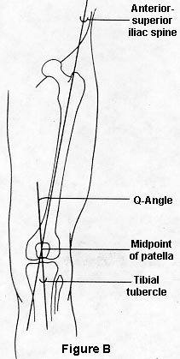

The soft tissues play a role to determine the stability of the knee joint.¹⁴ The vastus medialis and vastus medialis oblique (VMO) muscle fibres insert into the medial and distal aspects of the patella, while the vastus lateralis and vastus lateralis oblique muscle fibres insert into the lateral and superior margins of the patella. They act together to provide dynamic stability of the joint. The iliotibial band (ITB) insert into the lateral aspects of the patella. During knee flexion, the ITB passively draws the patella posteriorly and laterally and stresses on the PF joint.⁹
There are four particular bursae can be found in anterior compartment. They are Suprapatellar bursa, prepatellar bursa, subcutaneous and deep infrapatellar bursa. Their locations are as follows:
Bursa | Lying between
Subcutaneous pre-patellar  Deep infrapatellar  Subcutaneous infrapatellar  Suprapatellar | Lower patella/skin  Upper tibia/patellar ligament  Lower tibial tuberosity/skin  Lower femur/deep surface of  Quadriceps ( communicates with  joint)

They generally serve to reduce friction of structures around the knee.
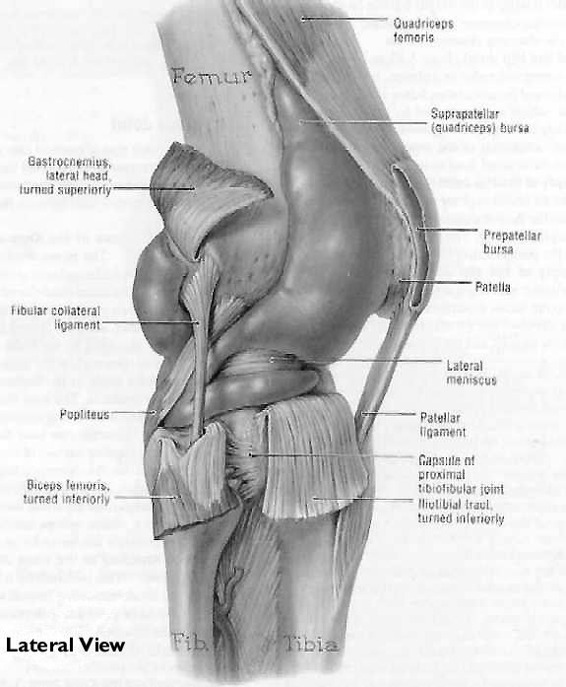

Subjective Examination
The structure of this particular subjective examination is more or less the same with the common examination. However, some points have to be mentioned.

To adolescent client (Mary Lee, 12), they may concern privacy and confidentiality. Therefore, the examination should be carried out as much as possible with the absence of parents. ² The rationale of the examination should be explained at the very beginning to reduce adolescents’ anxiety. ¹¹

Adolescents may not understand abstract issues and jargons, and thus technical wordings should be avoided. Therefore, abstract question such as “What’s your main problem?” should be modified to “I wonder if you would tell me why you come to see me?” ⁴

When we ask the frequency of pain we should use “always” or “sometimes” rather than just asking “how often”. Although it is somehow directing, simple and understandable words are more suitable in adolescent interview. Also, the complicated visual analog scale of pain should be reduced to three-leveled scale: no pain, mild pain or extreme pain.

Additional information such as CT, MRI, arthroscopy and blood test should be obtained if necessary.

 |  | Adult | Adolescent
C/O |  | What is the main problem? | I wonder if you would tell me why you come to see me
Pain | Frequency | How often? | Always?, Sometime?
Pain | Level | VAS | Three-leveled scale
Medical History |  | Ask the client directly | Ask the parents

Points to concern in this particular case;
- In past history→ common posture & vigorous motions, especially Lt.
- In social history→ whether she is a competitive dancer or not.

After gathering the information from the subjective examination, we can proceed to hypothesis making process.

Hypothesis
Chondromalacia

Chondromalacia may cause anterior knee pain. It is actually the pathological softening of articular cartilage .⁷ It can occur without any reason, that is idiopathic chondromalacia; it can be caused by overload and subluxation, that is secondary chondromalacia patellae. In Mary’s case, secondary chondromalacia patellae is more likely to happen because she has to perform a series of activities which may aggregate her pain when compare with other non-athletes. The frequency and duration of ballet lesson may make her easier to encounter such problems. Difference in weight bearing in her knee during dancing can explain why she got more pain on her left limb.

Overload

Overload refers to either stress on a load-bearing facet or sheer stresses in the depths of the articular cartilage between high contact and low contact area. ¹ It may be due to malcongruence and malalignment. When the patella shape is abnormal, the articular surface between patella and intercondylar will not be congruent, stress on one facet may be larger than that of the other. Malalignment of extensor mechanism, that is, the weakness of vastus medialis muscle causes the lateral tilt or subluxation of patella. This will lead to the same effect on the facets of patellofemoral joint. The expression of symptom may also be aggregated by environmental stress, as in our case that Mary suffers from environmental stress every time she is having a ballet lesson. As a result, overload might lead to chondromalacia or subchondral vascular congestion which leads to anterior knee pain.

Osgood-Schlatter disease
Osgood-Schlatter disease is common in active children with age between 11 and 14. The symptoms and signs of this condition arise as a result of repeated microfractures in the apophyseal cartilage between the proximal tibia and the secondary ossification center onto which the patellar tendon attaches. These cartilaginous microfractures occur as a result of repeated extension of the knee. Inflammation at the site of injury follows, resulting in pain and tenderness. Either one or both knees may be involved, but when it is bilateral, one side is usually more symptomatic. If activity is not restricted and microfractures continue over a period of several months, an abnormal cartilage calcification happen in the injury site which lead to enlargement of the tibial tuberosity. As Mary Lee plays ballet which involves jumping and running, powerful quadriceps contractions are essential. As a result, microtrauma may develop in tibial tubercle. For a 12-year-old girl, bony structure is immature, which might aggregate the avulsion. ^{10,12}

Overuse Injuries

Overuse injuries occur when the homeostasis between stress applied and the tissues response is disturbed. ¹³

In general, there are approximately 30% of all injuries incurred by young athletes involve the immature knee. The three anatomic sites in the immature knee, i.e. the epiphysis, the articular surface, and the apophysis are localized with growth cartilage. Many investigators have suggested that chondral growth centers may be more susceptible to repetitive microtrauma than are adult tissues. The cumulative effects of shear and compression forces, besides, may lead to a variety of osteochondral injuries.

There is a quite obvious association of various overuse syndromes with pubertal growth spurt. During the adolescent growth spurt, soft tissues must passively stretch to accommodate rapidly growing long bones. Previously supple muscle-tendon units shorten, and flexibility is diminished. The superimposition of repetitive microtrauma on vulnerable prestressed muscle-tendon units predisposes the child-athlete to a variety bursitises, tendinitises etc. ¹⁴

Besides, there are several contributing risk factors causing the overuse injuries, such as training errors, muscle-tendon imbalance etc. (refer to the table below)¹³

Risk Factors For overuse syndromes
- Training errors
Abrupt changes in intensity, duration, or frequency of
training
- Musculotendinous imbalance of strength, flexibility, or bulk
- Anatomic malalignment
Leg length discrepancies
Hip rotation abnormalities
Kneecap position
Bowlegs, knocked knees
Flatfeet
- Footwear
Improper fit
Inadequate impact-absorbing material
Excessive stiffness of the sole
Insufficient support of the hindfoot
- Playing surface
Concrete pavement versus asphalt, running track, dirt or grass
- Associated disease state
Arthritis, poor circulation, old fracture, or other injury
- Growth
In particular, the growth spurt

The most likely overuse injuries:

1. Jumper’s Knee
Since Mary Lee performs dancing frequently, the repetitive flexion and contraction of the quadriceps muscle gives continuos pulling force on the quadriceps tendon and patella tendon, this will possibly cause repeated microtears of the collagen fibers of tendons. The continuous inflammatory response towards the microtear together with prestress of the tendons during growth spurts attributes to the cause of patella and quadriceps tendinitises.⁷

2. Bursitis
Mary Lee may need to do certain motions include kneeling during dancing, this cause continuous friction between skin and the patella which develop to bursitis eventually.⁷

- ITB friction syndrome
ITB may be subjected to stretching during adolescence due to the elongation lag of soft tissue compare to bone growth. The stretching itself may cause pain. Additionally, when the knee flexes to 30º and back, ITB will pass over the lateral femoral condyle and may cause friction, and pain which builds in intensity, or even inflammation of underlying synovium. This is likely to happen in Mary as ballet involves similar actions very often. ⁹

Objective Examination
To obtain more accurate and specific information, objective examination must be performed. First, observations of position of patella, weight bearing of both limits, gait and cardinal signs should be made. Any abnormality such as Q angle larger than 20º or unequal weight bearing should be noticed.
Joints just proximal and distal to the knee joint should be cleared then. Hip and ankle flexion, extension, abduction and adduction are good indicators.
Then we will move to test every suspected symptomatic structure. The hypothetical syndrome stated above should have positive result in the following test:^{1, 23, 24, 25}

Jumper’s knee
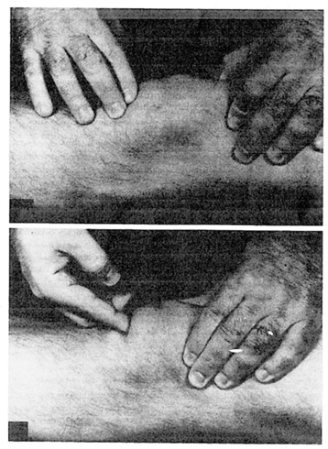
Fluctuation test.
Tenderness when the patella is displaced distally
(see figure on the right²⁵)

Osgood-Schlatter disease
Swelling of tibial tuberosity
Tenderness on palpation
Pain exacerbated when extend against resistance
Pain when full passive flexion

ITB friction syndrome
Ober’s test (reveal pain)
Thomas test

Subluxation
Apprehension test
Compression test

Overload due to malalignment
Abnormal Q angle
Deformity (patella alta, genu valgum, genu varum, etc.)

Bursitis
Fluctuation Test
Patellar tap Test

Advice
Whether Mary Lee can return to Ballet depends on her healing progress. Being a PT, we should further examine Mary to ensure that she is fit for the high intensity training. Once there is any recurrent symptom, the activity should be stopped.

The activity should be started with light intensity. The intersity can be increased if there is no irritable symptom.

PT DIAGNOSIS & MANAGEMENT OF MUSCULOSKELETAL DYSFUNCTION

SEMINAR PRESENTATION: KNEE PROBLEM (MARY LEE)

CHOW SHING CHI, SU
HO SIK HON
LAM CHI SHING, STANLEY
LEE NGA YAN, CHRISTINA
LEUNG LOK YIN, PATRICIA

Reference:
Books:
- Apley, A.G., & Solomon, L.1993. Apley’s System of Orthopedics and Fractures. 7th ed. London: Butterworth Heinemann Ltd.
- Engel, J. 1997. Pocket Guide to Pediatric Assessment. 3rd ed. St. Louis: Mosby.
- Fulkerson, J.P.1997. Disorders of the Patellofemoral Joint. 3rd ed. Baltimore: Williams & Wilkins.
- Green, M. 1986. Pediatric Diagnosis. 4th ed. Philadelphia: W.B.Saunders Company.
- Maitland, G.D. 1991. Peripheral Manipulation. 3rd ed. London: Butterwoth Heinemann Ltd.
- Moore, K.L. 1985. Clinically Oriented Anatomy. 3rd ed. Baltimore: Williams & Wilkins.
- Nicholas, J.A., & Hershman, E.B.1986. The Lower Extremity and Spine in Sports Medicine Volume 1. St. Louis: Mosby.
- Nicholas, J.A., & Hershman, E.B.1986. The Lower Extremity and Spine in Sports Medicine Volume 2. St. Louis: Mosby.
- Norris, C.M. 1993. Sports Injuries: Diagnosis and Management for Physiotherapists. London: Butterworth Heinemann Ltd.
- Scoles, P.V. 1988. Pediatric Orthopedics in Clinical Practice. 2nd ed. Chicago: Year Book Medical Publishers, Inc.
- Tecklin, J.S. 1989. Pediatric Physical Therapy. 1sted. Philadelphia: J.B. Lippincott Company.
- Tolo, V.T., & Wood, B. 1993. Pediatric Orthopedics in Primary Care. Baltimore: Williams and Wilkins.

Journal Articles:
- Cook, P.C.& Leit, M.E. Issues in the Pediatric Athlete. Orthopedic Clinics of North America 1995; 26(3): 453-464.
- Thabit, G. & Micheli, L.J. Patellofemoral Pain in the Pediatric Patient. Orthopedic Clinics of North America 1992; 23(4): 567-585.

Websites:
- Physiotherapy in Practice: Common Problems
http://www.advancephysio.com.an/articles/professionals/PatellofemoralJointPain.html
- The Knee
http://www.echo.uqam.ca/mednet/anglais/hermes_a/knee/part_5.html
- Chondro.htm
http://www.fammed.uokhsc.edu/Enid/chondro.htm
- CAS Q&A
http://www.knees.com/qa2.html
- Chondromalacia of the Patella
http://www.medmedia.com/oo1/45.htm
- Subluxation / Dislocation of the Patella
http://www.medmedia.com/oo1/51.htm
- Biomechanics of the Patello-Femoral Joint
http://www.medmedia.com/o15/95.htm
- Bursae and Bursitis of the Knee
http://www.medmedia.com/o12/214.htm
- Q angle of the Knee
http://www.medmedia.com/oo1/234.htm
- Examination of the Patellofemoral Joint
http://www.medmedia.com/oo1/511.htm
- Physical Therapy Corner: Knee Injuries and the Female Athlete
http://www.nismat.org/ptcor/female_knee/index.html
- Physical Therapy Corner: Patellofemoral Pain Syndrome
http://www/nismat.org/ptcor/pfp/index.html

