The Newsletter for Region VI
of the
NC Chapter of the International Association of Personnel in Employment Security

Volume 3, Issue 2 June 2000

Mini Institute:

A Mini-Institute was held in the Jacksonville Local Office on June 22, 2000. The theme was “Be Prepared for the Season”. The guest speakers were C. Douglas Bass, Director of Onslow County Emergency Services, and Mr. Finney Greggs, Executive Director of the Onslow County American Red Cross. These gentlemen discussed the importance of planning what we are going to do to keep our families safe during the hurricane season. Also, we received a lot of information about what happens during and after a hurricane or tornado. Of course an appeal went out for volunteers during this time of need. Mrs. Van Sickle, Regional Manager, and State IAPES President provided a state update and Mrs. Dosher, New Bern LO Manager, provided both region and state constitutions update.
Two Hurricane starter kits were given out as door prizes.


Total membership for Region VI as of June 2000 is: 157
*******************
Local Office Chairs:

Aberdeen: Larry Welch (910) 692-5404
Burgaw: Joy Hudson (910) 259-0240
Clinton: Shirley Cooper (910) 592-5756
Fayetteville: Tracy Huff (910) 486-1010
Elizabethtown: Sabra Grime (910) 862-3255
Jacksonville: Sherry Cash (910) 347-2121
Laurinburg: George Farley (910) 276-4260
Lumberton: Lee Newkirk (910) 618-5500
Morehead City: Frank Arnath (252) 726-7151
New Bern: Dottie Harris (252) 514-4828
Shallotte: Chuck Spangler (910) 754-6120
Whiteville: Lennette Singletary (910) 642-0146
Wilmington: Sherri Neville (910) 251-5777

Inside This Issue

- Local Office News
- LO News, Upcoming Events
- Awards
- Be Prepared

Local Office News

Aberdeen LO News

Southern Pines ESC moved to Aberdeen, in June, to a new building on 245 Shepherd Trail, Central Industrial Park.

Farewell and good luck to Tom Murdock. Joe McPhatter and Tamika Shamberger as well as Kathleen Howell and Sharon LeGrande of the Troy Branch Office, all departed on June 30, 2000.

Laurinburg LO News

George Farley became a grandfather on June 29, 2000. Zachary Farley weighed 9.5 lbs at birth.



Morehead City LO News

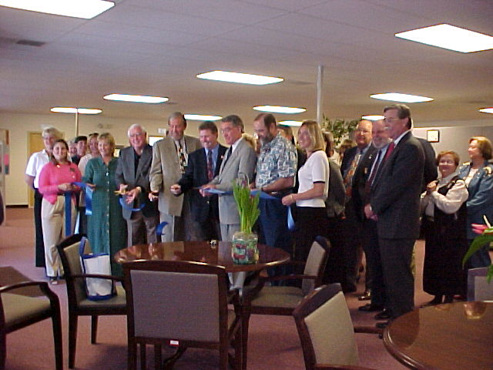

The local office manager, John Wittenstrom and staff would like to thank everyone that was able to attend the Grand Opening on April 6, 2000 of our new office. We are very excited about becoming a Job Link in the near future and would like to welcome our Job Link Partners, Carteret Community College, Vocational Rehabilitation, DSS, and Carteret County Schools.

We would also like to welcome aboard, Bridget Stubblefield as our newest Employment Consultant and congratulate Dawn Farrell-Harkins on becoming permanent.

More News!

New Bern LO News

The New Bern LO welcomes Christy Webb, new Employment Consultant and welcomes back Jamie Wallace. Also, the New Bern local office has scheduled an Open House for August 24, 2000.

Shallotte LO News

Note of Gratitude

Hello I am Willa D. Pigotte, Employment Consultant in the Shallotte LO. Along with my daughter, Larrisa Pigotte and our whole family, I just want to say thank you for your donations of shared leave, prayers, assistance, advice and just being there for us during Larrisa’s grave illness. She is out of the hospital now and doing much better. I am back at work but we still have a long way to go in her healing process. She is two years old and has an eating disorder, which causes other problems because of the lack of nutrients. We want to give special thanks to the Shallotte LO manager and her staff and Dorette and Evelyn in the Raleigh Business Office. Dorette and Evelyn, I feel you went beyond normal duty in the services you provided to me. The things you did for me provided the relief of a lot of the stress and tension I was feeling. You were a blessing to me.

The Pigotte Family

*****************************

UPCOMING EVENTS
*****************************

August 2-4, 2000
ESC UI Conference: In Asheville, NC

August 2000

Retiring this month: Joy Dosher, New Bern LO and Betty Worsh, Shallotte LO

August 2000
Executive Board Meeting: To prepare the plans for the upcoming year.

October 1, 2000
Membership Kickoff Campaign:
New member recruitment may begin July 1, 2000. Don’t forget our partners!

October 5-6, 2000
IAPES Institute: Fayetteville, NC

December 2000
Submission of Award Nominations:

*****************************
Awards
*****************************

Region VI had an impressive number of award nominations and winners for 1999. Now is the time to begin working on the nominations for 2000. Its not too early to begin gathering supporting documentation for your nominations. There will be another “How to write an award winning nomination” workshop at the Institute in October.

Future newsletter articles:

Please submit any articles, information or pictures for future newsletters for Region VI, to Susan Johnson in the Morehead City LO or Judy Jones in the Jacksonville LO.
The next newsletter will be for July –September. Please have your information in by September 15, 2000. Thank You

Be Prepared!
Family Disaster Supplies Kit:

Here are some suggestions on what supplies you may need when a disaster strikes!

Water: 1 gallon per person, per day for at least 3 days.

Food: Enough for at least 3 days.
Ready to eat canned meats, fruits and vegetables.

Canned juices, milk, soup
Staples-sugar, salt, pepper
High Energy foods-peanut butter, jelly, crackers, etc.
Vitamins
Foods for infants, elderly persons
Comfort food-cookies, chips, hard candy, instant coffee etc.

First Aid Kit: Bandages, Scissors, Tweezers, Needle, Antiseptic, Cleansing agent, Latex gloves, Sunscreen, Aspirin etc.

Tools & Supplies: Emergency preparedness manual, paper cups, plates, plastic utensils, battery operated radio, extra batteries, flashlight, cash, can opener, matches, plastic storage containers, signal flare, tape, compass, paper, pencil, whistle, map, garbage bags, disinfectant, personal hygiene items.

Clothing & Bedding: Take at least one complete change of clothing.
Shoes or work boots, rain gear, blankets, sunglasses, hat, gloves etc.

Special Items: Baby Items—formula, diapers, bottles, medications.
Adults—medication, denture needs, glasses, lenses and supplies.
Entertainment—games, books.
Family Documents—Wills, insurance papers, contracts, stock, bonds, passports, social security cards, immunization records, bank account numbers, credit card numbers, inventory of household items.

This information came out of a pamphlet from the American Red Cross.

Usefull Website Addresses:

www.redcross.org
www.fema.gov
www.nws.noaa.gov

It’s that time of the year again, be prepared!

