THE YIN-YANG SYSTEM OF ANCIENT CHINA: THE YIJING-BOOK OF CHANGES AS A PRAGMATIC METAPHOR FOR CHANGE THEORY

Mondo Secter

David Lam Center For International Communication
Simon Fraser University
Vancouver (Burnaby), British Columbia
tel. (604) 687-0088 fax. 687-0188
e-mail: secter@sfu.ca

Abstract
If a discussion of change were to encompass an Oriental perspective, it would have to include something about the Yijing (I Ching) or Book of Changes, a book which is said to have influenced Chinese and East Asian culture more than any other single book (Fung, 1952). The name, Yijing, means "Change Classic", and although its social and cultural impact in Asia is perhaps comparable to that of the Judeo-Christian Bible in the West, almost nothing is known about this 9th century B.C. secular work by non-sinologists outside Asia. (In this paper, the Yijing is sometimes referred to as Yi). The Yijing is a formal system based on a yin-yang (negative-positive) cosmology and philosophy that contextualizes change by framing conditions as archetypal patterns called hexagrams (gua). The Yi also establishes rules that govern relationships between hexagrams, as well as the transformations from one hexagram to another. The system can be depicted as a six-dimension hypercube (Figure 1), suggesting the possibility that the hypercube model and structure may have been known more than two thousand years ago. The Yijing resides at the heart of Chinese philosophy and culture and has come to symbolize East Asian thought (Chan, 1963: 262 ). Somehow the system resonated so strongly with the Chinese that it became the centerpiece of their thought and the dominant cultural "gestalt" of East Asia.. The key to the Yijing"s success may lie in way it establishes an equivalence between qualitative characteristics and binary value symbols. The Yi provided a time-tested system for addressing change that can now be discussed as a standard model for framing change in the 21st century. As a distinctly Oriental methodology it provides a valuable complement to Western decision models that are currently in vogue. This is a timely opportunity to consider an alternative system for contextualizing and symbolizing change.

Key Words: communication theory, cross-cultural communication, decision theory, problem structuring, I Ching (Yijing - Book of Changes)

The Yijing (I Ching) - Book of Changes: A Framework for Contextualizing Change

The ancient Chinese Book of Changes considers change through a prism which establishes a symbolic framework and semiotic model that serves as a ground for contextualizing ideas. As a conceptual tool, I suggest it can be useful for understanding the underlying rules of change, for establishing a common reference for change theory, and for bridging cultural difference, which itself is a form of change.
One way to understand the operational character of the Yijing is as a system of created meaning that was shaped by and which reflects correlative thinking, in contrast to causal thinking. In effect, The Book of Changes employs analogical associations in a non-logical

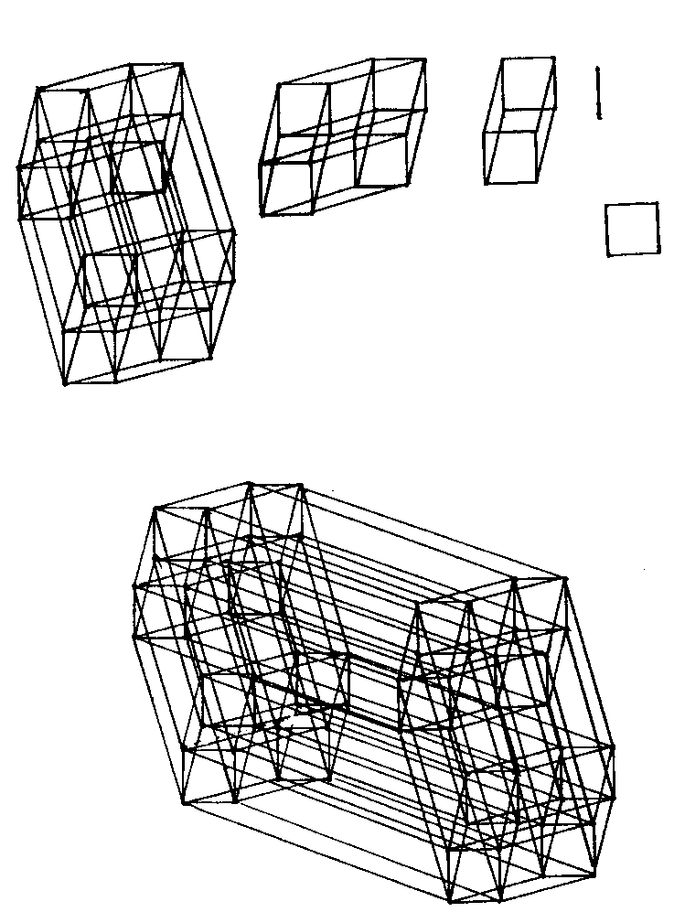
Figure 1

procedure, in that it is not based on the kind of causal implications of anything like the sort one finds in Aristotelian or modern Western logics. (Hall and Ames, 1995:124). From the perspective of correlative thinking, to explain an item or event is to first place it within a scheme organized in terms of analogical relations ... and then to reflect, and act in terms of the suggestiveness of these relations. ... Those who are suspicious of the explanatory force of these ... pseudoscientific schemata are so precisely because such schemes resist causal analysis. (ibid.:125-126.)
According to Fung (1952), the Yijing is one of the few books in the Orient that has no counterpart in the West. The original portion the Yijing - Book of Changes, was written around 820 B.C. and is predicated in part on representing qualitative concepts with binary symbols. The yin-yang system is certainly one of the oldest if not the earliest of works on the subject of change and transformation. Yin, represented as a divided line ( __ __ ) corresponds to 0 and yang, represented as a solid line ( _____ ) corresponds to 1. The sixty-four symbols or hexagrams are each equivalent to six-digit binary numbers depicted as a vertical sequence of divided and solid lines that range from 000000 to 111111 (0 to 63), with the largest binary digit at the bottom or on the left (Figure 2).

Each hexagram is formed by a pair of three-digit archetypal symbols or trigrams, whose digits represent fundamental qualitative measures (Secter, 1997). This simplifies a potentially
Figure 2

complex model by limiting the basic constructs or elements to eight, three-digit symbols with the values 0 to 7: 000, 001, 010, 011, 100, 101, 110 and 111 (Figure 3). This makes it conceptually manageable to think and work in six dimensions by breaking it down into three-dimensional constructs or matrices that interact with each other.
Historically, each symbol was accorded a distinct set of attributes or characteristics, thereby establishing a correspondence between binary or quantitative values on one hand, and descriptive or qualitative values on the other. Some ancient scholar had discovered a way to formulate equivalences between qualitative attributes or values and binary numerical values. The qualitative characteristics for the archetypal trigrams seem to be based on three measures:
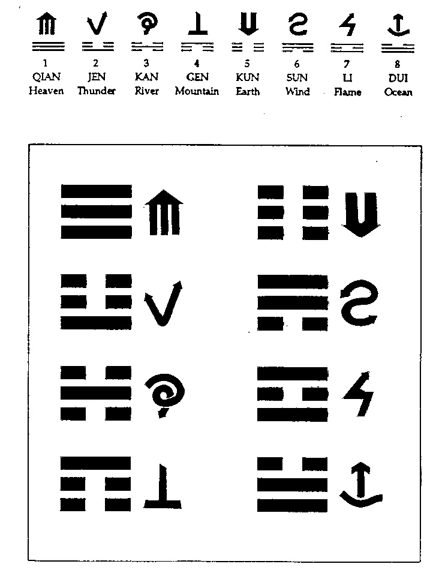
qualitative-quantitative; cooperative-competitive; risk easy - risk averse (ibid.). The sixty-four symbols have traditionally been used to classify, define, and organize information, conditions, and decision-making processes. The result was a of model of probability and change which most people understood or interpreted as divination. It was a system of relative predictability with a framework, constraints, rules, and a process of implementation.
Figure 3

YiJing Background

For the past thousand years yin-yang has played a significant role throughout East Asia. The underlying principles, values, and social implications of the Yijing left the shared indelible imprint of its six-dimensional methodology and philosophy on the cultures of China, Korea, Japan and Taiwan. This paper introduces readers to the Yijing theory of change in general terms, using management and organizational theory as a metaphor to identify or locate some of the systems benefits. To the degree one learns something about this universal Yijing system one will acquire an East Asian perspective on considering, comprehending, and contextualizing change. The yin-yang principles and system can be easily understood and put into practice, making the Yijing ideal as a common frame of reference for discussing, interpreting, and implementing change and for improving understanding, cooperation and collaboration between cultures and across professional boundaries. It already functions in this capacity for a large part of the worlds population.
As a system the Yijing, will provide the discussion of change with common terms and agreed meanings. This would make it possible to minimize misunderstanding and miscommunication in discussing, negotiating, and implementing change, both intra-culturally and inter-culturally. The hexagram symbols express or disclose a method of decomposition in which a unified whole is divided six times in a process of progressive bifurcation. This produces a methodology for making choices and decisions within an implicit matrix in which each resulting unit is 1/64th (1/2⁶) of the total. Because there are sixty-four starting categories and sixty-four possible outcomes, there are 4096 (64²) inter-relationships or interactions that describe basic scenarios or processes of transformation.
This was a system of classification in which the binary numbers possess attributes that do not seem to be assigned randomly, but inherent in the numbers themselves, as the outcome of rules that generated or yielded the numbers in the first place. In this way, the trigrams became the fundamental blocks that informed hexagram meaning according to the various ways they interact in pairs. This creates an applied model of change. The Yijing - Book of Changes provides a system for implementing strategies that deal with change by creatively integrating two three-dimensional matrices. Change is depicted as: a) the dynamic interplay between trigrams, called hexagrams,; and b) as the transformation of hexagrams into other hexagrams according to the rules that govern change.
The first layer of the Yi is probably over three thousand years old and consists of the hexagram symbols (Lynn, 1994:2). The second layer consists of the ZhouYi text or Zhou Dynasty Changes, written around 820 B.C. (Shaughnessy, 1983:49). The sixty-four hexagrams are arranged in a puzzling, apparently non-logical sequence (Figure 4), and together, the text and symbols provide a system for conceptualizing, contextualizing, and engaging change. The third layer is the Ten Wings Confucian Commentary which includes the philosophical ground for understanding the cosmological principles of the Yi system. This material was initially compiled in the 4th century B.C. (Lynn, 1994:2).
The philosophical interpretation of the Yijing can be traced to the seventh century B.C. from which derives its presently proposed use as an ethics-based model for making decisions, structuring problems, planning strategic choices, and implementing action. I am prepared to argue that the profound and mysterious Yijing was originally neither a divinatory work nor a philosophical book, but a mathematical text (Secter, 1998).

Some of the Faces of Change Theory

The Yijing - Book of Changes can be a useful key to understanding the East Asian mindset. The brief texts that accompany each hexagram symbol are cryptic aphorisms that serve as metaphors for contextualizing and negotiating situations by providing a vocabulary for sorting out the relationships among things as they come together and constitute themselves in unique compositions (Fung, 1952: 261).
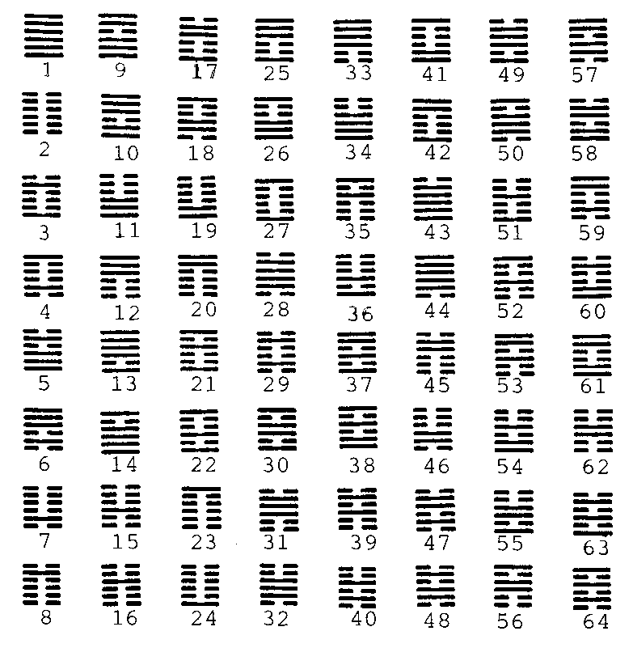
In the 1600s, Jesuit emissaries to China introduced to Europe the major works on Chinese thought and philosophy, including the Yijing - Book of Changes. One of the first to become interested in the Yijing work was Leibniz (1646-1716), one of the great mathematicians and philosophers of the day, who appreciated the work on many levels (Mungello, 1977). Since then, the Yijing has generally been treated in the West as both a book of divination, and as a work that provides oblique insight into Chinese mind, thought processes, philosophy, wisdom, and patterns of communication. The Yijing is an enigmatic text with its symbolic, cryptic, pragmatic, cosmological, and rational sides.
Figure 4
As symbolic, it uses symbols to represent both a formal structure and the qualitative meanings of its constituent components. It is a matrix with sets, subsets, and subsystems that employs non-linear concepts to activate or engage the intuition, so that it participates more fully in creative problem-solving and the decision-making process. In addition, the Chinese written characters or ideograms symbolically convey several layers of overlapping, interpretive meaning simultaneously (Liu, 1974).
As cryptic, it suggests ways of understanding the dynamic conditions of constant change (ibid.) but does not specify what the relevant understandings should be for any particular situation. Not only is the meaning of the text elusive, but the sequencing of the aphorisms and their six-digit hexagrams has presented unique and difficult challenges to all who would attempt to discern a pattern or logic to its order.
As pragmatic it reframes information and concepts by dividing the universe of possible conditions into sixty-four alternatives or classifications, and provides methods by which conditions can be understood as processes of transition from one into to another.
As cosmological, it presents a holistic theory of the operation of the universe in terms of yin and yang energies, which are interpreted as negative and positive energies respectively, somewhat analogous to the negative and positive poles of a magnet. It relates the nature and patterns of change to interconnected relationships in a matrix in which each hexagram has at least six lines of connectedness to other hexagrams in the system.
As a rational system, the hexagrams correspond to the binary values 0 - 63, whose formal rules of connectedness and transformation also apply to the attributes appended to each symbol. What has been understood as divination is actually an articulate methodology for dealing with decision-making.
The Yijing represents the merging of naturalistic philosophy with humanistic philosophy; of existential philosophy with rational philosophy; and of an individual philosophy with social philosophy (Liu, 1974: 319). We can only wonder why this work which has influenced 140 generations of Chinese is largely ignored by the vast majority of those Western scholars in such fields as Management, Organizational Research, Systems Theory and Decision Science who are intent on understanding the East Asian mindset, or who would probably benefit by being better informed in this area.
The Yijing has served as a valued reference and source of reflective advice for rulers, military officers, administrators, bureaucrats, and executives, as well as scholars, philosophers, and lay persons. According to the historical records, it has provided those who sought its advice with a variety of benefits, including a fresh point of view or an added perspective for viewing a situation, considering a decision, or dealing with some matter at hand, all the while doubling as a respected book of philosophy and divination. Western interpretations of Chinese culture must learn to appreciate the correlative mode of thinking if they are adequately to orient themselves with respect to the Chinese world they are seeking to understand (Hall and Ames, 1995:142). This paper would encourage those Western scholars who may be disinclined to give the Yijing a serious hearing because of its history as a method of divination to consider its practical potential in this light.

The Philosophical and Social Syncretism of Taoism and Confucianism

For twenty-five hundred years, two schools of thought have dominated in China: Confucianism and Taoism. To understand East Asia it helps to know something of these two contrasting, and often contending traditions, as well as about the Legalist school of thought whose origins can be traced to the seventh century B.C. Basically Confucians who sought the meaning of life by appeal to family and social obligations were opposed by those Taoists who sought to attune the human world to the regular rhythms of nature (Hall and Ames, 1995:203).
The common theme that runs through Confucianism, Taoism, and Legalism is the concept of self-regulation, with each school of thought differing in the way it wanted to accomplish this. And all three proposed adapting to changing times, but they interpreted this in significantly different ways. The Taoists held to an unbiased and impersonal view of social systems and a detached interest in the affairs of man. Their fundamental notion of personal growth was expressed through a self-cultivation that emanated from the individual and eschewed ritual. Each individual assumed personal responsibility for developing spontaneity and harmony with the natural order of things, disciplined oneself to live with uncertainty, and regulated oneself to live in harmony with nature. Taoism reflected an unconventional, anarchist, and asocial philosophy that derived from a notion of society as natural and non-authoritarian that is both horizontal and radically perspectival (Hall and Ames, 1995:237).
According to the Confucian school of thought, self-regulation can be summed up as filial piety and fraternal deference. It embodies four vertical relationships: ruler to people; husband to wife; parent to child; and elder to younger; and one horizontal relationship, between friends. Confucians advocated a code of loving others or ai jen (Tu, 1985: 84). This occurs within the social and ethical bond that allows ones own person to be defined by reference to those he loves (Hall and Ames, 1987:120-121). Whatever its origins, this was an intricate web of relationships and mutual obligations. Its primary unit of cohesion was the family, and it served to enhance predictability and reduce uncertainty. This web was extended to the clan, the group, the organization, and the state (Ames, 1983), thereby leading to social systems that were naturally self-organizing, and to governance that theoretically at least, would be intrinsically well-ordered, providing a form of social cohesion based on self-regulation and hierarchical obligation.
Confucian social organization was based on benevolence and ethics, and advocated observance of ritual that did not disrupt spontaneity, in which permissible choices were constrained by the parameters of conservative Confucian values (Ames, 1983:32). Taoism modeled its action on the principle of wu wei, or action without intention (ibid.: 41). Taoist behavior was authentic, spontaneous and natural, constrained by universal principles rather than social conditions, making it quite unpredictable. And yet Taoism and Confucianism both discussed government from the point of view of the people.
Legalism was the third school of thought that has maintained an ongoing influence on Chinese mind and management throughout the centuries. It some ways it was a hybrid of Confucianism and Taoism, and yet it opposed them both in the way it discussed government wholly from the viewpoint of the ruler or the state (Fung, 1952:312). More to the point, Legalism differed from Confucianism ... by beginning its social thinking not with the people but with positive laws and sanctions (Hall and Ames,:203). Moreover it urged the overthrow of the old, and attacked the custom followed by all the philosophers from Confucius downward, of seeking examples in antiquity to support ones arguments (Fung, 1952:316). Legalists also took an aggressive posture toward problem-solving that focused on efficiency and tended to extremes, approaching self-regulation vertically from the top-down (Ames, 1983:11).
The Legalists advocated a system of control that compelled and enforced order and efficiency through adherence to administrative policy, and imposed policies with a body of strictly enforced and universally applicable laws. They adopted the Taoist concept of a Heaven that rules the world with dispassion, and transformed it to justify dispassionate and oppressive rule of the people, with severe punishments employed to inspire compliance through fear. The Legalists adapted many other Taoist ideas to their own ends.
The yin-yang system as depicted in the Yijing, was apolitical. It had no policies, no laws, no rules, conventions, or specific agenda. Not only did it meet little if any resistance, but it became accepted by all three schools of thought as the common ground and cultural mediator. One could speculate that it was: prized by the Confucians for its ethics, implied social structure, and its historical pedigree; cherished by the Taoists for its cosmology and spontaneity; and was attractive to Legalists because of its formal structure and order. It is useful to understand that over a considerable period of time Confucianism was able to accommodate certain significant aspects of Taoism, Legalism, and the Yijing, leading to the neo-Confucian cultural synthesis that was traditionally known as the School of the Study of the Tao (the Way or Truth 13)(Fung, 1953:407).
In the eleventh century the ethicist and metaphysician Zhou Dun-yi (1017-1073), and cosmologist, Xiao Yung (1011-1077), became the most conspicuous neo-Confucians to borrow from Taoism (Fung, 1953, and Chan, 1963:460). A central theme was Zhous concept or theory inspired by the Yijing, that the many are [ultimately] one, and the one is actually differentiated into many, and that the one and the many each has its own correct state of being (Chan, 1963:460). A hundred years later, Zhu Xi (1130-1200) brought the development of neo-Confucianism into a harmonious whole and gave it new meaning which has influenced East Asia ever since (ibid.: 588-89) 14.
About the time of Zhu Xi, neo-Confucianism became known as Li Xue or school of principle (ibid.:751 and Fung, 1953:500,) and its variant, Xing Li Xue, School of the Study of Nature and Principle (Chan, 1963:14)15. Two other important influences were brought into the Confucian fold and integrated into neo-Confucianism; these were Buddhism, which arrived from India about two thousand years ago and became quickly tempered by Taoism; and the Legalist school of thought that originated seven hundred years earlier (ibid.:252) 16. There has been no Legalist presence for two thousand years but its influence has been continually present in the neo-Confucian synthesis that has continued exerting its combined, integrated influence for the past thousand years (Hall and Ames, 1995). This synthesis has proven to be a flexible, resilient, and viable cultural model that has provided a body of philosophical and cultural values that provided the framework for an evolving Chinese culture and extended to influence the cultures of Korea and Japan. Since the time of Zhu Xi, neo-Confucianism has defined the shared social and cultural consciousness of East Asia.

Yin-Yang as a Management Paradigm: a Window of Opportunity

Scholars publishing in management journals and journalists writing for responsible magazines often seem to miss the syncretism and focus on traditional Confucianism to the exclusion of Taoism. Some of the differences can be perceived in the traditional approaches Confucianism and Taoism took to interpreting the Yijing 17
The Yijing can be understood in several important ways.
1. It is a sophisticated communication model.
2. It functions like an expert system and case study reframing device
3. It is a contextualizing executive system.
4. It is a model of probability and change theory.
5. It is a cybernetic or semiotic system of symbolic reference (Cheng, 1991: 169).
Valued as a communication model it clearly has more in common with information theory than it does with divination. The sixty-four binary hexagram sets imply an internal matrix structure and an opportunity to form a conceptual transference between the Yijing and information theory.
It functions like an expert system in that it helps decision-makers reframe ideas by establishing a referencing with a body of constant qualitative decision parameters. This provides decision-makers with fresh points of view for considering issues by providing theoretical contexts and hypothetical processes. Moreover, it operates as a case study model in which a presumably competent agent formulates a relevant issue or inquiry. The system provides decision-makers with a viable decision framework in which the agent adapts or frames an inquiry according to the descriptive constraints that the system provides and the system in turn rewards the agent with a response that can be adapted to the inquiry.
This compels agents to recontextualize their ideas and to think about problem solving and strategies from fresh, often unexpected or unconventional perspectives, perhaps sufficient to give creative decision-makers a competitive edge.
The Yijing is an executive system that contextualizes information in concise, well-organized, albeit apparently enigmatic packets. Through practice with the system though, agents learn to comprehend actual conditions in terms of its classes or categories and their links to each other; and through experience, to interpret these networked packets or texts according to particular interests and specific (organizational) conditions. Agents receive one of 4096 response processes which provide them with a focal point and context. They in turn must assume full responsibility for making decisions and acting on those decisions.
It is a model of probability and change theory in which the unfolding transformation of conditions occurs according to established rules. These serve as parameters which depict change as transitions between two basic conditions: an existing one in present- time and a another one in future-time. In principle this reduces uncertainty. One way of providing a measure of predictability is by organizing outcomes into groups. These are based on the probability of obtaining a particular hexagram as a descriptive starting point; and the degree of proximity that it has to the transformed or ending hexagram.
It is also a semiotic system. The key to interpreting the symbols is found in the three-line trigrams. These are archetypal models for representing fundamental information according to three measures: qualitative-quantitative; cooperative-competitive; and risk easy-risk averse. Each hexagram can be understood in two basic ways: 1) as depicting an interaction between two parties, between a party and some condition or process; and 2) as depicting or describing a single party, state or process, in which case one trigram represents its internal or formative transactions (what comprises it), and the other represents its external or relational transactions (how it interacts, operates, or behaves).
The Yijing represents an expanded shift from a form of thinking that is linguistically analogical to one that is symbolically analogical (Liu, 1974). This moves the focus away from a methodological, goal-oriented, problem solving one to a cybernetic, relational, and process-oriented one, in which universal laws become a model for human actions (Fung, 1952: 390). In the Yijing system, information is implicit or inferred and compels interpreting agents to be fully attentive to nuance and context. A fuller appreciation for historical context of the Yijing and an understanding or grasp of its significance and its potential can provide valuable insight into the dynamics that frame the cultures of East Asia (Reischauer and Fairbank, 1960).

Yin-Yang Cosmology and Management

The Yijing probably took its final form during the third century B.C. but almost certainly required a thousand years to evolve up to that time (Liu, 1974). During the Warring States period (403-221 B.C.) it was enriched by the Taoists who had always accorded with its fundamental philosophy, and by the Confucians, for whom its moral aesthetic had a strong appeal. Perhaps one of the reasons the text and system survived was its inherent vagueness. This should not to be considered as a limitation since is probable that such vagueness accomplished for China what was achieved in the West by dialectical accommodations of distinctive viewpoints (Hall and Ames 1995:104). The Yi addresses transformation and change metaphorically, presenting paradigms for developing a thematic or totemic model that can be used for dealing with uncertainty when clear alternatives or courses of action are not obtainable by conventional means (ibid., 1995). It could be called a paradigmatic example of non-specific intervention.
The Yijing provides a method for dealing with decision-making under stress and duress, as well as in situations with significant unknowns, or with inherent complexity. This can help alleviate administrative perplexity, uncertainty, and frustration, and prevent the problems that can result from not being decisive when action is required. The Yi system can also provide agents with the confidence to act boldly, especially in situations where indecision and inaction would be problematic. In such cases the very act of decisiveness could transform an impossible or disastrous situation into one that is manageable.
The conditions that govern management and administration are generally universal, after compensating for culture. The Yijing notes (in the Great Appendix of the Ten Wings) that one who intuitively grasps its system can come to an understanding of all the principles in the world. As such, the paradigm of the Yijing mode of thinking is a universal feature of Chinese philosophy (Cheng, 1991: 15), advocating the middle way between extremes when dealing with things. Essentially it is a tool for reorganizing what appears to be chaos into a model of manageable and contextualized order. Although one of the purposes of the book is divination and fortune-telling, it does not require a large conceptual leap to reframe prognostication as a form of randomly generated predictability.
In planning and pursuing objectives, experienced managers, administrators, and other decision-making agents usually attempt to minimize uncertainty by planning for ways to anticipate and respond appropriately to the unexpected. The Ten Wings Commentary illumines the role of decision-makers with such advisory counsel and caution as:
- He who is conscious of danger creates peace for himself; he who takes things lightly creates his own downfall (Wilhelm, 1950: 353);
- Movement and rest have their definite laws, Events follow definite trends (ibid.: 280);
- by means of the easy and simple we grasp the (whole) (ibid.: 287); and
- the usefulness of the Yijing is related to clear-mindedness (ibid.: 317).
The concepts that link the Yijing to management are also found in the titles and texts of the sixty-four hexagrams, which cover such topics as: #23 - Separation (breaking apart), #3 - Difficulty at the Beginning (starting or initiating something), #6 - Conflict, #31- Penetration (undue or covert influence), #33 - Withdrawal (retreating or abandoning), #38 - Opposition (confronting opposition), #46 - Striving (making concerted effort), #51 - Thunder (dealing with shock or surprise), and #56 - Journeyer (making the best of things under foreign conditions or in an unfamiliar environment. They all themselves to broad interpretation, and as contexts they can be applied to a complete range of the situations and conditions that individuals and organizations might expect to encounter.

Determination and Divination: Probability of Potential Outcomes

The hexagram symbols and their aphoristic texts represent primary conceptual categories into which virtually any condition can be classified, grouped, or referenced. This process ontology of the Book of Changes provides a methodology which contextualizes that which is unknown or unclear to a system that is known and clear. Briefly, the Yijing creates a parallel between itself as a general or generic model, and the actual (or imagined) condition as a specific model. It then develops an analogy that forms a bridge between its own general vagueness on one hand, and the specific vagueness or uncertainty of the actual condition on the other hand. Clarity is provided by the agent who brings the resources of a cultivated consciousness, and experience with the Yi system to bear on the issue.
Because all things are located and derive meaning by virtue of their relationships, a condition that is unclear must have a context that is unknown, uncertain, or obscure. In geometry, one can determine properties of various forms with only limited information. The Yijing is a system of conceptual mapping that functions in a similar way. When the principles of change are known, and the rules of hexagram proximity or linking understood, a condition can be archetypally contextualized, its primary avenues of transformation ascertained, and the most probable paths determined with a high degree of reliability 18.
Each hexagram is a data-sphere with specific relationships to all other hexagrams. By establishing an accurate description for a particular if condition, it is possible to deduce a set of probable outcomes. Two ways these can be ascertained are by random generation (divination), and by rational determination (description). Both approaches identify a hexagram that represents the initial if condition, and one hexagram that represents the consequent then condition; however they do it from different perspectives. In those cases where there is no significant or relevant change within a given or proscribed time, both conditions are traditionally represented by the same hexagram.
Divination Mode: Using the traditional divination mode the agent employs a method of random generation (traditionally using sticks or coins) to select a hexagram that establishes an unplanned perspective from which to evaluate or consider a given condition. This randomly selected hexagram serves as a lens or prism through which to evaluate or consider the situation at hand. The random process may also describe mutations that results in one hexagram changing into a consequent then condition, which forms part of the overall prismatic process of contextualizing and considering the situation. Essentially, divination provides a way of thinking in which intention and desired outcomes become subsumed under the process of engagement and resolution. An optimal outcome is one that eventuates when the divined process is managed well.
Essentially, divination or random generation removes the agent from choosing the hexagrams that form each decision-framing process, either consciously or unconsciously. A completely unexpected perspective or outcome scenario is introduced for each situation or query. The agent is not only precluded from injecting a personal desire or agenda into the but is provided with a process that necessitates an immediate, unplanned interpretation and resolution; that is, a fresh orientation, and spontaneous, creative approach to dynamic problem solving. The agent must also present the information in a way that is consistent with the hexagrams and germane or relevant to the issue; and then recommend or initiate an appropriate course of action.
According to traditional Chinese thought, Yijing divination establishes the optimal framework for a given situation from the universal point-of-view. As such, these scenarios should be treated seriously, not as answers, but as perspectives that govern the decision process and the ensuing action. In his foreword to Richard Wilhelms translation of the Yijing, Carl Jung, the eminent psychiatrist, attributed the random divination process in which a query is matched with a hexagram, to the operational realm of the collective consciousness (Wilhelm, 1950). Although this method of generating hexagrams may seem to occur as if by chance, Jung referred this as equivalent to causal explanations (ibid.: xxv). That is, he considers it to be a process of synchronicity acting on the unconscious within the psychological phenomenology of the Yijing. This effectively reframes each issue or condition as one of sixty-four image-sets changing into one of sixty-four image-sets. Each response is not an explanation of a situation but a perspective on that condition.
Descriptive Mode 19: Using the Yijing in its descriptive mode, an agent defines a situation or issue in terms of an actual or probable starting condition and a preferred or expected ending condition. The hexagrams that represent both conditions are elicited indirectly by framing both conditions in terms of pairs of trigrams. Each pair represents the main parties or elements to the situation. The trigrams are chosen by approximating or matching the qualitative characteristics for the parties or elements to the attributes of the trigrams. A confirmation procedure is performed to assure that the hexagrams formed by the selected trigrams accurately reflect the starting and ending conditions. Alternatively, the agent can also employ a questionnaire to determine the trigrams for each condition 20. This is essentially a process of induction and not intuition.
The starting-ending spectrum reveals the proximity of the two conditions and the path or process between those conditions for each specific if-then scenario. Since each hexagram is also a binary number, an example of this proximity is made quite easily. Maximum proximity occurs when two hexagrams have five common digits such as 110010 and 100010; and optimum proximity exists when there are four common digits such as 110010 and 100110. In both cases the starting and ending conditions have the majority of their attributes in common. But when the starting condition is 110010 and the ending condition is 111100. This indicates a proximity of 3 or 50% which is just manageable or negotiable. Alternate ending scenarios can be created and compared, providing the agent with choices, but fewer than four common digits is seriously problematic and discouraged.
There is a variation of the descriptive mode, in which the agent defines a hexagram for the starting condition, and then identifies the six hexagrams that form the primary links or paths of transformation, or those obtained by altering only one of its six binary lines or digits. A discerning agent can then select which one of the six has the most appeal as an outcome condition. An enterprising agent can even explore the five other hexagrams with maximum proximity to that hexagram (note that the sixth is the same starting hexagram) to determine if there is a desirable or promising development 21. By limiting the descriptive mode evaluations to only one or two changes an agent can plan a course of action that offers a statistically higher probability of success or achievability than those processes that would involve changes in larger numbers of variables.

Hypothetical Example Using Yijing Description and Divination

The following example was created to provide the reader with an idea as to how the Yijing system can be used to contextualize and frame conditions. It is first necessary to form a query, but before that, a minimum amount of knowledge and information about trigram attributes is requires. For that purpose an abbreviated table of attributes is provided in Table 1. Consider that Parties A and B want to develop a co-venture and maintain an ongoing collaborative relationship and with each other. Assume they are well matched in terms of experience, equity, and resources. The query: In what way might their significantly different organizational cultures complement each other and be an asset, or a conflict and be a liability? or From a cultural point-of-view, how would these parties fare in a collaborative venture? To that end we will ascribe certain attributes to each party.

Descriptive Mode
Party A has strong, outgoing communication skills, and technological expertise. It is resourceful, versatile, and able to manage several new ventures simultaneously. It has an ability to change course with short notice, and can act quickly to cut its losses or generate returns on its investments. This equates to trigram 100, the symbol of Thunder. Party B is more grounded. It develops new projects, one at-a-time, after lengthily deliberation and consensus building. It usually plans far into the future, doesnt like to take chances, and is proud of its stability and dependability. This closely relates to trigram 001, the symbol of the Mountain. These trigrams combine to form two hexagrams, 100001 and 001100 22.
Hexagram 27, Sustenance and Nourishment is 100001 (33).23 Thunder, the first three digits is internal, and Mountain, the last three digits is external. This suggests an auspicious partnership if Party A manages the internal transactions, or relationships and activities within the organizational structure such as personnel, product development, and production, while Party B manages the external transactions or relationships with outside parties, such as suppliers, customers, and regulating agencies. The alternative is hexagram 62, Restraint and Insufficiency, 001100 (12), which has the trigrams reversed. This scenario suggests a partnership with problems from the start due to some deficiency or hindrance.

Table 1

An outline of the attributes of the four matter-based archetypes
Kun (kun) | Gen (geun) | Kan (kan) | Sun (swun)
000 | 001 | 010 | 011
0 | 1 | 2 | 3
sinking down | pressing down | swirling down | blowing down
accessible | impenetrable | penetrable | impermeable
all-encompassing | immovable object | assimilating | ephemeral
shapeless | massive | flowing | twisting
amorphous | resisting | coursing | elusive
spreading out | heaped up | delimited | unbounded
indefinable | piled | contained | billowing
all-absorbing | protective | confined | fanning out
encompassing | calm | easily confused | pliable
diverse | introspective | provocative | supple
divergent | dedicated | adaptable | resilient
accepting | principled | adjustable | multi-tasking
yielding | dependable | restrained | purposeful
open-hearted | humble | easily frustrated | reticent
maternal | faithful | tactical | proud
sheltering | responsible | expedient | surreptitious
humane | helpful | wild | secretive
nourishing | encouraging | courageous | clandestine
natural | ethical | brave | persistent
accommodating | immense | unpredictable | cerebral
unflappable | immovable | adventurous | seductive
undisturbed | self-assured | fearless | sinuous
unconcerned | unintimidated | welcomes risk | influencing
free of agenda | service oriented | ingenious | designing
----------------
mother | youngest son | middle son | eldest daughter
ample / huge | solid | portly | shapely
abundant | heavy | stocky | voluptuous
cow | dog | wild boar | rooster
soil | stone /mineral | timber /logs | trees/plants
pitch black | green | bright red | white /silver
early autumn | early spring | winter | early summer
southwest | northeast | north | southeast
An outline of the attributes of the four energy-based archetypes
Qian (chien) | Dui (dway) | Li (lee) | Jen (ren)
111 | 110 | 101 | 100
7 | 6 | 5 | 4
pressing forward | ascending | flaming | recoiling
Propelling | embracing | blazing | electric
irresistible force | receiving | incinerating | magnetic
dispassionate | overwhelming | intellectual | independent
autocratic | indifferent | explosive | individualistic
analytical | self-indulgent | temperamental | enterprising
despotic | tempting | equilibrium | enthusiastic
efficient | insensitive | self-control | stimulating
oppressive | immense | intelligent | encouraging
overpowering | provocative | schrewd | changeable
hard | daring | warm | personable
lean | defiant | friendly | charming
muscular | manipulative | energetic | inspiring
combative | teasing | cerebral | persuasive
unyielding | audacious | perceptive | convincing
controlling | impudent | methodical | creative
authoritarian | presumptuous | supportive | inventive
tireless | bold | insecure | exciting
impassive | immodest | vulnerable | instigating
contending | desirable | engaging | communicative
demanding | appetizing | alluring | arousing
inflexible | rash | dependent | adaptable
merciless | arrogant | passionate | swift
relentless | tempting fate | piercing | versatile
predictable | foolhardy | securing | resilient
prepared | inexperienced | tactical | elastic
----------------
father | youngest daughter | middle daughter | eldest son
blasting off | ascending mist | rising light / heat | rebounding
muscular | ripe | lithe | athletic
virile | nubile | impassioned | stimulating
unimaginative | sensual | spirited /spicy | ingenious
lean horse | sheep /goat | pheasant | dragon / reptile
metal | pond /evaporation | flame | grain
deep red | blue | yellow | deep ochre /orange
early winter | autumn | summer | spring
northwest | west | south | east

The bold names are Chinese pinyin spelling; the word in parentheses is the pronunciation.

The six discrete links" to hexagram 27 are examined with the most promising ones shown in italic type.24 The links are hexagrams: 23, Downfall - 000001 (1); 41, Decrease - 110001 (49); 22, Naturalness - 101001 (25); 21, Breakthrough - 100101 (37); 42, Increase - 100011 (35); and 24, Turning Point - 100000 (32). The last three (bold) require Party B to become less rigid and make an adaptation within the partnership, from 001 (Mountain) to: 101 (Fire and Light); 011 (Wind and Wood); or 000 (Earth). The five remaining links for Breakthrough are: 35 Progress, 38 Stalemate, 30 Attachment, 25 Naturalness, and 51 Provoking; for Increase they are: 20 Composure, 61 Instinctive, 37 Kinship, 25 Naturalness, and 3 Initial Difficulty; and for Turning Point they are: 2 Fruition, 19 Opportunity, 36 Constraint, 51 Provoking, and 3 Initial Difficulty.
Of the three second generation bold outcomes (potentially the most promising), two belong to hexagram 24, Turning Point: 2 Fruition or reaping the fruit of effort; and 19 Opportunity, the prospect of reaching an objective. Once the collaboration is established these outcomes are based on Party B enacting its cultural change first, and Party A then adopting its cultural change. If however the parties set their sights on 2 Fruition and Party A happened to change sooner that Party B (very possible since A acts more quickly than B), then the transitional result would be 23 Downfall. This may be too great a risk.
A cautious agent might recommend 19 Opportunity, avoiding any Downfall. Also if Party A happened to modify its culture prior to Party B, the partnership would attain its Opportunity through Decrease (which may not be a setback but a downsizing in structure or goals) instead of through Turning Point, which requires Party A to change from Thunder 100, to Lake 110, a more easy-going and less intense profile. This proposal requires both parties to modify their basic organizational cultures and adopt a modified cultural profile within the partnership. But the synergy indicates a positive result. With this elementary cultural or qualitative mapping device both parties can embark on and negotiate their collaboration with increased understanding and assurance. An actual cultural mapping would provide the parties with a more thorough analysis of their profiles and options 25.

Divinatory Mode

There are two main methods for generating hexagrams; the older, more orthodox method uses fifty sticks; the simpler and less orthodox method uses three coins 26. The three coins are dropped and the sum is added. with heads counting as 3 and tails as 2. When the total is odd (7 or 9) the binary digit 1 is noted; when it is even (6 or 8) the digit is 0. If the sum is 6 or 9 the digit is emphasized, indicating the digit will mutate or change in value from 1 to 0, or 0 to 1. This process is repeated a total of six times to create the six digits of the starting hexagram. When this was done for the above query, coins generated hexagram 10 Audacity or Boldness - 110111 (55). This does not describe the situation or parties, but provides a perspective from which both parties can consider the collaboration.
The aphorism for hexagram 10 reads (Wilhelm, 1950:44):
Treading on the tail of the tiger.
It does not bite the man. Success
This suggests that: a) the partnership itself is in some way daring and bold; or b) that the partnership could be successful if it takes a calculated risk and acts with daring and boldness. The agent would have the information to determine which applies in this case.
The specific text for the underlined 0 in the 3rd position from the left reads:
A one-eyed man is able to see, a lame man is able to tread.
He treads on the tail of the tiger. The tiger bites the man.
Misfortune. Thus does a warrior act on behalf of his great prince.
This indicates embarking on something without the full capability to accomplish the objective. The prospect of failure or disaster is extremely high, with an outlook ranging from dismal to ominous. Going ahead with a plan with this less-than-promising outlook can only be justified when the purpose is much larger the personal or immediate interests of the actors, such as in the service of ones country. Interestingly, the ending hexagram (the then condition) is the Creative or Substantive, 1 - 111111 (63), a symbol of strength and dominance with the largest binary value. This suggests that a party that manages to survive such a difficult experience will be like forged steel - much stronger for the experience. In this case, a responsible agent would probably recommend against the partnership.
When working with the Yijing (either divination or description), the main thought to keep in mind is that it serves as a framing device which can be used for considering and evaluating situations. For one who is familiar with the system and the language of the Yi, its success may reside in the manner by which it takes a situation and randomly introduces one or more perspectives. This will be meaningful to an agent who is familiar with the Yi system with regard to both its content meaning and context meaning. The primary thrust of the Yijing exercise is to expand or open up the problem-solving and decision-making options by interjecting an unexpected orientation into the deliberation process.
This method colors the consideration process with the notion has anyone thought about this before? If one keeps in mind the adage of Murphy's Law, that if anything can go wrong it will, then important decisions should not fail to contemplate any eventuality. Seen in this light, the Yijing is a gatekeeper whose usefulness lies in institutionalizing reminders which agents include as unlikely and unexpected possibilities in their thinking.

CONCLUSION

Given the serious commitment of the ancient Chinese to carefully observing nature and the cosmos, and the accuracy with which they recorded their observations, we should not be surprised that they devised a system such as the Yijing system to express their understanding of the principles that governed change as they grasped it. The Yijing model comprehends the universe as processes of transformation between pairs of transitory states or conditions expressed as binary values. These binary values permit a standardized system of referencing and comparison. Not only does the Yijing present a way to represent external events as change processes, it also offers a way to conceptualize internal events.
Traditionally, one identifies an issue or concern; clarifies it; and then frames it as a query. A random response provides a unplanned, qualitative lens through which to contextualize the issue and develop a hypothetical or actual course of action. This provides a creative approach to considering choices and alternatives, and precluded those problems inherent in being presented with a limited set of available choices, options, or strategy. It also reduces the chance of someone imposing or push a personal agenda.
This system utilizes texts and symbols to convey ideas in the form of symbols and text. These are linked in a multi-dimensional matrix. Interpreting the meaning of each symbol is in part a function of the hexagrams to which it has direct links. The meaning of each symbol is informed internally according to the attributes of the lines that compose it, and externally according to the symbols it is related to in one way or another. These are its internal and external transactions.
The Yi is a sophisticated matrix with multiple interconnections so that no symbol is further than six edges from any other symbol, so that even when several connections are lost or broken, the integrity of the system is maintained. The nature of decision-trees is such that there are no feedback loops or secondary links; and when any branch is severed, everything below it becomes disconnected from the system. In most hierarchical models and decision-tree systems, each choice limits the number of alternatives or subsequent choices, whereas in the Yijing matrix all options are constantly accessible or available, both conceptually and structurally or systemically.
This approach provides a common language for modeling change; a conceptual Esperanto or lingua franca in the same way that English is the language of international communication. If the conceptual framework of the Yijing is adopted as the international standard for contextualizing and framing change, it would bring a model of change that has stood the test of time and one that has been used by rulers, administrators, governors, generals, scholars and industrial leaders for over two thousand years as a method for dealing with decision-making and change. Moreover, an understanding of both descriptive and divinatory modes of using the Yijing would give deeper insight into Asian ways of planning, decision, and action.
The Yijing can offer several benefits to organizational problem-solving and managerial decision-making. but first it may be interesting if not productive to note that the Yijing arguably gives East Asians a culturally inherited method of mental mapping, relating, and strategic planning, that is coincidentally compatible with digital information and communication technology.
1. It compels the decision-maker to examine an issue from an unexpected perspective.
2. The new perspective represents a fundamental reframing of the issue.
3. The reframing generates and encourages a fresh line of thought.
4. Fresh thinking in turn fosters creative alternatives or solutions.
5. This process reduces the chance of getting stuck in a procedural or conceptual rut.
6. Historically, the Yijing process discouraged agents from imposing their own intention on problems-solving and decision-making.
7. Responsibility for the actual course of action is up to the parties concerned.
Each text received through divination is usually enigmatic, requiring an experienced agent - decision-maker to make it relevant 27. Responses are not absolute, definitive, or static, but are flexible, adaptable, and process-oriented within a continuous, evolving transformation. The Yi is an applied model with a theory of change governed by specific principles. These serve as operational laws rather than as rules, that reveal the possibilities and probabilities of transformation between two hexagrams (i.e., two states or conditions).
The overall Yijing process reduces uncertainty by providing contextual meaning. More importantly, the process is reversible, meaning that outcomes can be reconstructed to determine how they might have come about, or what led to them in the first place. The same process can be used for unraveling any given condition to make it meaningful or understandable. Both the hexagram name and its text are metaphors that speak directly to issues that impact on management and administration, such as problem-framing, planning courses of action, choosing alternative, decision-making, and enacting decisions.
To the extent that one is able to frame conditions in terms of the Yijing system it will be possible to rethink and explore decision-making from an East Asian perspective or context. This increased sophistication offers real promise of improvement in mutual understanding,
communication, and collaboration. Thus, the Yijing discloses itself as a relational system, a cohesive matrix, a multi-dimensional model, and the basis for problem-framing and decision-making methodologies. The challenge is to put it to good use.

References

Ames R. T. (1983), The Art of Rulership: A Study in Ancient Chinese Political Thought.
Honolulu, University of Hawaii Press.
Chan W.T. (1963a), A Source Book in Chinese Philosophy. Princeton, Princeton University
Cheng C.Y. (1991), New Dimensions of Confucian and Neo-Confucian Philosophy. Albany,
SUNY.
Cleary T. (1986), The Taoist I Ching, Boston, MA., Shambhala
Cleary T. (1987), The Buddhist I Ching, Boston, Shambhala
Fung Y.L. (1948), A Short History of Chinese Philosophy. translated and edited by Derk Bodde.
New York, MacMillan Publishing.
Fung Y.L. (1952), A History of Chinese Philosophy, Vol. 1. translated and edited by Derk Bodde, Princeton, Princeton University Press.
Fung Y.L. (1953), A History of Chinese Philosophy, Vol. 2. translated and edited by Derk Bodde, Princeton, Princeton University Press.
Hall D.L., Ames R.T. (1987), Thinking Through Confucius. Albany, SUNY.
Hall D.L., Ames R.T. (1995), Anticipating China. Albany, SUNY.
Legge J. (1963), The I Ching: The Book of Changes, New York, Dover.
Liu S.H. (1974), “The Use of Analogy and Symbolism in Traditional Chinese Philosophy.”
Journal of Chinese Philosophy. v1n3/4, p313-338.
Lynn R.J. (1994), The Classic of Changes: A New Translation of the I Ching, New York, Columbia UP.
Mungello D.E. (1977), Leibniz and Confucianism The Search for Accord. Honolulu, UP of Hawaii.
Reischauer E.O., Fairbank J.K. (1960), A History of East Asian Civilization. Boston, Houghton Mifflin.
Secter M. (1998), “The 'Zhou Yi' Hexagram Sequence: An Authentic, Intended Binary System Discloses A Rational, Bilateral Mathematical Symmetry.” The 8th International Conference on the History of Science in China. Berlin, 1998.
Secter M. (1997), “Culture’s Eloquence: Reframing Organizational, Culture by Consolidating Hofstede’s Four Dimensions Into Three.” currently in the Journal review process (pp 1-36)
Secter M. (1993), I Ching Clarified: A Practical Guide. Boston and Tokyo, Tuttle (also in
German, I Ging Handbuch, Diederichs Verlag, 1984).
Shaughnessy E.L. (1983), The Composition of the ZhouYi, (Ph.D. Dissertation, Stanford), Ann
Arbor, Michigan, University Microfilms International.
Tu W.M. (1985), Confucian Thought: Selfhood as Creative Transformation. Albany, SUNY.
Wilhelm R. (1950), The I Ching: or Book of Changes. translated by C.F. Baynes. Princeton, Princeton University Press.

Some Interesting and Helpful I Ching References on the Internet
http://iching.princeton.edu/ (Columbia Univ. Multimedia I Ching)
http://www.iching.com/interviews/pobarticle.html (I Ching & Synchronicity)
http://www.iching.com/oracle/oracle_ad.html (Oracle)
http://www.infinite.org/bioching/numbers.html (Interesting Articles)
http://members.aol.com/IChing1/atoj.htm

Table 2

http://members.aol.com/IChing1/ktoz.htm
http://pacificcoast.net/-wh/index.html#Transl (The I Ching on the Net)

Acknowledgments
I am especially grateful to Jan Walls, Director of the Asia - Canada Program in the Faculty of Arts at Simon Fraser University, and Director of the David Lam Center for International Communication at SFU, and to Greg Tropea, Professor of Comparative Philosophy and Logic, California State University at Chico, for their careful readings and constructive critiques of this paper. I also want to acknowledge the insightful comments from Errol Cowan, Professor of Planning at the University of Virginia, from Roger Ames, Professor of Chinese Philosophy at the University of Hawaii, and from the reviewer(s). This paper is much improved because of them. The author takes full responsibility for the errors that remain.
Notes:

The word "hexagram" was coined by the British sinologist, James Legge, the first person to translate the complete Yijing into English (1899). The word "hexagram" refers to the symbols composed of six divided and solid lines (binary 0 and 1). These are stacked one above to comprise each hexagram.
. There are several translations of the Yijing (I Ching) available in most languages, as well as a number of interpretations derived from one or more of the translations. In addition there are books that explicate the Yijing, and also books on other subjects that relate to the Yijing. Most traditional Yijing books are grounded in philosophy and cosmology within the larger context of divinatory decision-making. A few books are related to science (DNA, new physics, and complexity theory). Most translations of this enigmatic text are responsible works which are necessarily interpretive and by definition philological (linguistic). The two best known works are by James Legge (1899 and 1963), and Richard Wilhelm as translated by Baynes (1950). A few others are listed under References. The same cannot be said for many of the interpretations. While most may be sincere efforts many seem to be highly subjective, inspired by personal and social interests or agenda, and by intuition, rather than an understanding of Chinese philosophy and thought, and the disclosure of the original text. As a result, most do not present a reasonable or accurate interpretation of the Yijing text.
. E. Shaughnessy (1983:49), established the dating using historical data and philological methods. The original two layers of the text are called the Zhou Yi (Zhou Dynasty Changes). History attributes the writing of the first layer to King Wen (1171-1122 B.C.), and the second to his son, Duke Zhou. It is possible that the book apparently written around 820 B.C. was a rewrite of an earlier now lost version.
. Although the Yijing enjoys a high reputation throughout East Asia, most people know of it primarily as a book of divination, which is popularly interpreted as fortune- telling. This divinatory use, which usually seems to be associated with decision-making, can be traced back to the earliest records of the Zhou Yi.
. The Yijing is one of the five original Chinese Classics, and was rendered into accessible European translations only in the last hundred years. The introduction to the book by Richard Wilhelm in 1929 (Wilhelm/Baynes, 1950) by the renown psychiatrist, Carl Jung, has helped the book achieve a sustained level of popularity and notoriety in Europe and America.
. Leibniz is known among other things, as the inventor or binary numbers, and the independent co-discoverer of the calculus. The other co-discoverer of calculus was the Englishman, Isaac Newton.
. Within two hundred years of Confucius' death a set of appendices had been written by the Confucian school, called the Ten Wings. After it was appended to the Zhou Yi the joined texts were inseparable and became known as the Yijing (Yi Classic or Classic of Change), a book valued for a "clear philosophical spirit ... (that) has exerted more influence (on China) than any other Confucian classic" (Fung, p262-3).
. Tao is not a superordinated principle, but the process of the world itself" (Hall and Ames, 1995:186). Taoism should not to be confused with religious and ritual Taoism (neo-Taoism), a later intellectual movement that began in the Wei-Jin period (220-420 A.D.) (Chan, 1963:314). In this paper I spell neo-Taoism and neo-Confucian according to Hall and Ames (1995), with lower case for "neo".
. Ames (1994: 26-27 presents a concise but thorough philosophical and historical evaluation and comparison of Confucianism, Taoism, and Legalism. For Ames, Confucianism represents a positive conception of human nature whose objective is the personal, social and political attainment of the tao.
. Wu wei can be expressed as "doing without intentionality", or "doing without ado", (Chan, 1963:315), whereas wu, "non-being" was the ultimate of all, pure being, and the one and the undifferentiated.
. severe punishments were intended to inspire compliance, fear, awe, and complete allegiance to the ruler.
. Fung (1952) reviews the Legalist school of thought comprehensively in Volume 1, 1952:313-356), while Ames (1983), does a thorough analysis from a different perspective in the Art of Rulership, Chapter 1.
) 13 The Confucian concept of tao as the Way or Truth as something of human or social concern differs from the Taoist concept of tao, on one hand as "the universal principle of all things collectively", and on the other, as "the universal principle of all things individually", their inherent principle of beingness.
. 14 Zhu Xi (Chu Hsi) is considered one the most important figures in Chinas history, along with Confucius, Lao Tzu, Chuang Tzu, and Mencius.
. 15 While the origins of neo-Confucianism can be traced to the Han Dynasty (206 B.C.- 220 A.D.) the effort that actually "saved Confucianism from its possible annihilation by Taoism and Buddhism and ... defined the direction and nature of its resurgence" occurred in the early part of the ninth century (Chan, 1963:450). Neo-Confucianism was first known as Xing Li Xue, "the study of human nature and destiny" (ibid.:450). Li is Principle, and Li Xue is often referred to as the Rationalistic School or School of Reason. The concept of Li was furthered by the work of Cheng Yi (1033-1108), a student of Zhou Dun-yi, the pioneer of neo-Confucianism (ibid.:460).
. 16 Confucianism was successful in that it was able to absorb significant elements of Taoism, Legalism, and Buddhism, without losing its fundamental values, grounded in observance of ritual and a humanism (jen). The idea is, man can make the Way (tao) great, not that the Way can make man great (Chan, 1963:15).
g 17 When Buddhism came to China, it was mediated by Taoism more than Confucianism. One example of how Confucianism, Taoism, and Buddhism differ is seen in comparing their approaches to interpreting the Yijing. The Taoist I Ching (Cleary, 1986), by Liu I-Ming (c. 1796) is a guide to self-realization; and The Buddhist I Ching (Cleary, 1987) by Chih-hsu Ou-i (1599-1655) clarified issues in psychological, social, and spiritual development. These can be compared to traditional Confucian Yijing texts.
. 18 Each hexagram has link to those hexagrams with which it has five common lines or binary digits. The actual link however is formed by the digits that differ. Hexagrams 101011 and 001011 have the last five (rightmost) digits in common, and are therefore linked to each other at the first (leftmost) digit.
: 19 Secter has been developing this theory for more than a decade. He is currently working on a methodology to apply it in profiling organizational culture and a collaborative decision-making, in a forthcoming book, "Strategy, Ethics, and Power: the (Oriental) Way of Planning, Decision, and Action". It is not unreasonable to think that over the ages, many of those who were well-versed in the Yijing system probably employed the Yijing in a similar descriptive mode, if not formally then intuitively.
. 20 The responses are each related to features, attributes, or characteristics that belong to one or more of the trigrams. Each response is weighted or scored for each trigram. The two trigrams with the highest scores are combined to form the hexagram that represents the starting condition.
. 21 After changing one digit to form a new hexagram, that hexagram will have five additional paths or links without returning to the starting hexagram..
.22 Table 2 shows how the trigrams (or triplet symbols) combine to form hexagrams. The numbers relate to the hexagram symbols in Figure 4.
. 23 The numbers of each hexagram are those in the traditional Yijing sequence. The number is parentheses after the hexagram name and binary number is the numerical value of the binary number. There is no known relationship between a hexagram's binary value and its position in the traditional (i.e. received or King Wen) sequence.
. 24 It should be noted that all six have equal significance, and all six can eventually lead to the same outcome or ending condition, some in a more circuitous way than others. It is also important to understand that a "discrete" change that is apparently positive or attractive does not guarantee a second stage that is equally desirable or appealing. In some instances a discrete change that defines a slight setback can quickly lead to a desirable outcome. For example the 4th digit of 23, Downfall 000001 is linked to 35, Progress 000101; and the 6th digit of 41, Decrease 110001 is linked to 61, Opportunity. However if one prefers to have the odds for success on one's side then it can be desirable to try an maintain hexagram conditions that reflect positively on the condition.
. 25 This abbreviated example covers only one aspect of using the Yijing in the descriptive mode, but it does provide something of a flavor for some of its potential benefits.
. 26 The stick method has distinct benefits in generating results randomly but it is complicated and time consuming. The coin method, devised in the Warring States period (403-221 B.C.) is very easy to use.
. 27 Referring to some of the language employed in the Chinese Classics, including the Yijing, Hall and Ames (1995:210) write: the profound vagueness of these texts provided ample leeway for literati to exercise their imaginations and devise truly creative elaborations upon the original language.

