Thanksgiving Prayer of Communion

One: When we share a meal

All: we have the possibility of creating communion.

One: When we gather around the table to share the elements of a meal, bread and wine

All: we acknowledge that we are called into communion with all of creation.

One: It is a right, and good, and joyful thing to stand open
in the presence of God and one another as thankful people.

All: We lift our voices,
with those who have gone before us,
and with those today, throughout the world, as we sing:

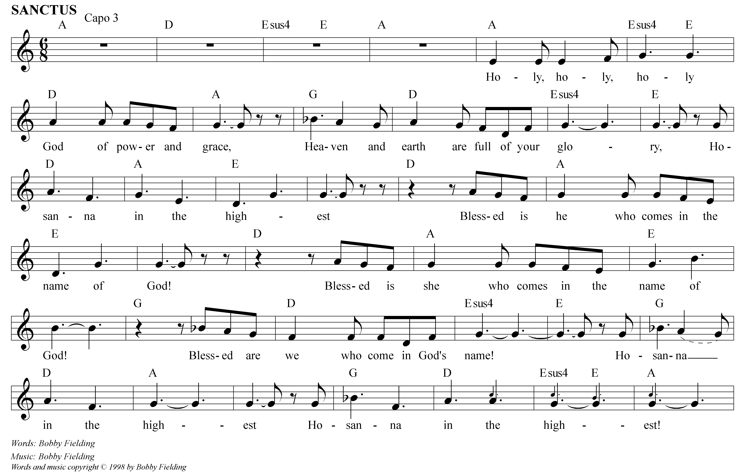

Prayer of Thanksgiving adapted from “Thanksgiving Prayer of Communion” Rauh – A Community of Faith 1998
Lord’s Prayer from Prayers for the Cosmos, Neil Douglas-Kotz

One: Yet in communion with each other we experience our brokenness,

All: but also the means to our healing.

One: Jesus knew this. His last gift was symbolized by a meal:

All:

On the night before he died,
Jesus took the bread
He broke it and encouraged us

To take and eat
That our lives, like his,
Might be food for the world. (pause)

At the end of the meal,
Jesus took the cup.
He gave thanks and praise.
Raising the cup he urged us

To drink from it,
To pledge ourselves to the new
and everlasting covenant
For the healing of our brokenness. (pause)

One: So when we break this bread and raise this cup

All: we are committing ourselves to a new covenant with creation.
For the healing of our world and all the gulfs that divide us from each other
is in our hands and in our lives.

One: And we remind ourselves again to chose to live a life of integrity, compassion and justice.
And so we pray:
The Lord’s Prayer
(from the original Aramaic)

O Birther! Father-Mother of the Cosmos,
Focus your light within us – make it useful:
Create your reign of unity now-
Your one desire then acts with ours,
As in all light, so in all forms,
Grant what we need each day in bread and insight.
Loose the cords of mistakes binding us,
But free us from what holds us back.
From you is born all ruling will,
The power and life to do,
The song that beautifies all.
From age to age it renews,
Truly – power to these statements –
May they be the ground from which all Our actions grow.

Amen

