Name: _____________________________

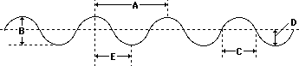
Wave Behavior and Sound Test
1 and 2. In the diagram above, what letter is a(n):
Amplitude? ________
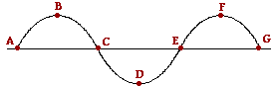
Wavelength/Period? __________

3. In the diagram above, which interval represents one full wavelength? (use translation)
A. A to C
B. B to D
C. A to G
- C to G

4-6. In the diagram above, what letter or letters are:
Peak(s)? ________________
Trough(s)? __________________
Crest(s)? ________________



7 and 8. If the dots on the diagram above are air molecules, circle the rarefaction and place a box around the compression.

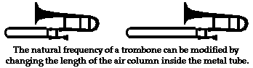
9. Circle the trombone slide position that should produce the highest pitch.

10. Will the trombone you circled have a higher or lower frequency? _____

11. Will the trombone you circled have a longer or shorter wavelength? ___

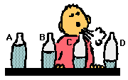
12. Which bottle in the above diagram will have the highest pitch? _____

13. In which item or location are you most likely to observe a vibration (anti-node)?
A. Destructive Interference
B. A trumpet bell
C. A clarinet key/finger hole
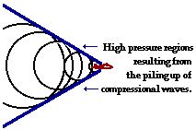
D. A trumpet mouthpiece
14. The diagram above is a jet traveling just beyond the speed of sound. This is an example of a _______________________.
A. Jet traveling slower than the speed of sound
B. Beating Frequency
C. Refraction
D. Sonic Boom
E. Trumpet

15. When you hear a beating frequency, then you are most likely hearing ____________.
A. a change in pitch as a vehicle passes you as you stand still
B. 2 slightly different volumes
C. vibrato
D. 2 slightly different pitches

16. When you experience the Doppler Effect, you may be hearing ______.
A. 2 slightly different pitches
B. a change in pitch as a vehicle passes you while you are standing still
C. 2 slightly different volumes
D. 2 different musical instruments tuning

17. A louder sound has a ____________________.
A. longer wavelength
B. lower amplitude
C. higher amplitude
D. shorter wavelength

18. A lower note has a __________________.
A. higher amplitude
B. shorter wavelength
C. longer wavelength
D. lower amplitude

19. T/F: In order for you to hear Mr. Corder speaking, the air molecules inside and in front of Mr. Corder's lips must eventually go into your ear canal.
A. True
B. False

20. Incoming ocean waves do not bring more water onto the shore. Why?
A. Water has a dipolar molecule.
B. The tidal forces are too great.
C. Ocean waves do not transport water.
D. Earthquakes are occurring on the ocean floor.

21. A transverse wave is transporting energy from east to west. The particles of the medium will move _______________. [Think carefully!]
A. in a circle
B. both eastward and westward
C. both northward and southward
D. east to west only

22. A wave is transporting energy from left to right. The particles of the medium are moving back and forth in a leftward and rightward direction. This type of wave is known as a(n) _________ wave.
A. standing
B. electromagnetic
C. transverse
D. longitudinal/compression

23. Which type of wave do fans in a stadium produce when they stand up and sit down?
A. Ocean Wave
B. Compression Wave
C. Standing Wave
D. Transverse Wave

24. How must the fans in a stadium move in order to produce a longitudinal stadium wave?
A. They must spin around
B. Up and down
C. Forward and backward
D. Left to right or side to side

25. In the movie Star Wars (the best movie ever despite these misconceptions), we hear the lasers, explosions, and engines of the starships in space battles. Why is this impossible?
A. Luke never became a Jedi
B. George Lucas used the wrong film format.
C. The starships don't get hot enough.
D. There is no air in space for the wave to travel through.
- Yoda didn’t use the force properly
- This is actually possible.

26. The sonar device on a fishing boat uses underwater sound to locate fish. What type of wave would you expect sonar to be?
A. Electromagnetic
B. Transverse
C. Standing
D. Longitudinal

27. MATH: Two notes that have a frequency ratio of 2:1 are said to be separated by an octave. The note that is an octave lower than middle C has a frequency of _______. (FYI: The frequency of middle C is 256 Hz.)
A. 128 Hz
B. 254 Hz
C. 258 Hz
D. 345 Hz
E. none of these

28. MATH: A kid on a playground swing makes a complete to-and-fro swing every 2 seconds. That means he/she has a 2 second Period. Frequency can be found using the following formula: Frequency=1/Period. The frequency of swing is _________. Please show your work.
A. 0.5 Hz
B. 1 Hz
C. 2 Hz
D. not enough information to solve the problem

29. MATH: A kid has a mass of 90 kilograms and a height of 1.33 meters. While swinging on a bigger swing, he/she has a period of 5.0 seconds. The child's frequency is ________ Hertz.
A. 0.2
B. 0.5
C. 0.02
D. 0.05
E. 0.002

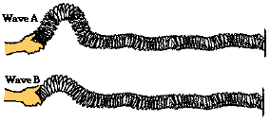
30. Mr. Corder attaches a slinky to the wall and begins introducing pulses with different amplitudes. What will happen?
A. Wave A will reach the wall first
B. Wave B will reach the wall first
C. They will strike at the same time
- Neither slinky will move.
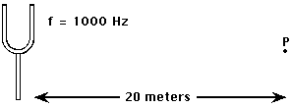
31. MATH: The time required for the sound wave to travel from the tuning fork to point P is __________. A proportion will be needed. (FYI: The wave is traveling at 340 m/s. This is the speed of the sound wave in air.)
A. 0.020 sec.
B. 0.059 sec.
C. 0.59 sec.
D. 2.9 sec.

32. While hiking through a canyon, you let out a yell. An echo is heard off a nearby canyon wall 340 meters away. (The speed of the sound wave in air is 340 m/s.) How long before you hear the echo?
A. 0.5 seconds
B. 1 second
C. 2 seconds
D. 1.5 seconds

33. MATH: The Beating Frequency is the difference of two frequencies played together. Two tuning forks with frequencies 440 Hz and 437 Hz are played together. What is the Beating Frequency?
A. 7 Hz
B. 877 Hz
C. 3 Hz
D. 338.5 Hz
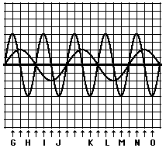
Constructive Interference occurs when waves with the same amplitude signs add together (a + b or –a + -b). Destructive Interference occurs when waves with the different amplitude signs add together (+a + -b or –a + b).
34. Constructive interference is found at points _______.
A. H I K P Q
B. G J M N
C. A B C D
D. P Q R S

35. Destructive interference is found at points _______.
A. A B C D
B. G J M N
C. H I K L O
D. K L M N O

36. Suppose that there was a ride at an amusement park that was titled "The Standing Wave," Which location on the ride would give the greatest thrill?
A. The period
B. node
C. anti-node
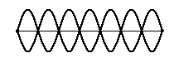
D. the wavelength
37. The number of nodes in the standing wave shown above is ___.
A. 6
B. 7
C. 8
D. 14

38. The number of anti-nodes in the standing wave shown above is ___.
A. 8
B. 6
C. 7
D. 14
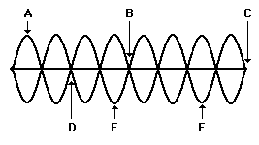
39. Of all the labeled points in the standing wave above, destructive interference occurs only at point(s)
A. A, E, and F
B. G, H, and I
C. A only
D. C only
- B, C, and D

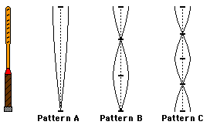

40. In the diagram above, the bar on the left is fixed (attached) to the floor at it's bottom and caused to vibrate. Which of the following conditions are not possible?
A. Pattern C
B. Pattern B
- Pattern A
- Pattern D
E. They are all possible

