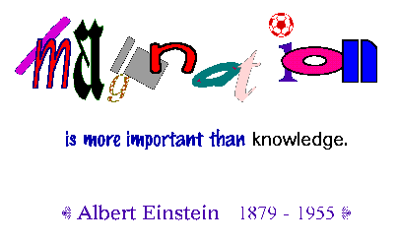
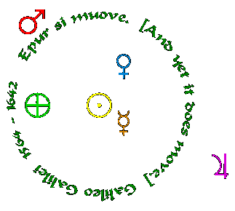
Properties of Matter Note Skeleton

- Matter - anything that takes up _______________; substance from which ________________ is made
- Chemical properties of matter - how matter _______________s into new matter
- Ex. of chemical properties: _________________ _________________
- Physical properties of matter - _________________________ properties of matter
- Ex. of physical properties: ________________ _________________ ______________ ________________ _____________ _____________

Review

- Which weighs more? 1000 g of marble or 1000 g of feathers
- Mass - the amount of ______________ in an object
- Units of mass: ___________ ___________
- Weight - a measure of mass
- Units of weight: ___________ ___________
- Volume - amount of space an object takes up
- Units of volume: __________ __________ __________ __________
- Volume = _________ x _________ x _________
- How do you measure the volume of regular shapes? ________________
- How do you measure the volume of irregular shapes? ____________________________________________
- ____ mL of water = ____ cubic centimeter of water
- Density - ____________ per unit of _____________
- Density = ___________ ÷ ____________
- Units of density: __________ __________
- __________________ has a lower density than ___________________.
- __________________ has a lower density than ___________________.
- __________________ has a higher density than ___________________.
- __________________ has a higher density than ___________________.

