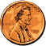Pennyweight
Day 1: Pre-Activity

Objectives: Gather as many pennies as you can (300 to 400 if possible). Bring them to class tomorrow.

Day 2: Massing
Learning Goal: Students will practice grouping and categorizing skills. Students will practice using the mass balance.
Objective: Determine the mass of a group of pennies with the same year. Compare the mass of that group with the mass of other years.
Procedure:
- Separate your pennies into groups according to year. I.e., put all the 1998 pennies together, etc.
- Place your individual groups of pennies with the classroom group.
- 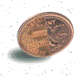The teacher will assign you to a certain year or a group of years.
- Make a chart to record the year, number of pennies, and total mass for the groups of pennies.
- Count all the pennies in that year. Record your data.
- Mass all the pennies with that year together. Record your data.
- Calculate the mass of one penny in each year. Record your result.
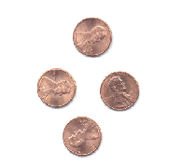
Questions to Ponder:
- Do pennies of different years have the same mass?
- If not, can you come up with a solution for this reason?
- What experiment(s) can you devise to find some answers?

Interesting Info:
24 grains = 1 pennyweight
20 pennyweights = 1 ounce (480 grains)

