Name: ______________________________

Heat Note Skeleton

1. How does heat transfer from one location or material to another?
a. _____________________________
b. _____________________________
c. _____________________________

2. Molecules are two or more ______________ that are connected together with bonds. (Hint: think really small)

3. Does everything in nature have heat energy? ___________ What causes heat energy? (Hint: It involves molecules.) __________________________
_____________________________________________________________

4. How is temperature different from heat? _________________________
_____________________________________________________________

5. What are the 3 scales used to report temperature? ___________________
_____________________________________________________________

6. Define Absolute Zero. ________________________________________
_____________________________________________________________

7. Can an object at 0 degrees Celsius have more heat energy than a different object at 100 degrees Celsius? ___________ Explain. ________________
_____________________________________________________________
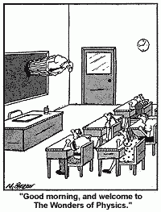

8. Fill in the chart below.
Term | Define | Draw an example
Convection

Conduction

Radiation

Insulation

9. Why/How does a thermos keep a drink warm? _____________________
_____________________________________________________________

