Your Name: _______________________________
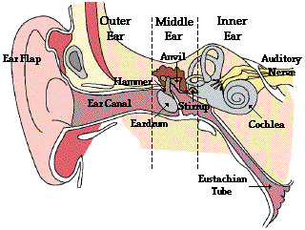
Ear Quiz (Front Page)
Directions: Match the parts of the human ear with their function(s). WRITE the letter in the indicated box next to the box. DO NOT draw lines or circle!
Ear Part | Your Answer |  | Function
- Eardrum |  |  | - transfer the vibrations of the eardrum to the inner ear.
- Pinna (Ear Flap) |  |  | - lets fluid drain down the throat and equalizes pressure on either side of the ear drum
- Auditory (Ear) Canal |  |  | - converts physical vibrations into electrical impulses
- Cochlea |  |  | - vibrates when impacted by sound waves that have traveled through the auditory canal
- The Ossicles: hammer, anvil, and stirrup |  |  | - collects sound
- Eustachian Tube |  |  | - provides a passageway for sound traveling from the pinna to the eardrum, and it protects the ear from infection
- Auditory Nerve |  |  | - pathway that transfers neural signals from the cochlea to the brain.

- What type of energy conversion is occurring when you hear sounds?
A. chemical to mechanical
B. electrical to mechanical
C. nuclear to electrical
D. mechanical to electrical
E. sound to thought

- While operating, the energy of the Ossicles can be described as ___________.
A. radiant
B. chemical
C. potential
D. nuclear
E. kinetic

Electromagnetic Spectrum Quiz (Back Page)

(You may use any visual aids around the room.)

10. The Electromagnetic spectrum is organized according to _______________.
- Amplitude
- Potential Energy
- Atomic Structure
- Valence Electrons
- Alphabetic Order
F. Wavelength

11. The energy of the Electromagnetic Spectrum can best be described as ________.
A. potential
B. chemical
C. radiant
D. nuclear
- kinetic
- thermal

- Which of the following has the longest wavelength?
- Radio Waves
- X-rays
- Gamma Rays
- Red Light
- Blue Light
- Microwaves

13. From longest wavelength to shortest wavelength, what are the colors of visible light?
- ___________________ E. ___________________
- ___________________ F. ___________________
- ___________________ G. ___________________
- ___________________

