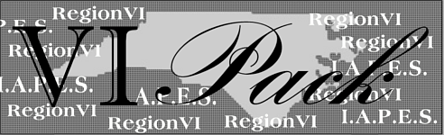

The Newsletter for Region VI
of the
NC Chapter IAPES
Volume 5, Issue 1 March 2003
Word from the Chair
Walker Biggs
We are already two months into the new year and all of the excitement that it brings. This is the time when claims loads increase (I don’t know how they can get any heavier) and we start looking forward to spring.
The Annual meeting has passed and we are now approaching the Annual State Convention in Charlotte. It will be held at the Adams Mark in Charlotte on April 2-4, 2003. Room rates are only $55.00/night during the convention, which is an excellent rate for the Adam’s Mark. Information and Registration forms are on the NCIAPES website and can be accessed at: Annual State Convention.
Upcoming events for Region VI are a mini- institute in Laurinburg in late April and a mini-institute in Jacksonville in September. We are also making plans for a Family Fun Day to be held in the Fayetteville area sometime during the year.
Annual Meeting
Judy Jones, Vice-Chair
The region meeting was held on Tuesday evening February 25, 2003 in the Clinton local office.
Ms. Candra Capers, Sampson Community College gave a brief presentation on the “Partnership between ESC and the Community College” and how it works in Sampson County.
Please congratulate Valeria Russ, Fayetteville LO and Nydia Gonzalez, Clinton LO, who were elected Region VI Chair and Vice Chair for 2004.
The Clinton local office won the plaque again for being the first LO in the region to have 100% membership. There will be a change coming for the 2004 campaign. Walker Biggs and Lee Newkirk, membership chair will be providing further information.
We had 9 individuals and offices to win Region awards. They will be competing for State awards, which will be awarded at the convention in Charlotte 2-4 April 2003.
**CHALLENGE**
The Morehead City LO issues the following challenge to the rest of the Region VI Local Offices.
They will raise $1000.00 for Walk America/ March of Dimes!!! (they are a small office with only 8 employees). They challenge the other offices in the region to also raise $1000.00 for Walk America/March of Dimes!!

Inside This Issue
1 | Word from the Chair
1 | Region VI Annual Meeting
2 | Legislative Update
2 | 2003 Membership
2 | Awards Program
3 | Region VI Officials
4 | Annual Meeting Pictures
5 | More Pictures
2003 Membership
It is not too late to join IAPES. In fact it is more important than ever to belong to your professional organization. IAPES has a paid lobbyist in Washington who represents us to those who control our purse strings and is continually educating our federal legislators as to the importance of our services and keeping an eye on legislation that could affect us.
The Clinton and Laurinburg local offices are 100% offices. The Laurinburg local office took a unique approach to membership this year. They held a yard sale to pay the membership dues of their staff. Each local office could do something like this to either pay for or offset the cost of membership for their staff.
As of March 3, 2003 membership for Region VI was 105, with 24 new members, which is 21 below our membership for last year. Let’s see if we can reach last years numbers and exceed them.
Ms. Candra Capers, speaker at the Region VI Annual meeting became our newest member during the meeting.
Legislative Update
John Wittenstrom, Legislative Chair
Hi there, I am your region Legislative Chair. My job is to keep you informed of anything that is happening in Raleigh or Washington that can affect Workforce Development, as we know it. I get this information from our NC IAPES Legislative Chair who in turn gets the information from IAPES or other sources.
Most of us that work for the state are SEANC (State Employees Association of North Carolina) members. We know that SEANC speaks for state workers in Raleigh and that is very important! But are all of us aware that the results of decisions made in Washington DC could walk in and meet you where you work? It is important to know how these decisions could affect workforce development and our very jobs. That’s why IAPES provides a voice (and a set of ears) in the capital on behalf of our members. This is accomplished by our legislative liaison Lee Foley who continuously monitors Work.
It is a proven fact that our legislators respond to their constituents when they hear from them. It is also a fact that the best way to contact your representative is with a letter. E-mail and phone calls are good but statistics show that our politicians, both State and Federal, appreciate the time and effort a voter puts into writing a letter.
Remember this whenever you are unhappy with our elected officials in Raleigh or Washington. Why wait every two or four years to make a statement.
If anyone has a question or concern, feel free to contact me at:john.wittenstrom@ncmail.net

Region VI IAPES Awards

Kaki Van Sickle
On Tuesday February 25, 2003 the following individuals received awards for the 2002 year. Service to Veterans: Large Office – Fayetteville
LVER – Julius Brackeen
DVOS – Juan Ruiz-Campos
Retiree: Charles Miller
Employee Performance: Dorothy Moody
One-Stop: Lumberton JobLink
Award of Merit: Cynthia Starks
Specialized Customer Service: Employment Source
Hall of Fame: Glenn McQueen
Thank you to those who took the time to submit nominations. Now is the time to make preparations for 2003 awards nominations. Look around at your co-workers and recognize those that make a difference.


Region VI
Local Office Chairs

- Aberdeen Mickey Elliott mickey.elliott@ncmail.net
- Troy Harry Baltes harry.baltes@ncmail.net
- Clinton Nydia Gonzalez nydia.negron@ncmail.net
- Fayetteville Gail London gail.london@ncmail.net
- Jacksonville Sherry Luffman sherry.luffman@ncmail.net
- Laurinburg George Farley george.farley@ncmail.net
- Raeford Mollietta Graham mollietta.graham@ncmail.net
- Lumberton Lee Newkirk lee.newkirk@ncmail.net
- Elizabethtown Sabra Grimes sabra.grimes@ncmail.net
- Morehead City Frank Arnath frank.arnath@ncmail.net
- New Bern Dottie Harris dottie.harris@ncmail.net
- Shallotte Chuck Spangler chuck.spangler@ncmail.net
- Whiteville Lennetta Singletary lennetta.singletary@ncmail.net
- Wilmington Sherri Neville sherri.neville@ncmail.net
- Burgaw Stewart Fentress stewart.fentress@ncmail.net

These are the individuals you should see in order to join IAPES or if you have any questions or problems. Also let them know of anything that is going on so that we can put it in future issues of the VI Pack.
Region VI Officers
And Committee Chairs

- Region Chair Walker Biggs walker.biggs@ncmail.net
- Region Vice Chair Judy Jones judy.m.jones@ncmail.net
- Secretary/Treasurer Gloria Morrisey gloria.morrisey@ncmail.net

- Awards Kaki Van Sickle catherine.vansickle@ncmail.net
- Membership Lee Newkirk lee.newkirk@ncmail.net
- Legislative John Wittenstrom john.wittenstrom@ncmail.net
- Veterans Chuck Spangler chuck.spangler@ncmail.net
- Education Cynthia Starks cynthia.starks@ncmail.net
- Fundraising Nydia Gonzalez nydia.negron@ncmail.net
- Website Sherri Neville sherri.neville@ncmail.net

Don’t Forget

Annual State Convention
April 2-4, 2003 Adam’s Mark Charlotte
Region VI Mini-Institutes
May 2003 Laurinburg Local Office
September 2003 Jacksonville Local Office

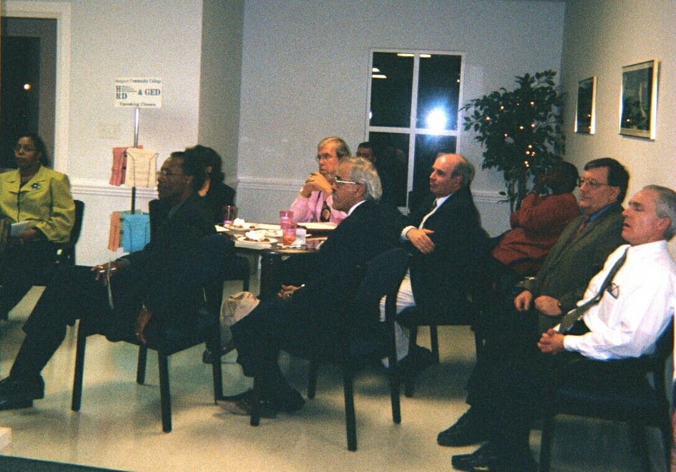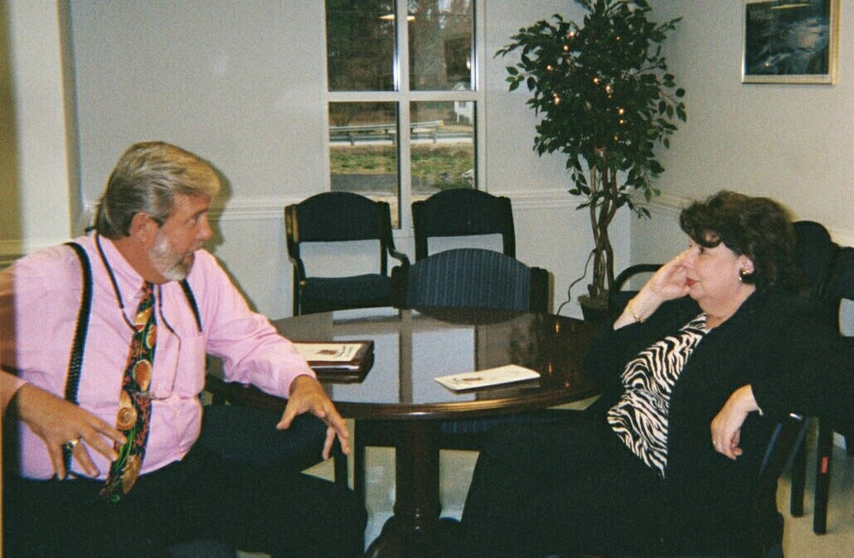
1. 2.
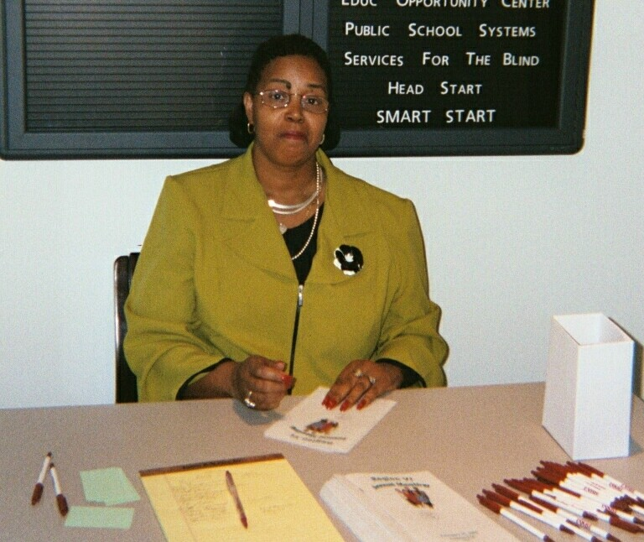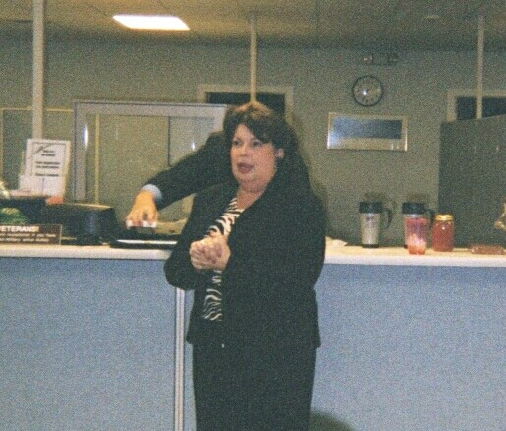
3. 4.
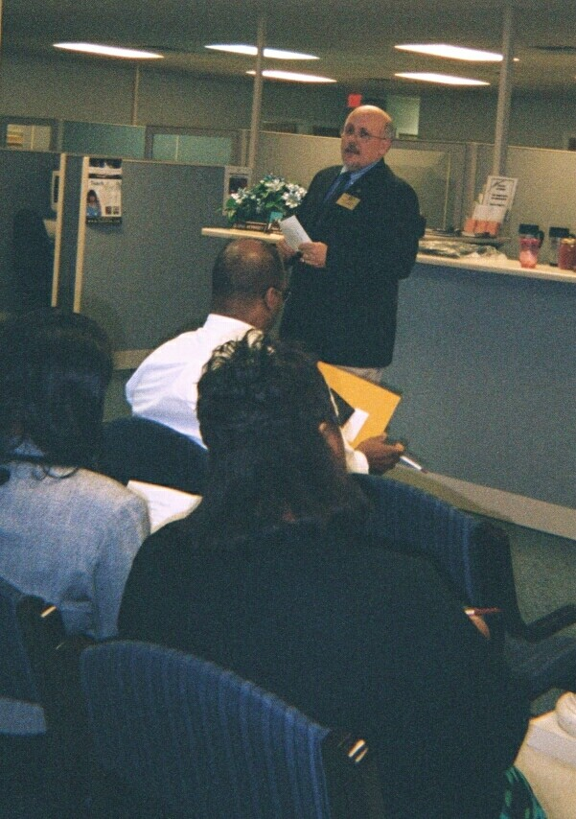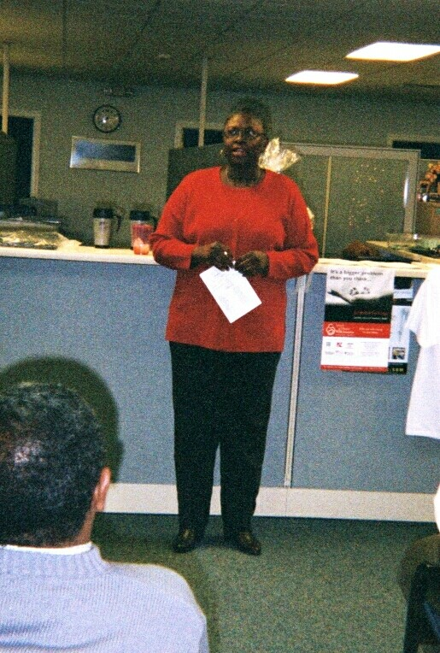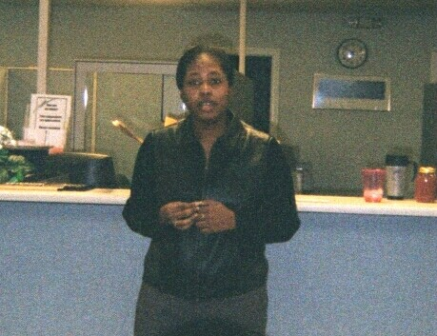
5. 6. 7.
REGION VI ANNUAL MEETING PICTURES
Left to right starting with top row: 1. Members listen to presentation 2. Kaki Van Sickle & John Wittenstrom, Morehead City LO, in high level discussion 3. Gloria Morrisey, Clinton LO, works registration desk.. 4. Kaki Van Sickle prepares to give out Awards. 5. Walker Biggs, Region VI Chair welcomes members to meeting. 6. Judy Jones, Region VI Vice-Chair conducts election of officers. 7. Candra Capers, Sampson Community College, guest speaker for meeting.
MORE PICTURES
