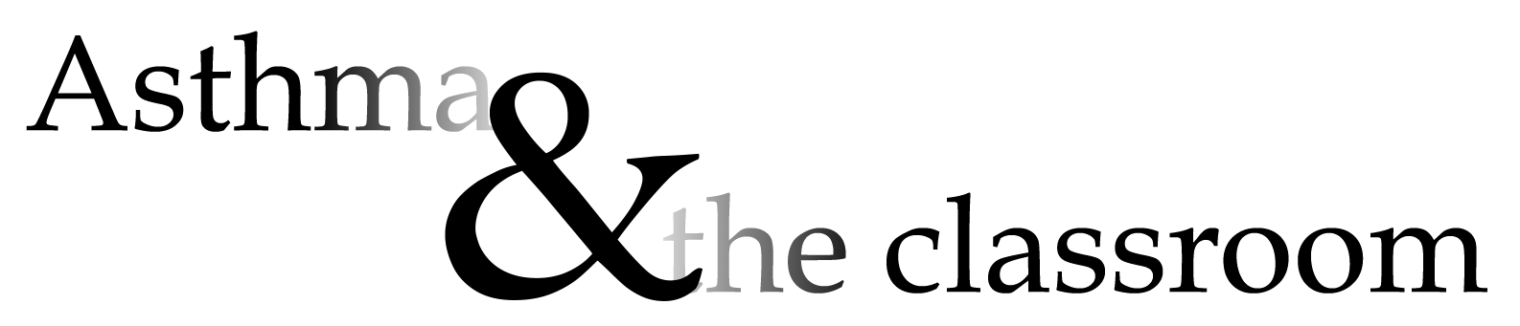

Asthma is a non-contagious chronic respiratory ailment caused by overly sensitive airways. An asthmatic’s airway narrows in response to irritation causing wheezing, coughing, or shortness of breath. An incident of restricted breathing – often called an “asthma attack” – can vary from mild to fatal.

Asthma is the leading cause of student absence. The ailment is present in 10 to 14 percent of school-age children. Effective treatment of the condition early can reduce the number and frequency of attacks as the patient grows older. Asthma cannot be cured, but it often enters remission as the sufferer ages.

Asthma attacks and their causes:

During an asthma attack, some irritant causes spasm and inflammation of the muscles around the airways. These symptoms may be accompanied by increased mucous production.

Each child reacts to a unique set of triggers that may incite an attack. Common irritants may include:
- Cold Air – many asthma sufferers experience increased symptoms when exposed to cold, dry air.
- Activity – physical activity or exercise can bring on an asthma attack. Laughing or crying may have the same effect. Heavy breathing will dry out the airways, producing the same effects as cold, dry air.
- Allergens – an asthmatic may have certain allergies that incite an attack. These will vary across children with almost infinite possibilities.
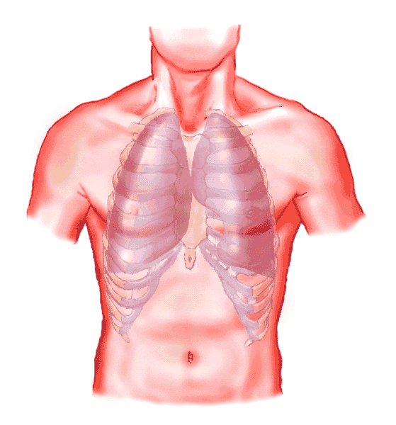
- Airborne Irritants – dust, pollen, smoke, or other airborne pollution can invite asthma symptoms. Depending on the severity of their condition, asthmatic children should probably not clean chalk erasers, play outdoors in pollutant haze, or be exposed to excessive tobacco smoke.
- Fumes – perfume, cleaning solutions, aerosols, markers, or other fume-producing products may be a problem for some asthmatics.

Treatment

There are a variety of asthma treatments, and any asthmatic should have a tailored treatment program with their physician. Treatments may include diet (since asthma may be related to allergies), shots, pills, or inhalers. Teachers should be familiar with their students’ particular treatments and medication.

An asthmatic should keep their medication easily accessible to quickly treat an attack at its onset. For mild cases, keeping medication in the classroom or nurses office may be sufficient. For more severe cases, some students may need to keep their medication on their person – particularly during recess or physical education. Extra medication should be provided to the school in the event the child’s supply is forgotten.

Teachers should monitor the child’s medication and inform the parents of any changes. If the medication does not end an attack or if a child is using the medication very frequently, the student’s parents should be informed. If treatment is regularly needed at the same time, the parents should be informed.

Signs of an attack:

Teachers should watch for the early signs of an asthma attack. When an episode is treated early, its severity can be reduced. Again, symptoms will vary across individuals, but may include:
- Coughing – a persistent or ineffectual cough (child is not coughing up phlegm) that is not related to another illness may be a sign of asthma. Even if the cough is related to a cold or other ailment, it should be monitored since heavy breathing can dry the airways and cause irritation leading to an attack.
- Wheezing – some asthmatics audibly “wheeze” during an attack. This occurs as air whistles through a constricted passageway. The wheeze is usually on the exhale as the sufferer cannot expel enough air to take in a good breath.
- Change in Behavior – if a known asthmatic suddenly becomes agitated or withdrawn, they may be experiencing difficulty.
- Pupil Dilation – this effect of reduced oxygen intake is exaggerated by some asthma medications.
- Use of Secondary Respiratory Muscles – if a child must lift his head or raise his arms in rhythm to breathe, this is a sign of serious respiratory difficulty.

These symptoms are especially noteworthy if they occur when a risk is expected – after recess, on cold days, after lunch, etc.

What the teacher should know

The classroom teacher of an asthmatic child should be familiar with the child’s treatment. He or she should know what to do in the event of a serious attack. During a serious attack, a child may experience labored breathing, show bluish lips, ear lobes, or nail bases, or find no relief from normal medication. The teacher should be familiar with the procedure to deal with this situation.

Panic can add to the severity of the asthmatic’s attack. A teacher should appear calm and in control, but they child should not think the problem is being taken lightly. If a child is suffering a mild attack that is not bothering them, the teacher should monitor the situation, but not fuss over it. Fear can amplify an attack - fear of not getting medication, fear of an unprepared teacher, or fear over an upcoming test.

The teacher should communicate with the student’s parents (or perhaps the school nurse) about the child’s specific treatments and risks. Knowing a child’s sensitivities, the teacher should help prevent attacks. If the student is sensitive to mold or pet dander, they should not be seated near the gerbil cage. If dust irritates a certain child, that young person should not clean dust erasers (and in severe cases, perhaps not work at the board – or at least be allowed to wash their hands immediately following).

An asthmatic should still be allowed and encouraged to participant in activities as long as they are able. If they experience problems, they should be permitted immediate treatment. Asthmatics can often tolerate short bursts of activity better than long endurance exercises. Be aware of the potential problems that may be introduced by activities with animals or foods. Consider educating the class on asthma and its treatment.

After an attack

A classroom teacher should be sensitive to the impact asthma may have on the whole child. Most asthma medications carry side effects. Some inhalers will make children hyper, restless, or even shaky. The child may be giddy - talking constantly or laughing at anything. Some medications will have the opposite effect, making the student drowsy. It can be difficult for a student to make up work since they want to sleep once they are home.

An asthma attack can leave the student scared and fatigued. A teacher should be sensitive to these possibilities and prepared to deal with each. The student may need or want a place to quietly rest following an attack. A child is often overheated after an attack. They will want a cool place to rest - though not cold or dry.

An asthmatic youngster may be anxious about their problem and access to treatment. He or she may be embarrassed by the problem or the disruption they fear it causes. They may have social problems stemming from their reduced involvement in physical activity or being singled out by their ailment.
Sources of information


Bronkie: The Dinosaur with Asthma
http://www.thriveonline.com/health/asthma/kids/index.html

American Lung Association
1-800-LUNG-USA
www.lungusa.org

Allergy and Asthma Network/
Mothers of Asthmatics, Inc.
1-800-878-4403
www.podi.com/health/aanma

American College of Allergy, Asthma and Immunology
1-800-842-7777
www.mcg.edu
Asthma and Allergy Foundation of America
1-800-7-ASTHMA
www.aafa.org

