Name: ______________________ Date: ________________ Block: _____
Social Studies 11 History Review Packet C
Recommendation: Complete this work in pencil.
Fill in the charts below in point form, study friendly notes citing specific information, vocabulary, key figures, and where appropriate dates.
1) Describe Canada’s growth as a politically autonomous nation during the 20th Century.
Era | Evidence of Growing Autonomy
WWI
(1914-1918)
Interwar Period
(1919-1939)
WWII
(1939-1945)
Post-WWII
(1945-2000)

2) Assess Canada’s role in the two World Wars and the Cold War and how each impacted Canadian society.
War | Canada’s Role | Impact on Canadian Society  (i.e. socially, politically, economically)
WWI
(1914-1918)
WWII
(1939-1945)
Cold War
(1945-1989)
3) Assess Canada’s participation in world affairs with reference to the following items:
World Affair | Canada’s Participation
United Nations and Human Rights
(i.e. Post-WWII)
Gulf War (1991)*
Somalia (1992)*
Rwanda (1993-1994)*
Yugoslavia (1999)*
*For these events, read pages 153 to 156 in Counterpoints
4) Describe how the federal government’s policies in the following areas developed or changed over the course of the 20th century. Cite specific evidence and time periods in your discussion.
Policy Area | Changes or Developments During the 20th Century
Immigration
Minority Rights
Welfare State
5) Explain economic cycles with reference to different eras and the labour movement in Canada.
Era | Description of the Nation’s Economic  Performance and Reasons Behind It | Government’s  Role / Reaction | Impact on Canadian Society | Impact on the Labour Movement
Roaring Twenties
Great Depression
Post-WWII Prosperity
OPEC Crisis of the 1970s
Debt Crisis of the 1980s and 1990s

6) Describe how the role of women has changed socially, politically, and economically in Canada during the 20th century. Reference specific time periods when providing evidence.
Area | Changes in the Role of Women in Canada during the 20th Century
Socially
Politically
Economically

7) Assess the impact of the following on Canadian unity. Describe each item listed and the federal government’s reaction to each. Cite general time periods or specific dates in your discussion.
Item | Description | Federal Government Reaction
Conscription
Crisis –
WWI
Conscription
Crisis –
WWII
Quebec
Nationalism
Bilingualism
Regionalism /
Western Alienation

8) Demonstrate knowledge of the challenges faced by Aboriginal / First Nations people in Canada during the 20th Century and their responses to the following:
Challenge | Description | Response
Residential
Schools
Reserves
Self-Government
Treaty Negotiations
9) Identify important Canadian cultural and scientific achievements between 1914 and 2000.
Cultural | Scientific

10) Map Review
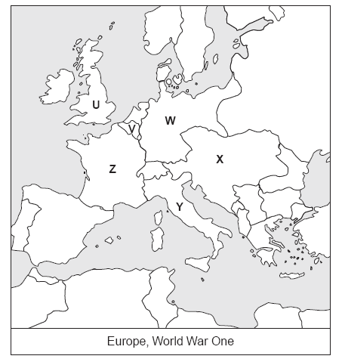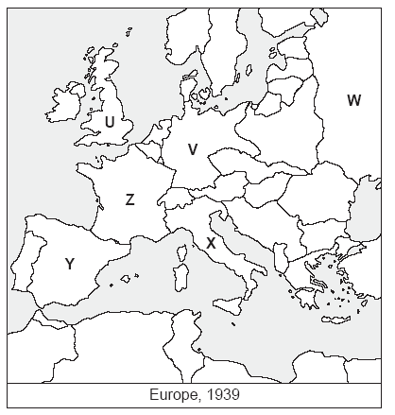
Identify the countries on the maps above.
“Europe, World War One” “Europe, 1939”
U: _______________________ U: ________________________
V: ________________________ V: ________________________
W: ________________________ W: ________________________
X: _________________________ X: ________________________
Y: _________________________ Y: ________________________
Z: _________________________ Z: ________________________
Which two letters represent countries that Which two letters represent European Canada fought in during WWI? members of the Axis Powers in World
__________ War Two? __________

11) Political Cartoon Review
a) Look at Fig. 3-4 on page 54 in Counterpoints. How were the Progressives able to effectively use their influence due to holding the balance of power in a minority government situation? (i.e. Hint: read p. 55 as well).
________________________________________________________________________________________________________________________________________________________________________________________________________________________________________________________________________
b) Look at Fig. 4-5 on page 82. How did tariffs contribute to a slowdown in world trade?
______________________________________________________________________________________________________________________________________________________________________________________________________
c) See Fig. 8-4 on page 195. What does the cartoon say about western Canada’s reaction to bilingualism? __________________________________
____________________________________________________________________________________________________________________________________
About Pierre Trudeau’s views?
________________________________________________________________________________________________________________________________________________________________________________________________________________________________________________________________________

