Afterword

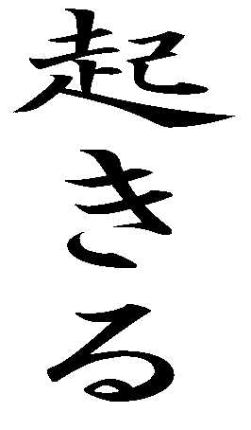

(get up, wake up, happen)

