New Mexico Journal
Vol. 1, No. 3 – December 2005 All the news that’s print to fit
Written and edited this time by Mike – all mistakes are his fault

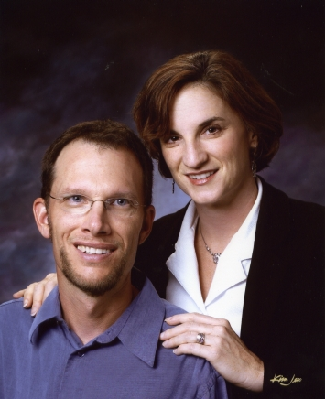
Tis the Season

Here we are at another holiday season, and we haven’t bought anything for anybody! Well, not exactly, but we’re having a giftless Christmas because we can’t afford much. People will just have to do with our winning presence without the presents. And of course, our much anticipated newsletter!
This holiday will find us in California. We are driving from Albuquerque to Glendale, where we plan to hook up for an evening with Fred Genge, his wife Elizabeth, and their daughter Mia. Then we will drive up to Fort Bragg, arriving on the evening of Christmas Eve. We’ll stay in Fort Bragg with my mom, and reconnect with my sisters Mari and Pauline until around New Years, then head back down to the Bay Area where we’ll hang out with Megan’s brother Michael and his wife April, and hook up with some friends. We may also try to get to Sacramento for an evening or so…but we’re not sure. Have a joyous holiday!!!

10 of the Longest Years of our Lives
September 2nd was a milestone for us. We celebrated 10 years of marriage. A decade doesn’t seem like a long time, but in the context of how long your average marriage lasts nowadays, I think that we’re doing pretty well. We’ve had some really good times over those 10 years, which keeps us coming back for more. We’ve also learned more about each other – mostly good stuff. And I’ve come to appreciate my wife in many more ways than ever, especially since she is supporting my butt while I screw around on this dissertation thing. So here’s to another 10!

Raising Arizona
In mid-September, Megan went to a Journalism and Women Symposium (JAWS) conference in Sedona, Arizona. Since she was already there, we made plans for me to drive out and pick her up for some camping and R&R – our anniversary trip. After packing, I headed out on the six hour drive from Albuquerque. I drove into lovely Sedona, which looks like a picture postcard with beautiful red-rock outcroppings all around, and drove to the hotel where Megan was waiting. After picking her up and eating, we drove up north of Sedona and pulled into the Oak Creek Canyon campground, where Megan promptly discovered that I had forgotten to bring flashlights, and the camp lantern, along with a host of other little things that I didn’t think about.
We navigated those little disasters, and enjoyed the campground and our hike up Oak Creek Canyon, though we were kept up one night by a bunch of Indian or Middle Eastern men having a wild time with some Arabic or Bollywood music.
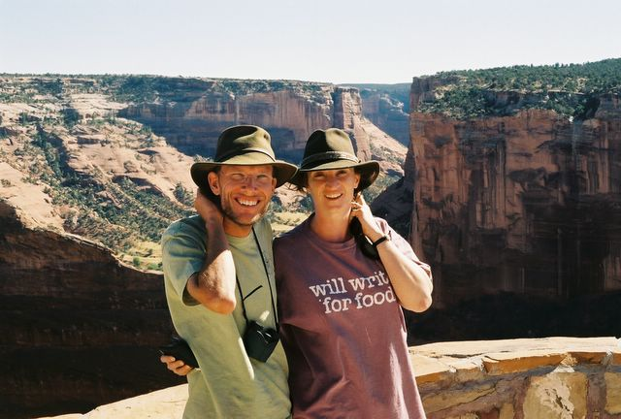
From there, we drove up to Flagstaff and spent a night in a nice old hotel downtown, then drove onto the Navajo Reservation to Canyon de Chelly, a really remote US National Park covering a canyon sacred to Navajos and other tribes. We spent two nights there, taking hikes into the canyon during the daytime and camping in a very cool campground run by a local Navajo man at night. It was in this place that I saw the most beautiful dawn I think I have ever witnessed, with the sun peeking over the desert in the east and the full moon setting in the west, and the sky color ranging from red/orange to deep purple. Though here, as usual, we found solitude disturbed by a man who seemed to have a penchant for loud music and large bonfires.
Even the drive back to Albuquerque, which we took mostly through the Navajo reservation, was beautiful, marked by dramatic stone edifices and natural structures. All in all, it was a trip worth taking for our anniversary.

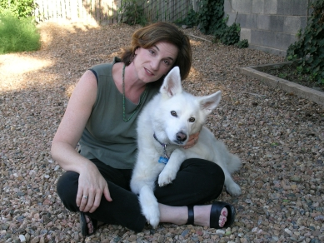
Hannibal update
Hannibal did it again. One day in early November, I was home with him and noticed that he was having trouble walking and standing. He had been normal in the morning, but in the afternoon he was out of it. I laid him on his bed and sat with him for awhile after calling the vet. At his age, you never know what these things mean. The vet came over, and discovered he had a high fever. She gave him some fluids, an antibiotic and a narcotic and told us to monitor his temperature. Three hours later, it hadn’t gone down, so off we took him to the Urgent Care facility, where he spent two nights, getting fluids and generally feeling lousy. After tests, and $1000 later, it turned out the old boy had a massive bladder and urinary tract infection.
However, after a regimen of antibiotics and some tender loving care, he’s come back to almost his old self. He celebrated his 15th birthday on November 15th. I’ve put a photo retrospective of his life up on http://www.geocities.com/Athens/4209/hannibal/Hannibal15/Hannibal15.htm. We had hoped to take him with us to California, but the trip might be a little much for him, so we are leaving him in the capable hands of some neighbors. Hopefully, nothing will happen to him while we’re gone.

Megan’s Promotion and Freelance Work
Megan accepted a promotion at the New Mexico Business Weekly. She is now working on special publications, where she puts together special focus sections on various business sectors that are inserted into the weekly paper. In addition, Megan has taken a number of freelance jobs. You can find her CityBeat articles in various ArtBusiness magazine publications, including pieces on Fort Bragg/Mendocino and Sarasota. She also recently contributed a story to Bankrate.com which was reprinted in some papers around the country, including the Detroit News, the Sacramento Bee, and the Atlantic City daily. She was actually encouraged to apply for the Barbara Jordan Media Award by the Texas Governor's Committee on People with Disabilities after they read her article, “Concept of designing for people in all stages of life comes of age” in the Austin American-Statesman. However, she discovered that the article did not meet the requirements of the award, namely that she is not a Texan nor did she write about Texans. You will also soon find a Megan article about Los Alamos, NM in AAA Magazine.

Speaking of Los Alamos
Megan and I made an interesting trip up to America’s former “secret city” when she was putting her article together. Los Alamos is very interesting. The city did not exist until the Manhattan Project was started, and the government realized it needed a far away and secret place to conduct nuclear research. The Los Alamos National Laboratory was created, and scientists were brought in from all over the United States, and even foreign countries, to work on developing the United States’ first nuclear weapon. The secrecy was so strong that scientists only knew that they were to report to a nondescript address on the Plaza in Santa Fe, to a woman named in their letter. When they arrived in Santa Fe, they often wondered if they were in the right place because Santa Fe was so small. Once there, and once they reported to this woman in a small office, she typed up an index card with their information and then sent them by car to the secret facility, then at least 2 hours away up a steep and winding dirt road. Los Alamos was not really a town so much as a barracks for scientists and their families.
Today the city has a large museum dedicated to the laboratories, which are run by the University of California. It also boasts one of the highest I.Q. rates in the country, and its library is the busiest outside of the major cities. Don’t forget to check out Megan’s short article on the place in AAA Magazine!

Mike’s Standardized Patient Experiences – Taking 10 for the Team
My Standardized Patient work has gotten interesting. I have played some interesting characters, and the most interesting is coming up…a lawyer who has a good marriage and a couple of kids he is proud of, but who has liaisons with men 2-3 times a year and is afraid that he has AIDS. That will probably really throw the medical students for a loop. I also have finally made good on being a GTA. For those of you who are squeamish, don’t read on – my first GTA assignment involved 10 prostate exams in 3 hours, performed by medical students on me. The money was really good -- $40 an exam – but really, you’d think that I’d find better ways to make extra money! Ouch!
Well, I actually do get money from other places. I have been doing some off and on catering for a guy who serves Asian-themed food. Mostly my job consists of setting up the food, usually lunches, and taking it down when it is finished. It’s not much but it is a little extra money that we can count on, which helps a bit.

Visitors
We were twice blessed with the visit of Sarah James from Detroit, who came down get together with us and with another friend. Evidently, Megan and I, and our beautiful new state, had quite a profound effect on her. She is now considering a move to our city. I think she would like a new adventure, as well as trying something that will allow her to utilize her Spanish language skills. Albuquerque is a good place for that, in a temperate climate, with a lot of Hispanic and Indian culture in a beautiful setting. She also knows a few people here which will help her transition to a new place. Besides, she could never get us to come to Detroit, as she constantly complains. Though I’ve reminded her that I visited her in summer 2004, she complains that I was only in Detroit because I was attending a statistics workshop in Ann Arbor, MI.

The New Year
This New Year will hopefully bring more progress on Mike’s dissertation, as well as a field research trip for him down to Central America. Megan has applied for a Knight Fellowship, which would be a great experience for her. Hannibal will simply look for food and naps!

Closing
We are maintaining our website somewhat regularly, so if you haven’t been by lately, come see what we’ve done with the place!

http://www.geocities.com/Athens/4209

As always, you will find us at 1300 Hermosa Drive SE, Albuquerque, NM 87108

