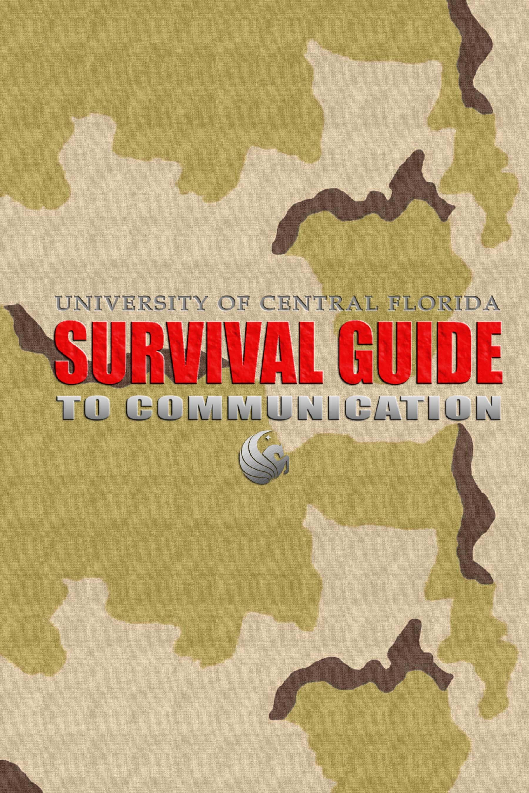

University of
Central Florida
Survival Guide
To Communication

Publication Editor

Eric Eddy

General Editors

Sherry Mathews
Sandy Plasner
Elizabeth Zenker
Technical Editors

Rose Benedicks
Michael Mendetta
Bonnie Spivey

Writers

Rose Benedicks
Anthony Buxton
Eric Eddy
Jeremiah Grover
Timothy Grysko
Robin Horn
Christopher Kenney
Sherry Mathews
Michael Mendetta
James Moore, Jr.
Heather Moore
Sonia Peñaranda-Mena
Sandy Plasner
Bonnie Spivey
Melanie Trickey
Elizabeth Zenker
William J. Walsh II

Who We Are

Rose Benedicks Christopher Kenney
Technical Editor Writer
Rhetoric and Writing Forms Research and Documentation
English/Technical Writing English/Technical Writing

Anthony Buxton Sherry Mathews
Writer General Editor
Online Communication Page Elements and Design Layout
Computer Science/ English/Technical Writing
Information Technology

Eric Eddy Michael Mendetta
Publication Editor Technical Editor
Mechanics, Punctuation, and Proofreading Oral Communication
Computer Science/ Computer Science/Information
Information Technology Technology

Jeremiah Grover Heather Moore
Writer Writer
Rhetoric and Writing Forms Mechanics, Punctuation, and
English/Technical Writing Proofreading
English/Technical Writing

Timothy Grysko James Moore, Jr.
Writer Writer
Oral Communication Visual Elements/Graphics
Computer Science/ Computer Science/Information
Information Technology Technology

Robin Horn Sonia Peñaranda-Mena
Writer Page Elements and Design Layout
Research and Documentation Writer
English/Technical Writing English/Technical Writing
Sandy Plasner
General Editor
Rhetoric and Writing Forms
English/Technical Writing

Bonnie Spivey
Technical Editor
Page Elements and Design Layout
English/Technical Writing

Melanie Trickey
Writer
Rhetoric and Writing Form
English/Technical Writing

William J. Walsh II
Writer
Visual Elements/Graphics
Computer Science/Information Technology

Elizabeth Zenker
General Editor
Online Communication
English/Technical Writing

Table Of Contents

Introduction

How This Book is Organized 1
Navigation 1
Helpful Graphics 2
Glossary 2
Resources 2

Chapter 1: Rhetoric and Writing Forms

Rhetoric and Elements of Style 5
Rhetoric 5
Aristotle’s Three Modes of Persuasion 6
The Rogerian Argument 8
Audience 8
Determining the Audience 9
Audience Classifications and Needs 10
Style: Definition and Elements to Consider 11
Types of Style 12
Beginning the Writing Process 13
Outlines 14
Collaborative Group Writing 15
Aspects of Collaboration 15
Final Considerations: Research and Grammar 18
Professional Writing Forms 18
Memorandums 18
Headings 19
Text Body 20
Proposal Writing 22
Types of Proposals Needed 22
Developing a Successful Formal Proposal 27
Writing Styles and Strategies 29
Instructions 31
Resumes 32
Writing Journalism 35
Questions to Begin 35
Inverted Pyramids 36
Journalism Ethics 36
Academic Writing Forms 37
Essays 37
Development of the Essay 37
Types of Essays 39
Strategies 40
Research Paper 41
Beginning the Assignment 41
Choosing a Topic 42
Researching the Topic 42
Extracting the Information 42
Writing the Paper 43
Abstract 43
Scientific and Laboratory Writing 44
Writing for Scientists 44
The Lab Report 45
Peer Editing 45
Analysis 46
Evaluation 46
Writing 47
Literary Response 48
Character 48
Plot 49
Theme 50
Point of View 50
Rhetorical Analysis 51
Creative Writing Forms 52
Short Story 52
Characters 52
Structure/Organization 52
Point of View 53
Dialogue 53
Script Writing 53
Poetry 54
Rhyming Couplet 54
Sonnet 54
Haiku 55
Limerick 55
Villanelle 55

Chapter 2: Research and Documentation

Resources 59
Library Navigation 59
Navigating the UCF Library 59
Finding a Document with a Call Number 65
WebLuis 66
Choosing a Search Type 66
Choosing a Search Level 71
Searching for Journals 74
Internet Resources 76
Search Engines 76
Search Techniques 80
Essential Sites 83
Creating Your Own Data 85
Surveys and Questionnaires 85
Interviews 87
Documentation 88
Plagiarism 89
Reasons for Citations and UCF Policies 89
Avoiding Plagiarism 90
Differences between Quoting, Paraphrasing, and Summarizing 90
Different Citation Styles 91
Parenthetical Citations 92

Chapter 3: Grammar, Punctuation, Mechanics, and Proofreading

Overview 99
Grammar: Writing at Its Most Basic 100
Parts of Speech 100
Noun 100
Pronoun 101
Verbs 101
Prepositions, Adverbs and Adjectives 101
Conjunctions 101
Interjections 102
Sentence Patterns: What kind of phrase is this? 102
Sentences Problems: What kind of mistake is this? 103
Sentence Fragment 103
Fused Fragment 103
Comma Splice 103
Pronoun Case 104
Subjective Case 104
Objective Case 104
Possessive Case 104
Punctuation: The Stage Directions 105
Endmarks 106
Apostrophes 107
Inclusion marks 108
Quotation Marks 108
Parenthesis and Brackets 109
Dashes 110
Colons 110
Ellipses 111
Commas and Semicolons 111
Commas 111
Semicolons 113
Mechanics: The Lighting Props 114
Number Use 114
Italics 115
Hyphens 116
Using Capitols 116
Abbreviations and Acronyms 117
Acronyms 118
Proofreading: The Dress Rehearsal 118
Time Strategies 118
Reading for Errors 118
Second Opinion 119
Proofreading Marks 119
Multiple Drafts 121
Things to Check Each Time You Read Your Draft 121

Chapter 4: Visual Elements and Graphics

Introduction of Visual Aids 125
Maintaining the Reader’s Interest 125
Choose the Appropriate Visual Aid for the Purpose 126
Place Your Visual Aids in the Appropriate Location 126
Make Your Visual Aid User-friendly 126
Fully Integrate Your Visual Aid With Text 126
Placement of Visuals 127
Types of Visual Aids 127
Photographs and Drawings 128
Tables 128
Graphs 129
Line Graphs 131
Bar Graphs 131
Pie Graphs 132
Flow and Organizational Charts 134
Icons 135
Color 136
Symbolism 136
Complementing Colors 137
Contrast 138
Screening 138
Types of Computer Images 139
JPEG Format 139
GIF Format 140
BMP Format 140
Computer Graphics Software 140
Using Microsoft Excel 141
Basic Tutorial for Creating a Simple Graph 142
Quick summary of Visual Aids 146

Chapter 5: Page Elements and Design Layout

Textual Elements 149
Font 149
Serifs and Sans Serif 150
X-Height 150
Width 151
Size 151
Line Length 152
Case 152
Affects of Uppercase 153
Uppercase vs. Lowercase 153
Textual Treatment 154
Italics 154
Bold 154
Other Textual Treatment Considerations 155
Headings 157
Clarity 157
Tone 157
Page Headers/Footers 158
Graphic Elements 158
Graphic Treatments 158
Watermarks 159
Listing Devices 160
Line Work 162
Underline 162
Strikethrough 163
The Dash 164
Hyphen 165
Highlighting cues 166
Lines That Box Off Text 166
Grayscale 167
Lines for Headers/Footers 167
Spatial Elements 168
Horizontal Spacing 169
Rivers 169
Kerning 170
Vertical Spacing 170
Superscript/Subscript 170
Leading 171
Heading Placement 171
Textual Organization 172
Text Fields 172
Lists 173
Columns 173
Field Grids 174
Justification 175
Alignment 176
Symmetry vs. Asymmetry 176
Margins 177
Page Dimensions 177
Shape 178
Paper 178

Chapter 6: Online Communication

Web Browsers 181
How Web Browsers Work 182
Common Browser Tasks 182
Types of Online Communication 184
Netiquette 184
Email 185
Chat rooms 187
Instant Messaging Applications 188
Newsgroups 189
Bulletin Boards 189
Classes Online 190
Degree Programs 190
UCF Required Computer Skills 191
Publishing Small Websites 192
Elements of Web Development 192
Audience 193
Purpose and Objective 193
Information 194
Specifications 194
Presentation 195
Building Your Website 195
HTML 196
HTML Editors 199
Uploading Files to Your Pegasus Account 200

Chapter 7: Oral Communication

The Reasons for Speech 203
Learning to Speak Well 203
Mind Mapping 204
Listing 206
Free writing 207
Microsoft PowerPoint 208
Non-Verbal Communication 213
Body Movement 214
Facial Expression, Eye contact 214
Visual Examples 215
Audience Interaction/Reaction 215
Handouts 216
Presentation Environment 217
The Room 217
Seating 219
Lighting 219
Temperature 220
Audio in Presentation 220
Video and Presentation 220
Fonts, Font Size, and Background Color 221
Giving the Presentation 221
Appearance 222
Speaking voice 223

Glossary 227
Resources 233

Introduction

Dear Reader:

The Survival Guide for Communication was written for you, the students, professors, and staff at the University of Central Florida. It was written to assist you in completing all of the types of written projects required at UCF using current standards in the dynamic areas of writing, research, online communication, and oral communication. This manual, designed to serve as a practical quick reference, is not an exhaustive handbook for writers. The Survival Guide is your handy computerside companion as you research a paper online, email a professor or colleague, compile a works cited page, proofread your writing, practice a speech, design and lay out a page, double-check your grammar and punctuation, and, of course, write.

We, the writers, are a mix of junior and senior Technical Writing and Information Technology majors at the University of Central Florida. The Technical Writing majors have taken many specialized English courses in literature, creative writing, and technical writing, and the Information Technology majors have taken a large amount of classes in computer architecture, networking, and programming. These classes have given us the tools needed to prepare this manual.

How This Book is Organized

This book is filled with relevant facts and techniques to help you improve communication skills. You will find a variety of topics on contemporary and traditional writing forms that can be applied to the academic and business environment.

The text is divided into seven chapters with titles that will help you to quickly locate specific topics. The Table of Contents includes subheadings below the titles that provide an overview of the contents within each chapter.

Navigation

Page numbers are listed along side each item to make it easy for you to find that particular point of interest. You can use the headers at the top of each page as a guide within the text because they identify the chapter number and title along with the page number.

The gray divider pages will help you to find the beginning of each chapter and the first page of each chapter provides an outline of the topics covered entitled “In This Chapter…”

Helpful graphics

You will see shaded boxes entitled “Did you know…” in every chapter. Find these boxes to learn useful hints, cautions, and procedures related to the subject matter in the text. Be sure to read the bulleted lists in each section because they provide a quick summary of key facts on important topics.

You will also find graphics that help to better explain process steps. Graphics, such as screen captures, clarify procedures by showing you to how to perform certain tasks as in using the LUIS system at the UCF Library for example. These illustrations make learning procedures described in The University of Central Florida Survival Guide to Communications so much easier than attempting to visualize a computer screen through text instructions alone.

Glossary

At the end of the seven chapters, a glossary provides concise definitions of terminology relating to the chapter contents. Understanding the definitions of these words and phrases will enhance your understanding of the text.

Resources

Resources are located after the glossary and are divided into chapter sections. They include books, journals, and websites that provide you with current references used to present the ideas found in this book. We felt that you may want to access these in case you should need to explore more in-depth details about communication forms.

We spent months of the 2003 spring semester researching, writing, and editing The Survival Guide to Communication, and we hope that all of our hard work fits your specific needs.

The General Editors
Technical Documentation I
Spring 2003

Chapter 5

Page Elements and

Design Layout

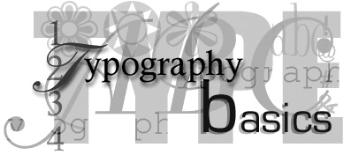

Page Elements and

Design Layout

In this Chapter
- Textual Elements
- Graphic Elements
- Spatial Elements

Graphical Elements

There are no rules to the use of graphical elements and their design, but there are considerations on their use that should often be observed and practiced. Since document content ought to reflect the needs of a reader, the use of graphic elements should be used with the intentions of supporting the document’s message through clarity and consistency.

Establish early on a format for the design and use of the elements. With the use of a format you can effectively draw cohesion through a document and present the message while avoiding an unbalanced appearance.

Did you know…?
 | Estimate whether or not the use of a graphical element in a document is relevant to the information and useful in supporting the information. An overuse of graphic elements in a document can generate inconsistencies and confusion.

Graphic Treatments

Graphic treatments enhance a document and help draw the reader's attention to the document content. When an effective use of graphic elements is visible in a document, a reader can grasp the writer’s message more quickly or identify important items faster when scanning the document.

Watermarks

A watermark is a light-colored, often gray, monogram or pictorial representation that appears in the background a document. Used as a copyright-protection method, a watermark verifies the authenticity of authorship. It can also be used to trace the origin of a paper’s creator, identify original prints, or to release authority. Unfortunately, the use of watermarking documents has decreased in recent years as more paper companies produce specialized watermarked paper for mass distribution and use. Such paper is most often used in printing resumes and specialized reports.

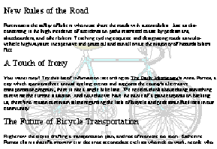
Figure 5.7 Bicycle Watermark
There are instances when a watermark is used for decorative purposes. For example, say you would like your finished document to have a specialized watermark that shows this document is copyrighted but do not want to use specialized paper watermarked paper. In such case you can create a watermark easily by using a word processing program.

Listing devices

Listing devices is a technique used to limit the amount of word use needed to explain an idea and save space on a document. As the writer you should always keep in mind the reader and how effective the use of a listing device will be to the reader. Bullets, letters, numbers, and other such listing devices are used as an informative way of pointing out important topics or a list of steps.

Though bullets, letters, and numbers are used as guidance tools, there are occasions where the use of these listing properties is purely for decorative purposes. In such cases make sure the use is sporadic in the document.

If you plan on using a listing device anywhere in a document, separate it one line from the body of text and indent all items from the left margin. Most bullets are automatically indented five spaces from the left margin on most word processing programs. To date, this indentation format has become the standard in documentation.

Bullets
Bullets are used before the start of an item on a list of items of equal importance. Depending on the document format, bullets should only be used when the listing sequence itself in a document is not important. Do not use bullets for list that have fewer than three items. Also be aware of the tone and format of the list as you go from one item to another; it should be parallel. Here is an example of a bulleted list that accompanies text.

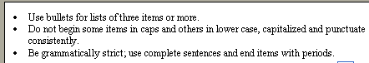
Figure 5.8 Bulleted Lists

Letters

Letters are used to set a hierarchy of information instead of bullets. Unlike bullets where all information is of equal importance, letters equate an alphabetical order of process. What is most important is first followed by second most important and so forth. Second, lettered list have one abstraction that makes them distinctly different from bulleted lists and that is supporting items. Supporting items in a lettered list vary from a one word reference to a string of supporting sentences. In short, letters are most often used for the creation of outlines. However, Letters are not to be used for lists that require steps.

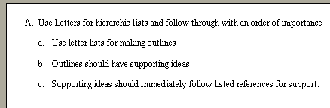
Figure 5.9 Lettered Lists

Numbers
Number lists should be used when there is a progression of steps to follow. Numbering indicates to the reader that a sequence of important action is to take place. If the list is a long complex order of detailed ideas consider writing out a short paragraph to explain the sequence, otherwise use short statements and combine steps only if the steps are related.

Numbering is sometimes used in combination with lettered lists as supporting sub-items. The following is an example of a numbered list of steps and a lettered list using numbers in support.

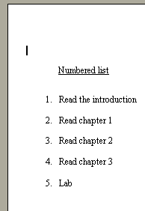 | 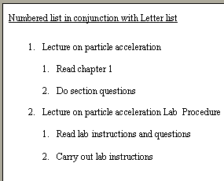
Figure 5.10 Lists

Line Work

Line work is not used today like it used to be. Line work helps a document by anchoring attention to a graphic or text on the page. Lines also help to create structure in a document, usually in the form of a divider, between text and other graphic elements. At the same time, when used correctly, line work can make two objects, such as text and graphic illustration, work as a unified piece with depth.

Underline

Before the use of computers and word processing programs, there was the typewriter. Back then underlining text to show emphasis was a commonly accepted writing technique, however that is no longer the case. With the common everyday use of word processing programs today, underlining text has been surpassed by the graphical text treatment of italicizing to show emphasis.

The elements of design create every object around us. Nothing can exist without these ingredients. The discipline of learning the power of these elements and formatting them within the principles of design is the responsibility of the designer.

Figure 5.11 Bad emphasis
Notice that the overuse of the underline has made the text hard to focus on and attention is placed more on the underlined words than the prose as a whole. Instead of using the underline to attract attention and emphasis, which draws away from the clarity of the prose, italicize words. Using the latter of the two treatments leaves the prose clean of irregularities that could potentially be considered an eye sore.

The elements of design create every object around us. Nothing can exist without these ingredients. The discipline of learning the power of these elements and formatting them within the principles of design is the responsibility of the designer.

Figure 5.12 Good emphasis

Did you know…?
Tips: Only use an underline on a level one heading when necessary and avoid any use of the underline on text within a document at all costs. Underlining text in a document it is an unattractive typographic abomination as is the overuse of bold face text.

Strike Through

Another graphical element from the age of the typewriter that has slowly vanished thanks to the use of word processing programs has been the strike through. Strike through, a method commonly used in editing, was the act of drawing a line through a word or line of text in a document for editorial purposes.

When ideas appeared unbalanced because the document theme or sentences lacked parallelism, writers who used typewriters would mark the selections with a strike through, a black line that drew through the middle of the selected text. This line helped to mark what text was to be removed during the re-write.

With the use of word processing programs today, the strike through method has taken on more than the task of marking what selections should be removed. The latest word processing programs track strike through marks as a way to track each level of editing made to a document. Instead of deleting the stroked selections automatically after each editing revision, they are left alone in case a new editing revision rejects the previous edit.

Original sentence→ This is a sentence in a document.
First revision→ This is a A sentence in a document is…
Second revision → This is a A sentence in a document sentence
in a document is …

Third revision → This is a sentence in a document is…

Figure 5.13 Editing

The Dash

The dash can function like a comma, colon, or parenthesis in the sense that it set off parenthetical material and introduces clauses that can explain or expand upon an idea. There are two types of dashes used in the English language, Em dash and En dash.

Em Dash
Em dash is the most commonly used form of the dash. Called an Em dash because the amount of space on a line used is the same size used for the typeset letter M, the Em dash organizes phrases and clauses within a sentence. A single Em dash is used to indicate more importance to a statement that would normally be placed in parenthesis. A double Em dash is used only when there are missing letters in a word. Magazines and newspapers practice the use of a space before and after the dash for consistency and uniformity while other forms of print only use one space after the dash. Whether the Em dash has a space before and after is the choice of the typist.

Parenthetical sentence | With three character witnesses, the defense is sure to win the case—assuming all goes well.
Missing letters | “Why is Mr. T----s saying such things in his writings?”
Figure 5.14 Em dash

En dashes
The other form of dash, the En dashes, can be used in place of a hyphen between compound adjectives when at least one element is a two-word compound. The En dash usually replaces the word to between capitalized names, linkage between oppositions, and is used to indicate duration of time or location. If the words “thru,” “of” or “at” can be used in place of the dash, then an en dash is appropriate. Never space before or after an en dash.

10:00 am-12 noon ←Time Duration
Boy clothes-Girl clothes ←Oppositions
Orlando-Kissimmee, Florida ←Capital names
Figure 5.15 En dash

Hyphens

The dash is an under rated but highly used line work in documentation. Often, the hyphen is used incorrectly to break a word. Using too many hyphenated line breaks in a row creates unattractive text that is difficult to read.

As a general rule, three hyphens in a row should be your maximum. Discretionary hyphens can be placed where you prefer a word to split.

“… A corporate employee needs to develop his or her own net-
work of peers, two or three, to count on to look over and critique their work (Jones, 205).”

Figure 5.16 Using the dash
Most computer programs provide a discretionary hyphen. As you key the text, watch all your line breaks carefully; then go back over the text you have entered and edit every single line of the document. While this may take a little extra time and effort, the payoff is the professional “look” your text can create.

Highlighting Cues

Highlighting cues is a visual technique used to direct attention to a specific part of a document. A warning, cautions, troubleshoots, and other such highlighting cues emphasize information to a reader that would normally be overlooked when skimming through the document. The most common of highlighting cues are lines that box off text (also known as pull quotes).

Lines that Box Off Text

Lines that box off text on a document are usually referred to as pull quote. A pull quote is a short quotation used as a graphic device to summarize surrounding material and draw attention to it. Used often as a design element, pull quotes can be set up as large type, in highlighted color, or simply boxed separate of the document body. Screens, boxes, and borders are other variations of pull quotes used attract attention.

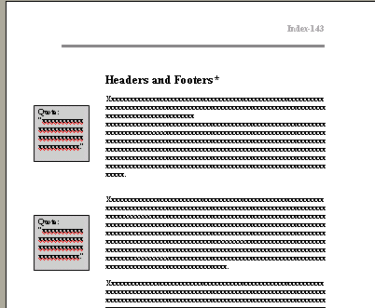
Figure 5.17 Pull Quotes

Pull quotes are often used to break up large amounts of text in a document to make reading easy. Many designers prefer large sans serif typefaces when doing a pull quote because it stands out more against sans text and is easier to read. One of the most common pulls quotes is called the “Grayscale.”

Grayscale

Grayscale is an overlooked graphic treatment of great value that writers should often use in their documentation. There are instance when a section of text in a document is of high importance (for example, warnings) and requires some form of treatment to emphasize and make it stand out. In such cases, instead of moving the text somewhere else on the page to attract attention, box the text and place a shaded background behind it.

Warning:
To avoid potential fire or explosion from fan when turning the electricity on, after connecting wires, wrap a piece of electrical tape around exposed twisted end sections.

Figure 5.18 Warnings in Grayscale
One good trait of using grayscale in a document is the ability it has to draws in the reader’s curiosity. Used mostly for “tips” and “warnings” the grey background emphasizes to the reader’s attention that the highlighted text has a level of importance slightly above everything else on the page and should be noticed first. This graphic element also makes browsing easier on the reader who wants to focus quickly on items of interest.

Lines for Headers and Footers

Lines generally denote the direction of eye movement especially if they are used as graphical elements. As a result some lines are designed to work as page dividers (horizontal, vertical, or side line text separators) to hold and to unite elements on a page. There are however some textual elements, such as header and footer notes that are kept at either (top or bottom) ends of a document page, that because of the size of font used is so small (limited between an 8pt or 10pt) are unfortunately overlooked.
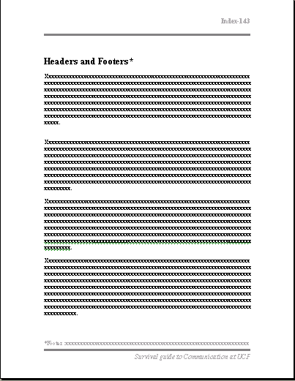
Figure 5.19 Lines in headers and footers

Nevertheless, using a line as a graphical element to segment the body text from the top and bottom of the page creates a linear patter of visual texture. Coincidently the eye pattern for reading will gradually move from the top of the page to the bottom, reading headers, body, and footers.

