

Bournemouth University
School of Design, Engineering & Computing
Fern Barrow, Poole BH12 5BB
Dorset, United Kingdom

Automatic GUI Generation

By

Bharat Gohil

Under the supervision of Ali Adams

Dissertation submitted in part-fulfilment of requirements for the degree of
BSc(Hons) in Software Engineering Management

April 1999

Contents

Abstract 3
Acknowledgements 4
1. Introduction 6
1.1. Overview 6
1.2. Project Introduction 6
1.3. Project Aim & Deliverables 6
1.3. Project Plan 7
1.4. Report Overview 8
2. Related Literature 10
2.1. Overview 10
2.2. Research Method 10
2.3. Related Literature 10
3. Generic Case Study Identification 14
3.1. Overview 14
3.2. Generic OOA Concepts 15
3.3. Generic Case Study 16
3.3.1. Problem Definition 16
3.3.2. Requirements 16
3.3.3. Analysis 16
3.3.4. Design 18
4. AutoGUI Generation 20
4.1. Rules Identification 20
4.2. AutoGUI Software Development 27
4.2.1. CASE Tool 27
4.2.2. Architecture 29
4.2.3. Additional Rules 32
4.3. Generated AutoGUI Interface 34
5. Results 41
5.1. Overview 41
5.2. Benefits 42
5.2.1. Three-Tier Architecture Synchronisation 42
5.2.2. Product Prototyping 43
5.2.3. Object Oriented Development Approach 43
5.3. GUI Standardisation 43
6. Conclusions 45
6.1. Project Plan Evaluation 45
6.2. Problems Encountered 45
6.3. Future Work 46
6.3.1. Design Patterns 46
6.3.2. UML Support 46
6.3.3. Semantic Modelling 46
6.3.4. Additional Rules 46
6.3.5. External knowledge database 47
7. Appendices 49
7.1. A - Project Plan Gantt Chart 49
7.2. B - Project Proposal 52
7.3. C - Project Files 54
8. Glossary 56
9. Bibliography 58

Abstract

In this report, rules for the automatic generation of graphical user interfaces from object oriented analysis models, are proposed.

The main deliverable is a set of rules, which are needed for the process of transforming a given OOA model into a fully functional and navigable graphical user interface.

The strategy in identifying a suitable set of mapping rules was conducted by identifying a generic case study and then using this case study to extract the rules for its given OOA model.

A CASE tool was implemented, using C++Builder. This was developed to verify and adjust the rules that were identified in the previous stage. The CASE tool also allows users to create and manipulate OOA models and to generate the corresponding GUI forms for them.

In addition to identification of the mapping rules, a highlight into the benefits to standardise the creation of intuitive GUI interfaces is given.

Due to our modest success in this young research area, a paper is being written in collaboration with the project supervisor to encourage further research into this area and to pave the way to standardising the CASE tool that has been produced.

Acknowledgements

I would like to thank my project supervisor Ali Adams for his invaluable guidance and advice throughout this project.

I would also like to thank Steve Webster for his helpful contributions.

In addition, I would like to thank both Ali Adams and Steve Webster for the help and encouragement to produce an “Automatic GUI Generation” paper to be published.

Finally, I would like to extend my thanks to my family who have given me the motivation and enthusiasm throughout my academic life and my nieces for the grateful loan of their Ladybird’s “Spelling & grammar” book.

Bharat Gohil

27th April 1999

1
Introduction

1.1 Overview

1.2 Project Introduction

1.3 Project Aims & Deliverables

1.4 Project Plan

1.5 Report Overview

Introduction

Overview

This chapter informs the reader of the reasons for the study and what deliverables are expected.

Project Introduction

In this project, rules for the automatic generation of graphical user interfaces (GUI) for object oriented analysis models (OOA), are proposed.

A generic case study is used to identify and extract a comprehensive set of rules for the generation of a functional GUI interface from a given OOA model for the case study. The generated GUI forms are fully navigable along object relationships and allow full manipulation of data.

Generic OOA concepts for Problem Domain Component’s (PDC) are used as a basis to extract rules for AutoGUI generation.

An investigation into this young research area was carried out to identify related work that transform OOA models into GUI interfaces. Throughout this study, the following questions are attempting to be answered

- Are there any existing tools that transform OOA models into GUI interfaces?
- How to map an OOA model into a functional GUI interface?
- How to automate the transformation from the OOA model into a GUI interface?

C++Builder was used to implement the AutoGUI CASE tool. The CASE tool allows users to create and manipulate new OOA models and to generate the corresponding GUI forms for the given OOA models.

Project Aim & Deliverables

The aim of this project is to identify a suitable set of rules for the automatic generation of graphical user interfaces for a given generic object oriented analysis model.

The project deliverable is a set of rules that map concepts from an OOA model (classes (containing both concrete and abstract), relationships (both instance and part-of types), attributes and methods) to suitable Windows controls, which are needed for the automatic generation of functional GUIs.

In addition to identification of the mapping rules, a highlight into the benefits to standardise the creation of intuitive GUI interfaces is given.

Project Plan

The first task of the project is to investigate existing research and CASE tools that transform OOA models into GUI interfaces.

The next stage of the project is to identify a generic case study, which will be used to identify the rules.

Once, a suitable set of rules have been identified, the design of the software application will start. Implementation rationale decisions will be carried out to find the appropriate way of implementing a CASE tool to verify these rules.

A generic case study will be modelled using the CASE tool as a test-bed to create a functional GUI interface. This will verify the completeness and correctness of the GUI generation rules and eliminate any excessive or overlapping rules.

Finally, more research will need to be carried out due to the research development that may have occurred within the duration of this project.

The project schedule can be found in a Gantt chart format in Appendix A, showing detailed information about the project schedule.

Report Overview

The following shows an overview of the contents of the chapters covered in this report.

Chapter 1 : Introduction

This chapter informs the reader of the reasons for the study and what deliverables are expected.

Chapter 2 : Related Literature

This chapter shows what others have said, written or researched regarding Automatic GUI Generation. It discusses how these contributions illuminate my topic and how the literature relates to my study.

Chapter 3 : Generic Case Study Identification

This chapter identifies a generic case study, which will be used as an example application to identify, verify and adjust the rules.

Chapter 4 : AutoGUI Generation

This chapter discusses the rules that have been identified using the example application. It also discusses how the CASE tool was implemented for testing the example application.

Chapter 5 : Results

This chapter tells the reader how the project went overall and states if the project was a success. It also discusses the conclusions reached from the study.

Chapter 6 : Conclusions

This chapter covers the problems risen and the appropriate actions taken to solve them. Briefly describes differences between plan and implementation and areas that could be studied further.

Chapter 7 : Appendices

Here are some supplementary details that the reader may need to refer to when necessary.

Chapter 8 : Glossary

The glossary contains the main terms that are introduced throughout the report.

Chapter 9 : Bibliography

The bibliography cites some books, journals, papers and other sources that have been referred to throughout the study.

2
Related Literature

2.1 Overview

2.2 Research Method

2.3 Related Literature

Related Literature

Overview

This shows what others have said, written or researched regarding Automatic GUI Generation. It discusses how these contributions illuminate my topic and how the literature relates to my study.

Research Method

The majority of the project investigation was carried out using Bath Information and Data Services (BIDS). This is an on-line Internet based system, which allowed me to search for related papers.

The second source of information was directly from the Internet using search engines, mainly “AltaVista”. This was primarily used to gather literature about graphical user interface design methodologies, guidelines and standards.

Related Literature

- The “User Interface Design : Tips and Techniques” paper [Amb98] focuses on guidelines that should be considered when designing user interfaces.

There were about 20 guidelines that are mentioned in this paper. Some of which have been taken into consideration when laying out components for our AutoGUI Generator.

Some of the useful guidelines in this paper are to keep components consistent, for example-if the button ‘Exit’ leaves the program, do not use ‘Quit’ in other parts of the program. Another interesting guideline that is misused number of times, is that windows should appear in the center of attention.

However, this paper lacks other fundamental guidelines that are necessary for designing GUIs, for example–enforcing protection handling for destructive actions. It also lacks any guidelines concerning form navigation.

- In the paper “Heuristic evaluation of user interfaces”[Mol90], Molich & Neilsen states that

“Human-computer dialogue construction appears deceptively simple, yet it is full of subtle pitfalls”

The above quote illustrates clearly the problems with interface designs in GUI systems. It seems that the knowledge of good interface design is either poorly understood or poorly implemented by designers.
- The “Automatic GUI Generation from Database Schema Information”[Shi97] paper discusses an experimental system that automatically generates various GUI components and lays them out on the screen, in a similar fashion to Microsoft Access Database Management System.

However, the rules are generated from Entity Relationship diagrams (ERD) and unlike ours, can’t handle complex data structures like OO classes and their hierarchies.

Shirota and Lizawa mentions the term “Application Viewpoint” [Shi97], which acts as a center of attention and an entry point into the GUI interface. This concept is also used in our project. By selecting different application viewpoints, the output GUI interface varies according to what particular class is chosen to act as center of attention.

Although, this paper is only partially related to my subject area, the concept used here to generate a GUI interface from an ERD gave me some indication of how to generate a GUI interface from an OOA model.

The paper clearly highlighted potential problems into automatic GUI generation

“It is difficult because the data structure are complicated, the algorithm for the layout of the data is also complicated. The criteria for layout evaluation are not clear and difficult to design layouts which satisfy the human aesthetic sense”[Shi97]

This does lead to the conclusion that developing a system to automatically generate a GUI interface from an even more complex data structure like OO classes, which encapsulates data and methods is highly complicated, hence the minimal research in this area.

- Because of the complexity of GUI generation, there is only one system that we have found that produces an automatic GUI interface from an OOA model.

The Balzert system “JANUS”[Bal96] is similar to the system we have developed.

The paper discusses in depth, the set of rules that are needed to map OOA attributes and methods to suitable controls. It also, describes some of the rules that are used for transformation using graphical notation, which greatly enhances the understandability of the mapping rules.

However, there are no guidelines for laying out components onto GUIs.

Another problem with Balzert’s system, it does not allow data representation of calculated object attributes and data manipulation that is performed through calculating class methods.

Even though our rules were identified before this paper was found, it confirmed that our strategy process for rule identification was correct and the identified rules were comparable.

This concludes that there should be a standard set of rules that map generic OOA concepts into a well laid out GUI interface which support form navigation and takes into consideration data manipulation and method invocation.

3
Generic Case Study
Identification

3.1 Overview

3.2 Generic OOA Concepts

3.3 Generic Case Study

Generic Case Study Identification

Overview

This chapter identifies a generic case study, which will be used as an example application to identify, verify and adjust the rules.

Before the rules can be identified, two pre-stages need to be carried out.

Firstly, we need to identify generic OOA concepts to form the basis for rule classification and ensure we cover a comprehensive set of likely OOA models.

Secondly, we need to identify a generic case study, which uses all the OOA concepts to form the basis for rules identification.

Generic OOA Concepts

Using a case study, an OOA model will be produced. This generic case study covers the following OOA concepts:

This classification will ensure that the rules will cover all the OOA concepts above and also acts as a checklist for verifying the rules.

Generic Case Study

Problem Definition

The following is a problem definition for a case study, which is going to be used as a example application to identify, verify and apply rules for the automatic generation of a navigable GUI interface.

“A centre requires a simple information system to support the management of a hotel”

Requirements

The system must support the following features:

- the system must be able to accommodate two types of rooms – Bedroom & Conference.
- the client must specify the type of room when making a booking.
- information as to whether a room is available for a particular date.
- the system must be able to keep track of all bookings for a particular room. When a booking is made, the client’s details must be recorded if not present in the system.
- the system must record a separate booking for each room requested by a client.
- the system must keep track of all rooms, clients and their bookings.

In addition to the typical services for adding, modifying and removing information about rooms, clients and bookings, the following services have to be provided:

- list all clients.
- list all clients who have bookings.
- list all bookings made for a given room.
- list all bookings made by a given client.

Analysis

Using the Coad & Yourdon OOA modelling method [Coa91], the PDC of the case study above is going to be modelled.

Various activities must be carried out before the OOA model is constructed.

- Finding Classes & Objects

The classes that are identified are:

- Client
- Booking
- Room (Abstract, to enforce requirement 2)
- Conference
- Bedroom

In order to specify an entry point to the system, a high-level system class must be specified:

- Room Booking System

- Identifying structures

The next stage involves identifying structures, there are three kinds of structures: Gen-Spec, Whole-part and inheritance structures:

- Client will have a “Part of” connection to the Room Booking System.
- Booking will have a “Part of” connection to the Room Booking System.
- Room will have a “Part of” connection of the Room Booking System.
- Client will have a “Instance” connection to the Booking.
- Room will have a “Instance” connection to the Booking.
- Conference and Bedroom will be inherited from the Room, which is an abstract class.

These structures can now be added to the OOA model.

- Identifying Attributes and Services

The final activity includes identifying the attributes, in a perspective view of a class and defining services that operate on the attributes for that particular class.

The OOA model for this problem domain is shown below:
OOA

Design

This section covers the desired dynamic behaviour of the system. The Interface Flow Diagram (IFD) of the PDC shown below, represents the main design activity to illustrate the runtime navigation between the GUI forms along object relationships.
IDF

The entry point to the system is the System Form, which represents the Room Booking System class. This is known as the “Application Viewpoint”.
The white boxes represent concrete class forms, whilst the grey boxes represent abstract class forms.

The thin lines represent the action flow between the navigable forms. Whilst, the solid lines represent the forms that are referenced from other forms, for example, in order to make a booking, you must specify the client id and the room id.

The Room form uses polymorphism to automatically detect and display the type of Room object that is being manipulated. Polymorphic forms displays both the abstract and the concrete class contents, by grouping the base and derived attributes together, followed by base and derived methods together.

4
AutoGUI Generation

4.1 Rules Identification

4.2 AutoGUI Software Development

4.3 Generated AutoGUI Interface

AutoGUI Generation

Rules Identification

Using the generic case study, a set of GUI generation rules have been identified in accordance with the OOA concepts discussed in Chapter 3.

The following enlists the rules based on the OOA classification:

Class Rules

- Classes can be Abstract or Concrete and are represented using different colours:
Abstract = Purple
Concrete = Grey

- There must be an entry point to the system, which will be represented by a single class to be called the System class(application viewpoint).
- Each class is mapped onto a single form.

- Class components (attributes, relationships and methods) are to be placed within the form as shown:

- A class Detail form must have global buttons at the bottom to close it with different return values as shown below. Only the System class form can have an Exit and About button.
Bevel
- The title of the System class form should be the title of the System class.

Inheritance Rules

- If a class is abstract then there is no form created for it. However, any concrete descendent class from it, will contain its components.
- If class Y is derived from an abstract class X, then generate a Detail form for class Y based on class X, generate the components for class Y on the same form, and group similar components together as shown below:
Note : Multiple inheritance is not supported yet.
Attributes Rules

- There are three kinds of attributes which are represented using different colours:
Key = Cyan
Intrinsic = Blue
Calculated = White


- An attribute must have the following properties:
Type →
Minimum Value →
Maximum Value →

- The type property for an attribute can be mapped to a suitable Windows control, as follows:
Bool → Check Box
Integer → Scrollbar
or
→ Spin Button
or
→ Edit Box
String → Edit Box
Date & Time → DatePicker
Currency → Masked Edit Box
- A calculated attribute must have a corresponding calculating method and both are represented together as follows:
Label Edit Box Button
Label = Name of calculated attribute
Edit Box(Read-only) = Key attribute’s value
- The value of numeric attribute must be shown in different colours, depending on its value:
Positive value = Blue
Zero value = Black
Negative value = Red

Relationships Rules

- There are two kinds of relationships:
Instance =
Part of =

- A relationship may have cardinality pair of (1..1, 1..m, m..m).
- A relationship is represented in both forms of related classes in accordance with the following table:
1 m m

instance

part-of
Normal Font
Bold Font
Shows Details form

Shows
Collection form
Collection Rules

- The title of the Collection form should be the name of the Class + “s”.

- The placement of components on the Collection form is as follows:
- The text in the combo box should be the name of the class types in the hierarchy (both abstract & concrete classes).
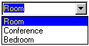

- In the Collection form, the list box font type is:

“Normal” = Collection of Pointers
“Bold” = Collection of Objects

- When a class type is selected in the combo box of the Collection form, it should show only the corresponding items in the list:

- A collection will automatically support “Add”, “Remove”, “Modify” and “Clear All”.
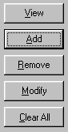
or double click on item to view its Details form

- If an abstract class type is selected in the combo box of the Collection form, then disable the “Add”, “Modify”, “Remove” and “Clear All” buttons, but enable the “View” button.
or double click on item to view its Details form

- In the Collection form, when one of the functions is selected “Add”, “Remove” or “Modify” the default button caption is changed in the Detail form.

- When one of the functions in the Collection form is selected, the title of the Detail form is also changed.
Its title should be the name of the function + Class type.
- If you navigate to a shown form, just change focus to that shown form and update if necessary.
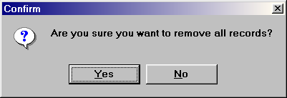
- If a destructive action is selected (Remove, Clear All) a confirmation box must be displayed, before carrying out the action:

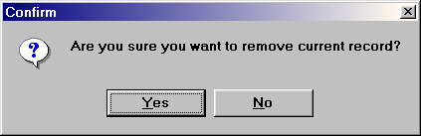
- When navigating to a Detail form of Class X from Class Y and the form has Class X’s key attribute as a field, then the field must be read-only.
- All Collection forms default functions are automatically on the Collection form, separated at the bottom:
Bevel
Methods Rules
- There are two kinds of methods and they are mapped as follows:
Intrinsic → Small button
Calculating →
- Calculating member functions work on calculated attributes and therefore their results are to alter those attribute values.

AutoGUI Software Development

CASE Tool

A case study has been implemented using C++Builder (Professional Edition) for Windows 95. C++Builder was chosen because of its Rapid Application Development (RAD) model that facilitates the fast Windows application development, in addition to my good knowledge and experience of this tool.

The snapshot below shows the final AutoGUI Computer-Aided Software Engineering (CASE) tool developed during the course of the project, with its functionalities enumerated.
1
4
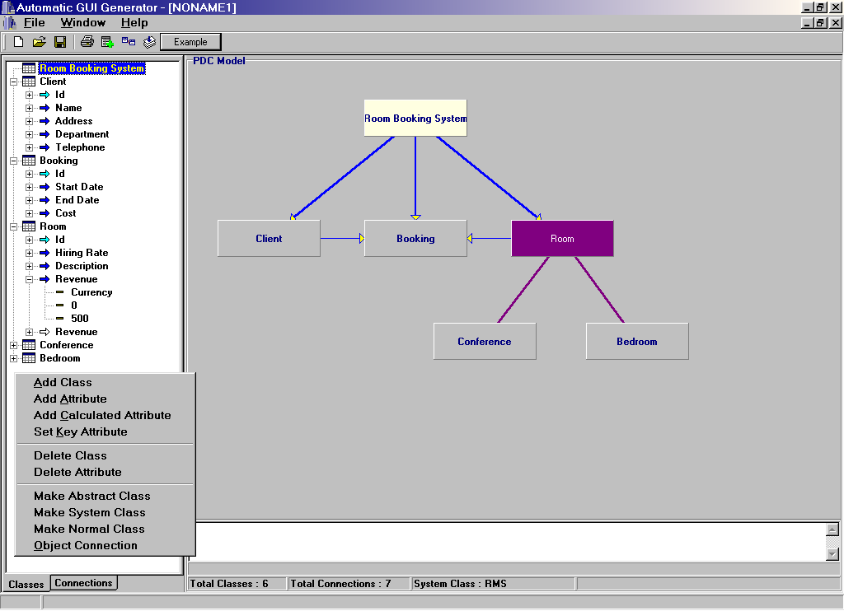
2
3
5
6
7

AutoGUI functionalities:

- Functions that can be performed by the CASE tool
- New object model
- Open existing object model
- Save current object model
- Print object model
- Add a new class
(Dialog box used to name the new class)
- Add a new object connection
(Dialog box used to define connection properties)
- Generate GUI interface for the current OOA model
- Example of an OOA model
(Our case study – Room Booking System)

- This context menu is used to perform related functionality to the current object model’s part where a right mouse click has occurred.

- There are two pages on the details pane, the first page (Classes) shows all the classes in the model, complete with their attribute names and properties as indicated by circle 4. The colour of the attributes indicates whether the attribute is intrinsic or calculated and whether it is the key attribute for its class:
Key = Cyan
Intrinsic = Blue
Calculated = White
On the other hand (tab), the second page (Connections) shows all the relationships between the classes in the model. The relationship types are shown in the main pane, as indicated by circle 5.

- This shows an attribute with its properties (type, minimum value and maximum value).

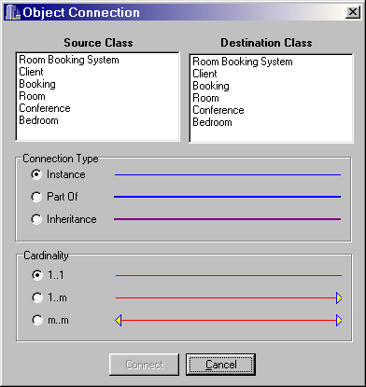
- In the main pane, the object model can be created and manipulated.
The colour of the class represents its type, as follows:
System class = Yellow
Abstract class = Purple
Concrete class = Grey
The colour of the relationship represents its type, as shown in the snapshot below:
Instance = Blue (Normal to mean referencing)
Part Of = Blue (Bold to mean containment)
Inheritance = Purple
Whilst the cardinality of the relationships are shown using our own notation.

6. Status bar is used for live-display of three pieces of information:

Total Classes - Number of classes in the current object model
Total Connections - Number of relationships between classes
System Class - Application viewpoint, which is used to as an
entry point to the system

- Displays any error messages that may occur during automatic generation,
for example, it will display error messages if the system
- has no classes to generate from.
- contains duplicate class names.
- contains duplicate attribute names.
- no system class is represented.

Architecture

The AutoGUI CASE tool is a single-tier architecture, which combines all the three layers (Presentation, Logic, Data Access) into a single module, as illustrated below

Data Access
Database
Logic

Presentation
Layer

AutoGUI CASE Tool

Whilst the Presentation layer represents the GUI part of the system, the Logic layer carries out the processing that is initiated by the user in accordance with the specified dynamic behaviour of the system. The Data Access layer communicates with the relational database to store and retrieve object attributes (fields) and object relationships (foreign keys).

There are various algorithms that have implemented to interrogate the classes and attributes of the OOA model, for the process of generation.

For the generation of the GUI to work at runtime, the forms need to be stored in a list for manipulation. This will allow for form navigation in accordance with the interface flow diagram.

There are many ways to implement a list. One way of carrying out this problem is to use arrays, alongside records (Structs). But this is not the most flexible mechanism for implementing containers because a fixed size must be specified.

A better approach in many cases is to use a linked list, which allows the size of the container to vary as objects are added and removed. Since it does not necessitate the storage of objects in a fixed physical sequence (even though they still have a logical sequence, making the list a type of ordered collection).

Below shows the structure of a singly linked list. Items which are to be stored in the list can be of any type (void*). An item (form) is encapsulated within a Node object for traversing the list across nodes.

This data structure is flexible enough to be used in future software development projects as it uses void*, but on the other hand it is type-unsafe. A better approach would have been to use templates, but the current C++ compiler forces you to implement member functions inline in a long header file.

The following code shows how a new form is created at runtime and added to an existing linked list (MyForms):

// Create a new form at runtime.

TForm* mainform = new TForm(Application);

// Set caption of form = name of system class.
mainform->Caption = SystemClassName;

// Set up other attributes of the form.
mainform->Position = poScreenCenter;
mainform->Height = 86;
mainform->Width = 227;

// Add form to the link list.

MyForms->Add(mainform);

The Windows controls are also created at run time and an extract of the code that creates a component and places it on the appropriate form is shown below:

// Create a new button at runtime.

TButton* OKButton = new TButton(Application);

// Set the properties.

OKButton->Caption = "OK";

OKButton->Top = 136;

OKButton->Left = 71;

// Now indicate what form the control should appear on.

OKButton->Parent = MainForm;

Some of the event handlers for components, like Buttons are created manually on temporary forms and once the component is created at runtime, the appropriate event handler is assigned to that object event, as illustrated below:

// Assign an event handler to an existing event function.

OKButton->OnClick = EventHandler_MainFormHide;

// Note: The flexibility of the code, because a new button // is created at runtime and an event handler assigned to // it at runtime too!

Additional Rules

Although, it is outside the scope of the project, PDC-Database mapping rules have been identified whilst developing the CASE tool.

Below are some of the rules for the transformation (synchronisation) from the Logic layer to the Data Access layer.

- For any given problem domain, there can only be one system class.

- For the system class, generate a database.
Name of database = System class name.
=
Room Booking System

- For each other class, create a corresponding table.
Table name = class name +”s” + “Table”.
Clients Table
Id
Name
Address
Department
Telephone

=

- For every attribute, including calculated ones, create a field in the table.
Field name = attribute name

- If an attribute is calculated, then its field must be made read-only.

- The key attribute of a class is mapped to a primary key field in the class table.

- For every class relationship, create a field in the table to hold a foreign key representing the primary key of the class on the other-side of the relationship.
For every derived class, create a new table for the class and copy fields from the table(s) of its base class(es) and insert the fields into the derived class table, in inheritance hierarchy order (most base class first, …, ending with the derived class fields).

Conferences Table
Id
Hiring Rate
Description
Revenue
Seats

=

Generated AutoGUI Interface

Having identified the necessary automatic generation rules as described in details in section 4.1, and implemented the CASE tool accordingly, the AutoGUI generator has generated the following functional GUI interface, given the problem domain described in Chapter 3 as an input.

Please refer to Section 3.3.4 for the interface flow diagram of this case study.

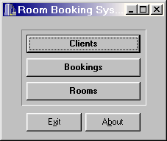
The snapshots are enumerated in accordance with the mapping rules.

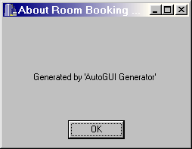

Rule 6
Rule 5
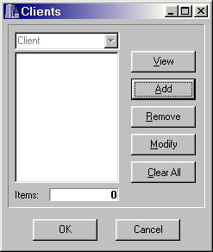
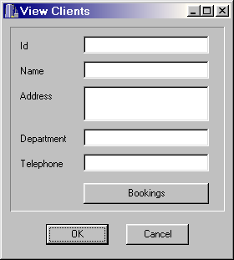
Rule 17
Rule
22
Rule 29
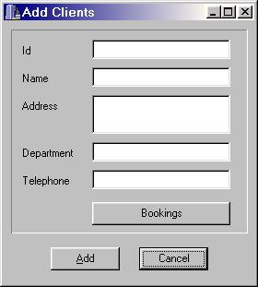
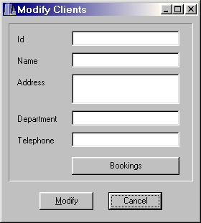
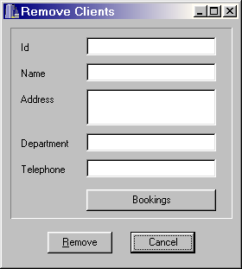
Rule 5
Rule 25
Rule 17,18,19
Rule 24
Rule 27

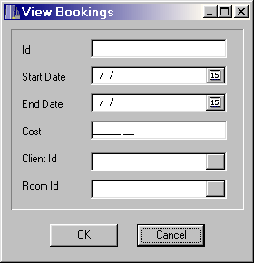
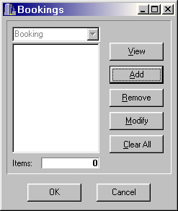
Rule 16
Rule 18
Rule 11
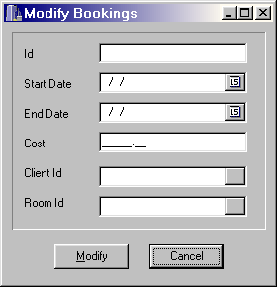
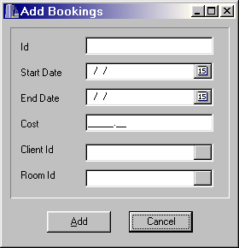

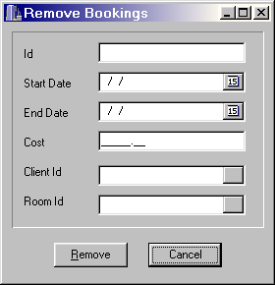

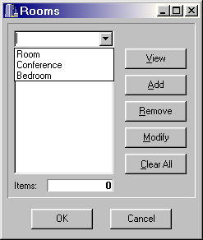
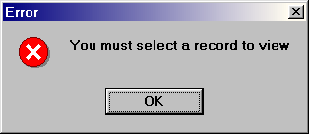
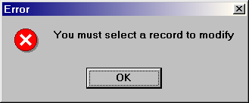
Rule 19
Rule 16
Rule 21

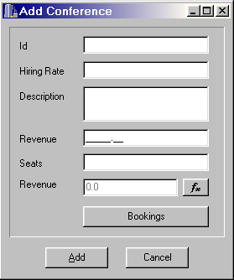
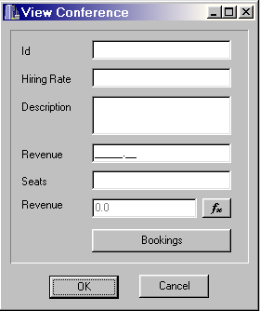
Rule 8
Rule 12

Rule 16
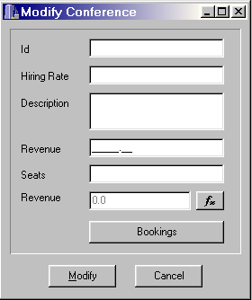
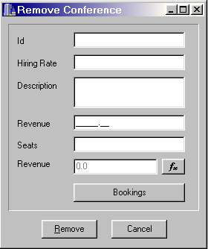

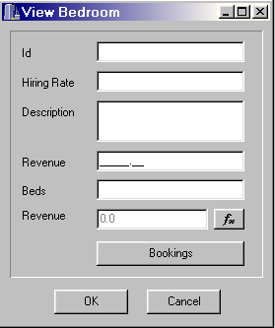
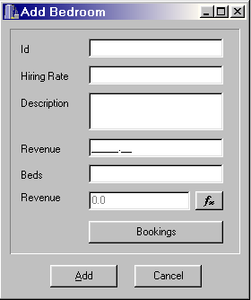

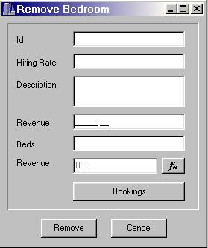
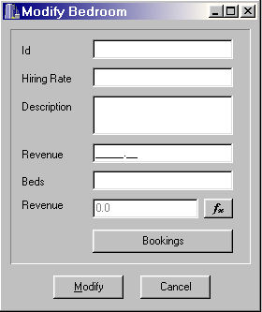

Rule 25
5
Results

5.2 Overview

5.2 Benefits

5.3 GUI Standardisation

Results

Overview

The aim of the project was to identify suitable rules for the generation of an automatic GUI interface for a given OOA model. The main aim and deliverables have now been accomplished successfully, including the development of a CASE tool to demonstrate the rules using a generic case study.

This project has given me a great inside into Object Orientation by increasing my knowledge in OOA, OOD and OOP. It has also increased my reading productivity and methods of researching. I have also gained a thorough understanding into the C++Builder development tool.

The questions initially asked at the start of the project were

- Are there any existing tools that transform OOA models into GUI interfaces?
- How to map an OOA model into a functional GUI interface?
- How to automate the transformation from the OOA model into a GUI interface?

Firstly, the transformation from the OOA model into a GUI interface must contain mapping rules. These are listed in Chapter 4 and shown according to the OOA classification.

The creation of the GUI interface is carried out at runtime. Once the user defines an OOA model using the CASE tool, the CASE tool automatically produces a fully functional and navigable GUI interface.

As there have been only a few papers concerned with automatic GUI generation, a paper is being written in collaboration with the project supervisor to encourage further research into this area.

Benefits

Automatic GUI generation has many benefits, which are discussed below.

Three-Tier Architecture Synchronisation

Modern distributed applications are made up of three fundamental types of application components – Presentation, Logic and Data Access.

The Presentation layer allows the user to interface with the system to retrieve and manipulate information. The functionality provides an interface to the user, to allow them to navigate through various parts of the application. This layer frequently performs limited amount of data validation.

Whilst the Presentation layer represents the GUI part of the system, the Logic layer carries out the processing that is initiated by the user in accordance with the specified dynamic behaviour of the system.

The Data Access layer serves the Logic layer with the required data through the Database Management System (DBMS).

The layers communicate with each other using standardised middleware tools like the Common Object Request Broker Architecture (COBRA), which encapsulates these functions behind Interface Definition Language (IDL) interfaces.

Developers can then develop each application component (layer) separately. The benefits are that developers who are good at user interface design skills concentrate on the Presentation layer and do not need to know about the inner workings of the application Logic layer or even how the data is accessed or retrieved from the database.

The process of developing such an application using this architecture is usually complex and can lead to a mismatch in synchronisation between the layers throughout the life-cycle of the distributed application (maintenance-induced mismatches).

The main advantage of the automatic GUI generation is to automate the synchronisation of the Logic layer and the Presentation layer in a three-tier architecture. This can reduce software development time considerably. In addition, synchronisation between the Logic and Data Access layers can be enforced using the additional database mapping rules in section 4.2.3.

The AutoGUI automatically can be set to detect any changes in the OOA model (Logic layer) and it automatically adjusts the GUI interface (Presentation layer) and the database scheme (Data Access layer), and keeps them synchronised.

Contrast this with the manual synchronisation in today’s system and the associate problems with it, which may not be responsive enough to market demand / changes.

Product Prototyping

The AutoGUI CASE tool can also aid in requirements elicitation, as a basis of demonstrating a “quick and dirty” prototype to the customer, because a fully navigable and functional GUI interface can be produced directly from customer requirements.

Object Oriented Development Approach

There are two ways in approaching a software development project using Object Orientation.

The first approach is “Problem Oriented” approach [Hoy93], where the analysis of the system is carried out using use cases or scenarios. While the second approach is “Target Oriented” approach [Hoy93], where the analysis of the system is carried out using the requirement specification. In the latter case, the OOA model is partially a “Preliminary Design”, and therefore the design stage of the object oriented process may not need to be carried out for small scale projects.

If the AutoGUI CASE tool is used, it can directly produce the end software product from the initial OOA model.

GUI Standardisation

Our approach (mapping rules) could form the basis for a standardised GUI generation guidelines.

The quote raised in the “From OOA to GUIs : The JANUS System” paper [Bal96]

“A main disadvantage of today’s User Interface Management System (UIMS) is the missing support for ergonomic design of GUIs”,

clearly explains the problems with existing user interface CASE tools. There are many interface design guideline books, but none of which shows where to place controls on a GUI interface to keep it ergonomically usable.

Producing a user interface that meets all users aesthetic taste can be very tricky. As there are no concrete current ergonomic guidelines for GUIs, one of this project’s tasks was to produce a GUI standard. It is very important that the user interface is designed in such a way as to maximise usability and productivity and minimise user stress levels. By standardising GUI interfaces, this also reduces the amount of training that is required by users to use the system effectively.

6
Conclusions

6.1 Project Plan Evaluation

6.2 Problems Encountered

6.3 Future Work

Conclusions

Project Plan Evaluation

The project plan initially produced was comparable to the actual project progress. The only issue that was of concern, was that the development work had started before all the rules were identified for the generic case study (class inheritance). However, this did not have any great impact on any of the other tasks that had to be carried out.

An extra bonus that was not expected, is the accidental identification of necessary mapping rules from the Problem Domain Component (PDC) to the Data Management Component, when the database was used to manage the data storage and retrieval. These rules were added into the CASE tool.

Beside the development issues, the project progress went according to plan, to within +/- 2 weeks. On the positive side, a paper is being written which was not intended at the start of the project.

On the other hand, even though the project was started early and took longer, the final result was a new contribution to software development.

Problems Encountered

No major problems were encountered. However, when carrying out literature research, it was noticed that papers that were gathered were misleading! There were a number of papers, which the title did not reflect their contents.

The implementation of the CASE tool took longer then expected, because the development work was different to other projects that have been carried out in the pass. When automatically generating the GUI for the OOA model, all the navigable forms and functional Window controls had to be chosen and created at runtime. This included the placement of controls onto forms and overriding the default event handlers with user-defined functions at runtime.

This also necessitated changing the database scheme at runtime, where the creation of runtime tables for the databases were more tedious than originally thought.

Future Work

AutoGUI CASE tool can be improved in many ways, which are discussed below.

Design Patterns

This report has described in detail the necessary rules that are required to map class attributes and methods to suitable Windows controls. This could be taken further by producing a number of AutoGUI generation design patterns.

Design Patterns are “descriptions of communicating objects and classes that are customised to solve a general design problem in a particular context” [Gam95], in other words there are standard solutions to standard problems.

Standard design patterns (set of related rules) will allow developers of CASE tools, such like “Microsoft Visual Modeller” or “Playground” to embed these reusable patterns (as opposed to the non-reusable mapping rules) into their CASE tools for the automatic transformation of OOA models into GUI interfaces.

UML Support

Other future enhancement could be to extend our CASE tool to support Unified Modelling Language (UML). UML is a visual modelling language that is now widely used. It allows a smooth transition from the requirements from the user to the computer domain, by communicating through a common language throughout all visual models. All the members of the development team can work with the same terminology – thus minimising communication problems and increasing efficiently.

Currently, our CASE tool does not support UML, because UML uses an alternative notation compared to Coad and Yourdon notation, which is used throughout this project.

Semantic Modelling

Furthermore, our CASE tool does not allow for any semantic modelling of object behaviour, which may need a separate treatment before the AutoGUI generation process.

Additional Rules

More work can also be carried out, on set of rules that transform the Logic layer to the Data Access layer. Even though some of these rules have been identified in this project, they have not been validated for completeness and less emphasis have been made on these rules.

External knowledge database

For a greater flexibility, an external knowledge database can be created to store AutoGUI generation rules independently of the CASE tool. This would facilitate the fine tuning of the rules and testing them at runtime. It would also enable the user to customise the rules to their own needs and requirements.

Overall, the project has been a great success and hoping that it will encourage other researcher to investigate my project findings and continue further developments in this research area.

7
Appendices

7.1 A - Project Plan Gantt Chart

7.2 B - Project Proposal
7.3 C - Project Files

Appendices

A - Project Plan Gantt Chart

The project Gantt chart can be seen on the next two pages.

B - Project Proposal

The next page shows the project proposal.

C - Project Files

A disk is supplied with this report, including all the project files listed below:

About.h
About.cpp
Childwin.h
Childwin.cpp
Connection.h
Connection.cpp
Generate.h
Generate.cpp
List.h
List.cpp
Main.h
Main.cpp
NewClassDialog.h
NewClassDialog.cpp
Node.h
Node.cpp
TemplateCollection.h
TemplateCollection.cpp
TemplateDetails.h
TemplateDetails.cpp
AGUIGEN.exe - Executable AutoGUI CASE tool
AGUIGEN.bpr - AutoGUI project file

8
Glossary

Glossary

AutoGUI Rules - Mapping rules used to transform an OOA model into a
GUI interface.

Abstract Class - This is a class that provides functionality inherited by
other subclasses and does not have objects
instantiated from it.

CASE - Computer-Aided Software Engineering.

Concrete Class - A class that can be instantiated.

Class Method - Behaviour of an object.

Class Attribute - Single piece of data that belongs to an object.

Cobra - Specification used to define distributed object
Architecture.

DBMS - Database Management System.

GUI - Graphical User Interface.

IFD - Information Flow Diagram.
Diagram that models an interface between objects.

IDL - Interface Definition Language.
Language used to define an interface of an object.

Key Attribute - Attribute that represent a particular class.

OOA - Object Oriented Analysis.

OOD - Object Oriented Design.

OOP - Object Oriented Programming.

PDC - Problem Domain Components.

Polymorphism - The ability to allow different classes of objects to
respond to the same message in different ways .

System Class - Which acts as a center of attention and an entry
(Application into the GUI system.
Viewpoint)

9
Bibliography

Bibliography

[Coa91]

“Object Oriented Analysis”

Coad. P & Yourdon. E
1991-Second Edition

[Shn92]

“Designing the User Interface”
Shneiderman. B
1992-Second Edition

[Gam95]

“Design Patterns”
Gamma, Helm, Honson and Vlissides
1995

[Bal96]

“From OOA to GUIs : The JANUS System”
Balzert. H

1996-JOOP Volume 8, No. 9

[Shi97]

“Automatic GUI Generation from Database Schema Information”
Shirota. Y & Lizawa. A

1997-Systems and Computers in Jan, Volume 28, Number 5

[Hoy93]

“On the purpose of Object-Oriented Analysis””
Hoydalsvik. G and Sindre. G
1993-OOPSLA

[Amb98]

“User Interface Design : Tips and Techniques”

Ambler. S
1998

[Wat95]

“Client Server Technology for Managers”
Watterson. K
1995

[Mol90]

"Heuristic evaluation of user interfaces"
Molich. R and Nielsen. J
1990-ACM

